OSS PaaS and DevOps

Step-by-step workshop

March 2018

Information in this document, including URL and other Internet Web site references, is subject to change without notice. Unless otherwise noted, the example companies, organizations, products, domain names, e-mail addresses, logos, people, places, and events depicted herein are fictitious, and no association with any real company, organization, product, domain name, e-mail address, logo, person, place or event is intended or should be inferred. Complying with all applicable copyright laws is the responsibility of the user. Without limiting the rights under copyright, no part of this document may be reproduced, stored in or introduced into a retrieval system, or transmitted in any form or by any means (electronic, mechanical, photocopying, recording, or otherwise), or for any purpose, without the express written permission of Solliance.

Solliance may have patents, patent applications, trademarks, copyrights, or other intellectual property rights covering subject matter in this document. Except as expressly provided in any written license agreement from Solliance, the furnishing of this document does not give you any license to these patents, trademarks, copyrights, or other intellectual Information in this document, including URL and other Internet Web site references, is subject to change without notice. Unless otherwise noted, the example companies, organizations, products, domain names, e-mail addresses, logos, people, places, and events depicted herein are fictitious, and no association with any real company, organization, product, domain name, e-mail address, logo, person, place or event is intended or should be inferred. Complying with all applicable copyright laws is the responsibility of the user. Without limiting the rights under copyright, no part of this document may be reproduced, stored in or introduced into a retrieval system, or transmitted in any form or by any means (electronic, mechanical, photocopying, recording, or otherwise), or for any purpose, without the express written permission of Solliance.

The names of manufacturers, products, or URLs are provided for informational purposes only and Solliance makes no representations and warranties, either expressed, implied, or statutory, regarding these manufacturers or the use of the products with any Microsoft technologies. The inclusion of a manufacturer or product does not imply endorsement of Solliance of the manufacturer or product. Links may be provided to third-party sites. Such sites are not under the control of Solliance and Solliance is not responsible for the contents of any linked site or any link contained in a linked site, or any changes or updates to such sites. Solliance is not responsible for webcasting or any other form of transmission received from any linked site. Solliancew is providing these links to you only as a convenience, and the inclusion of any link does not imply endorsement of Microsoft of the site or the products contained therein.

© 2017 Solliance. All rights reserved.

Contents

OSS PaaS and DevOps workshop step-by-step 1

Abstract and learning objectives 1

Overview 1

Solution Architecture 2

Requirements 3

Exercise 1: Environment setup 4

Task 1: Provision a resource group 4

Task 2: Provision a lab virtual machine 4

Task 3: Provision a Jenkins server 6

Task 4: Connect to your Lab VM 11

Task 5: Install an SSH client 14

Task 6: Install Visual Studio Code 16

Task 7: Install Node.js and NPM 21

Task 8: Install MongoDB Community Edition 25

Task 9: Install Docker 29

Task 10: Create GitHub account 35

Task 11: Fork the starter app 38

Task 12: Prepare GitHub account for VS Code integration 40

Exercise 2: Run starter application 44

Task 1: Clone the starter application 44

Task 2: Start MongoDB 45

Task 3: Launch the starter application 47

Exercise 3: Migrate the database to Cosmos DB 50

Task 1: Provision Cosmos DB using the MongoDB API 50

Task 2: Update database connection string 51

Task 3: Pre-create and scale collections 53

Task 4: Import data to the API for MongoDB using mongoimport 55

Exercise 4: Containerize the app 59

Task 1: Create an Azure Container Registry 59

Task 2: Install Docker extension in VS Code 60

Task 3: Create Docker image and run the app 62

Task 4: Run the containerized App 65

Task 5: Push image to Azure Container Registry 67

Exercise 5: Set up Web App for Containers 70

Task 1: Provision Web App for Containers 70

Task 2: Navigate to the deployed app 71

Exercise 6: Create Azure Function for order processing 73

Task 1: Provision a Function App 73

Task 2: Configure storage queues 74

Task 3: Create Cosmos DB trigger function 76

Task 4: Create Queue function 86

Exercise 7: Create Logic App for sending SMS notifications (Bonus) 95

Task 1: Create Free Twilio account 95

Task 2: Create Logic App 99

Exercise 8: Configure CI/CD pipeline (Bonus) 113

Task 1: Prepare GitHub account for Jenkins integration 113

Task 2: Configure Continuous Integration (CI) with Jenkins 119

Task 3: Trigger CI build 126

Task 4: Create Free Visual Studio Team Services Account 128

Task 5: Create a VSTS personal access token 130

Task 6: Configure Jenkins for Team Services integration 133

Task 7: Create a Jenkins service endpoint is VSTS 135

Task 8: Create a Team Services release definition 136

Task 9: Trigger CI/CD pipeline 144

After the workshop 148

Task 1: Delete Azure resource groups 148

Task 2: Delete WebHooks and Service Integrations 148

Appendix A: Manually provision resources from ARM template 149

Provision a lab virtual machine 149

# OSS PaaS and DevOps workshop step-by-step

## Abstract and learning objectives

This hands-on lab is designed to help attendees gain a better understanding of how to integrate and deploy complex Open Source Software (OSS) workloads into a PaaS infrastructure. Attendees will migrate an existing MERN (MongoDB, Express.js, React.js, Node.js) stack application from a hosted environment into Azure PaaS services, leveraging modern DevOps tools.

Attendees will learn how to:

* Provision Web App for Containers for hosting OSS applications
* Migrate a MongoDB instance into Cosmos DB
* Implement serverless technologies, such as Logic Apps and Azure Functions, to enhance OSS app functionality
* Provision an Azure Container Registry
* Build Docker images and push them into the Azure Container Registry
* Enable continuous deployment with Jenkins and Visual Studio Team Services (VSTS)

## Overview

Best For You Organics Company is one of the leading health food suppliers in North America, serving customers in Canada, Mexico, and the United States. They have a MERN stack web application which they host on-premises and are looking to migrate their OSS application into the Cloud. They will be creating a custom Docker image for their application and using a Jenkins and Visual Studio Team Services (VSTS) continuous integration/continuous delivery (CI/CD) pipeline to deploy the application into a Web App for Containers instance in Azure. In addition, they will be setting up Azure Cosmos DB, using the MongoDB APIs, allowing them to leverage the power of Cosmos DB, without having to make application code changes.

In this workshop, you will complete the OSS application and database migrations into Azure. You will create a custom Docker image, provision an Azure Container Registry, push the image to the registry, and configure the CI/CD pipeline to deploy the application to a Web App for Containers instance. You will also help them implement functionality enhancements using serverless architecture.

## Solution Architecture

Below is a diagram of the solution architecture you will build in this lab. Please study this carefully, so you understand the whole of the solution as you are working on the various components.

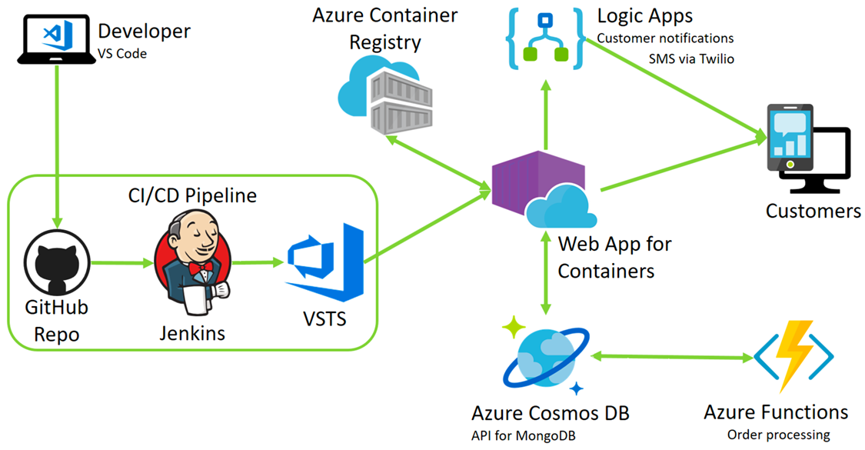

The solution begins with using Visual Studio Code (VS Code) as a code editor, leveraging its rich integration with GitHub, Docker, and Azure to simplify tasks throughout the workshop. From a high level, you will package the entire OSS application inside a custom Docker container using the Docker extension in VS Code. The image will then be pushed to an Azure Container Registry as part of a CI/CD pipeline using GitHub, Jenkins, and VSTS. This Docker image will then be deployed to a Web App for Containers instance, as part of the continuous delivery process using Release Management in VSTS.

The MongoDB database will be imported into Azure Cosmos DB, using mongoimport.exe, and access to the database from the application will continue to use the MongoDB APIs. The database connection string in the application will be updated to point to the new Cosmos DB.

Serverless architecture will be applied to order processing and customer notifications. Azure Functions will be used to automate the processing of orders. Logic Apps will be applied to send SMS notifications, via a Twilio connector, to customers informing them that their order has been processed.

## Requirements

1. Microsoft Azure subscription ($50 Azure pass codes will be provided)
2. Virtual machine configured with:
   1. Visual Studio Code
   2. Azure CLI
   3. SSH shell (such as GitBash or PuTTY)

## Exercise 1: Environment setup

Duration: 40 minutes

In this exercise, you will set up your environment for use in the rest of the workshop.

To activate your Azure pass, go to <www.microsoftazurepass.com>, and select Start. (It is recommended you use an In-Private Browser session, as other log-ins can persist and cause errors during the activation step.)

**IMPORTANT:** Many Azure resources require unique names. Throughout these steps you will see the word “SUFFIX” as part of resource names. You should replace this with a unique value, such as your initials, or another value to ensure the resource is uniquely named.

#### Task 1: Provision a resource group

In this task, you will create an Azure resource group to be used for the resources used throughout this workshop.

1. In the [Azure Portal](https://portal.azure.com/), select **Resource groups**, select **+Add**, then enter the following in the Create an empty resource group blade:
   1. Name: Enter hands-on-lab-SUFFIX
   2. **Subscription:** Select the subscription you are using for this hands-on lab
   3. **Resource group location:** Select either **East US**, **West US 2**, **West Europe**, or **Southeast Asia**, as these are currently the only regions which offer Dv3 and Ev3 VMs. Remember this location for other resources in this hands-on lab 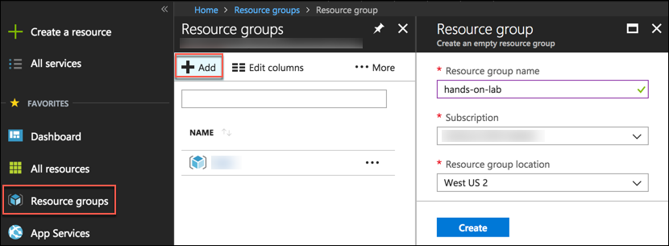
2. Select **Create**.

#### Task 2: Provision a lab virtual machine

In this task, you will provision the virtual machine (VM) you will use for this lab.

1. CTRL+Click the **Deploy to Azure** button below, and you will be taken to the Azure portal, and presented with a form for a new custom deployment (which uses an Azure Resource Management (ARM) template from a GitHub repository). You will be presented with a blade to provide some custom parameters as show in the screenshot below. (If you want to review the steps being performed by the ARM template, see Appendix A.)

[](https://portal.azure.com/#create/Microsoft.Template/uri/https%3A%2F%2Fraw.githubusercontent.com%2FZoinerTejada%2Fmcw-oss-paas-devops%2Fmaster%2FTemplates%2FTemplate-OSSPaaSVM.json)

1. In the Custom deployment blade that appears, enter the following values:
   1. **Subscription:** Select the subscription you are using for this hands-on lab
   2. **Resource Group:** Select **Use existing**, and select the “hands-on-labs-(SUFFIX)” resource group
   3. **Location:** Use the same location as you used for the resource group
   4. **VM Name:** Accept the default VM name, **LabVM**
   5. **VM Username:** Accept the default user name, **demouser**
   6. **VM Password:** Accept the default, **Password.1!!**
   7. Check the box to agree to the terms.

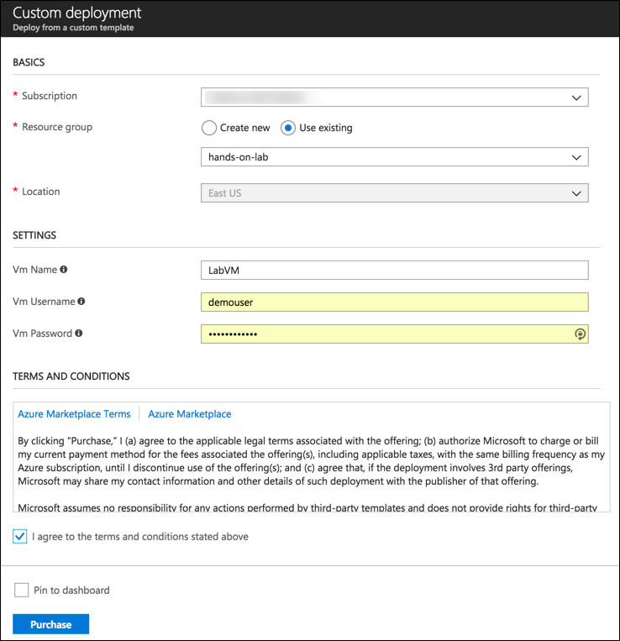

1. Select **Purchase**.
2. It may up to 10 minutes for the virtual machine to complete provisioning. You can move on to the next task while you wait for this to complete.

#### Task 3: Provision a Jenkins server

In this task, you will provision an Azure Linux virtual machine (VM), which will serve as your Jenkins server for this hands-on lab.

**NOTE**: This will be used in bonus Exercise 8, which you can perform if you have time at the end of the workshop.

1. In the Azure portal, select **+New**, enter “Jenkins” into the **Search the Marketplace** box, then select the **Jenkins** compute item from the results.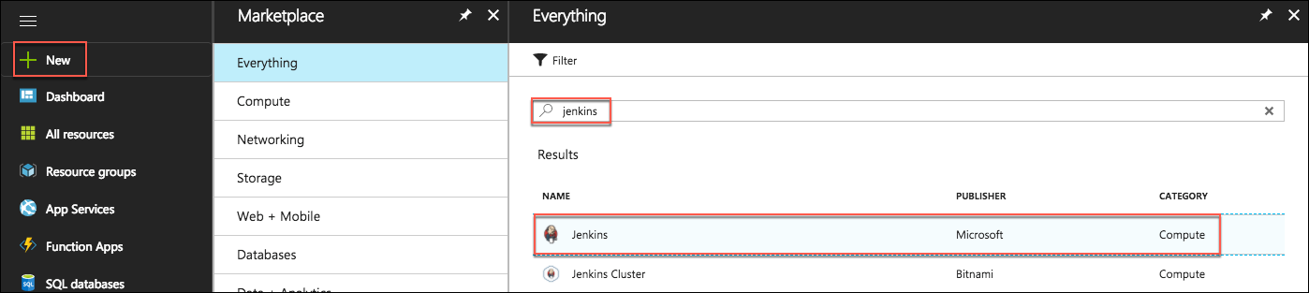
2. On the **Jenkins** blade, select **Create**. 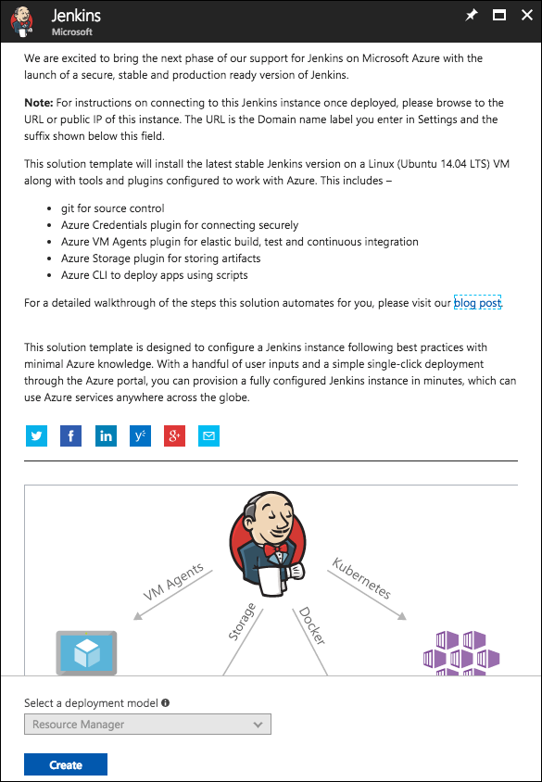
3. On the **Create****Jenkins Basics** blade, enter the following:
   1. **Name:** Enter “Jenkins”
   2. **User name:** Enter “jenkinsadmin”
   3. **Authentication type:** Select **Password**
   4. **Password:** Enter “Password.1!!”
   5. **Subscription:** Select the subscription you are using for this hands-on lab
   6. **Resource group:** Select **Create new**, and enter “jenkins-SUFFIX” (Note: this will use a different resource group than the other resources in this lab)
   7. **Location:** Select the location you are using for resources in this hands-on lab
   8. Select **OK** to proceed to the **Settings** blade. 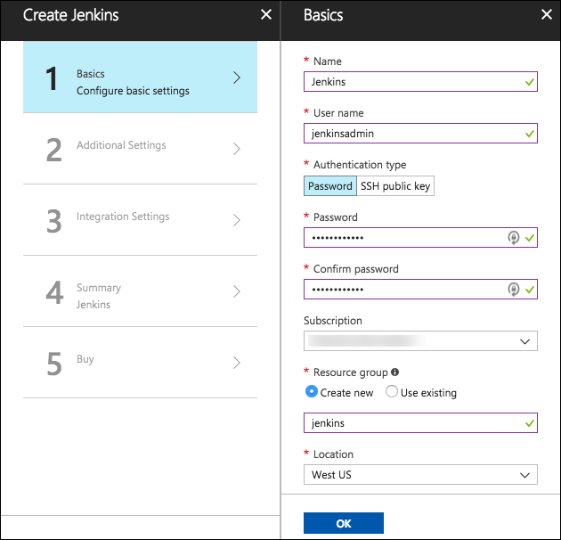
4. On the **Settings** blade:
   1. Select **Configure subnets**, and then select **OK** on the **Subnets** blade to accept the defaults.
   2. Enter a unique **Domain name label,** such as “Jenkins-SUFFIX.”
   3. Ensure the **Jenkins release type** is set to LTS.
   4. Select **OK** to proceed to the summary screen. 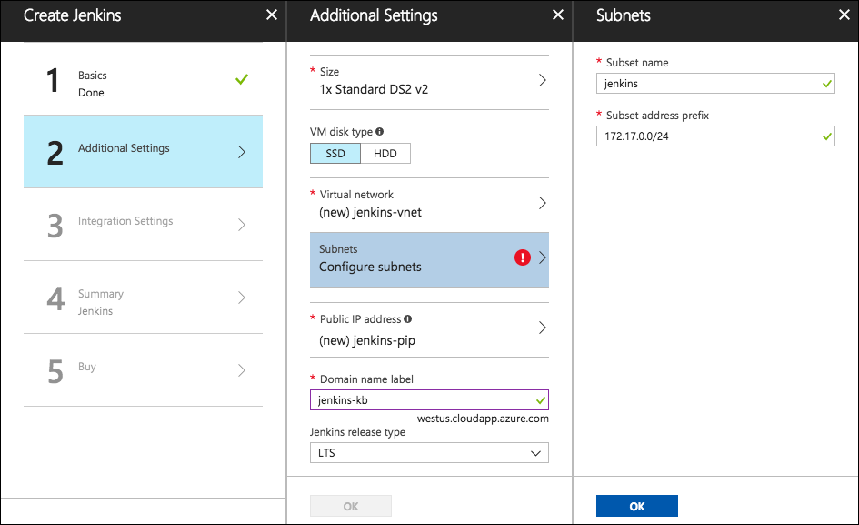
5. On the **Jenkins Integration Settings** blade, select **OK**. 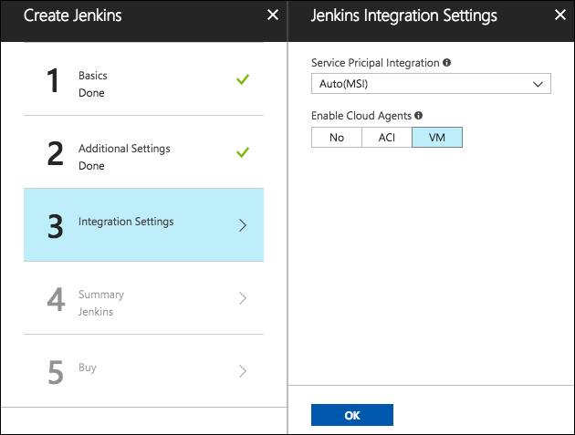
6. On the **Summary** blade, ensure validation passed, and select **OK**. 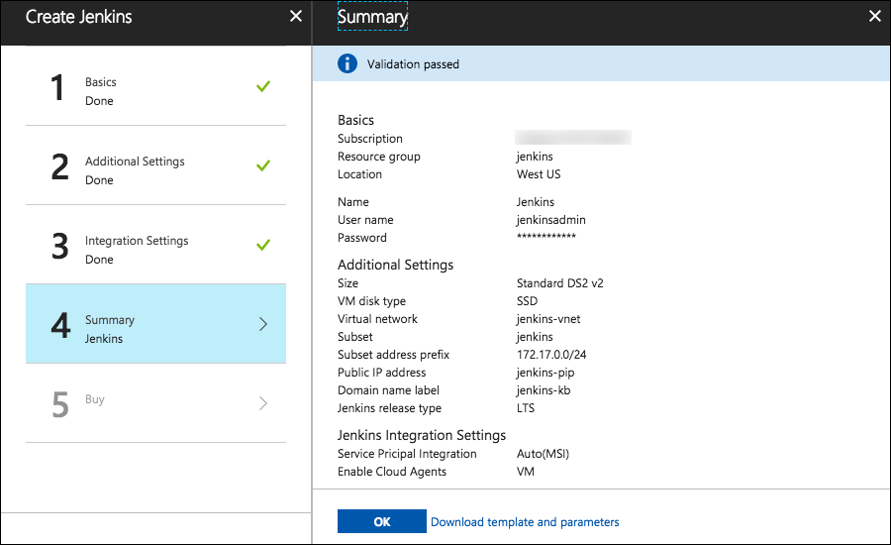
7. Select **Create** on the **Buy** screen to provision the Jenkins server. 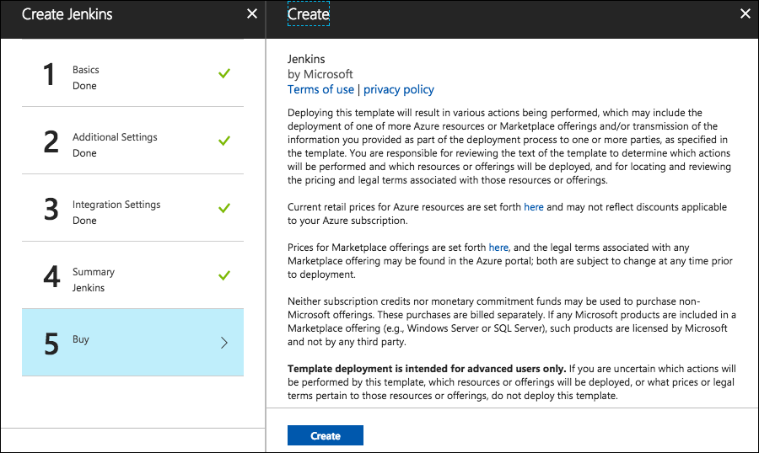
8. It can up to 10 minutes for the VM to provision. You can move on to the next task while you wait.

#### Task 4: Connect to your Lab VM

In this task, you will create an RDP connection to your Lab VM. If you are already connected, skip to Step 6.

1. Navigate to the Azure portal and select **Resource groups** from the left-hand menu, then select the **hands-on-labs-SUFFIX resource group** from the list. If there are too many, enter “hands-on-labs” into the filter box to reduce the resource groups displayed the list. 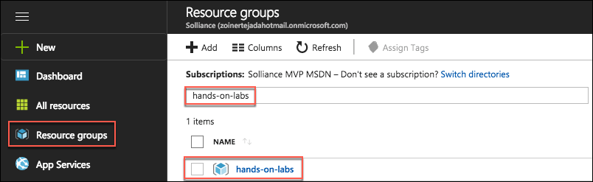
2. Next, select **LabVM** from the list of available resources. 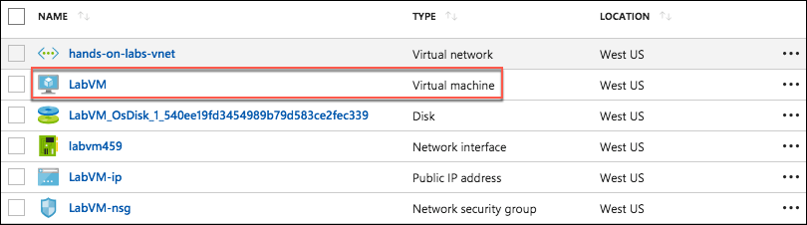
3. On the**LabVM** blade, select **Connect** from the top menu, which will download an RDP file. 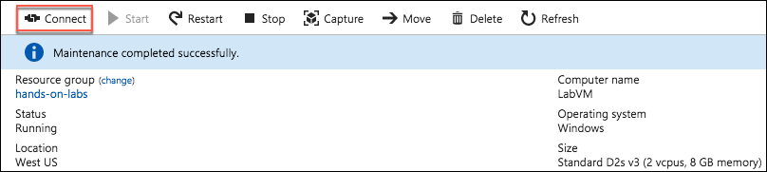
4. Open the downloaded RDP file.
5. Select **Connect** on the Remote Desktop Connection dialog. 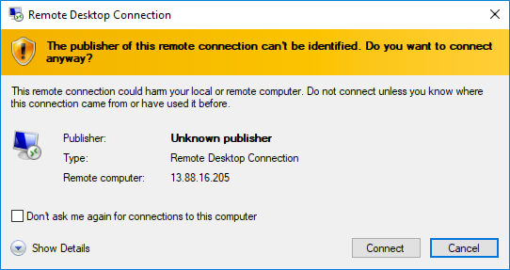
6. Enter the following credentials (or the non-default credentials if you changed them):
   1. **User name:** demouser
   2. **Password:** Password.1!!

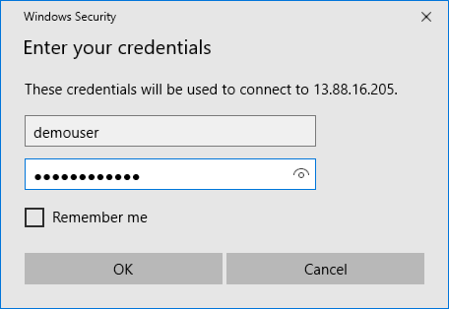

1. Select **Yes** to connect, if prompted that the identity of the remote computer cannot be verified. 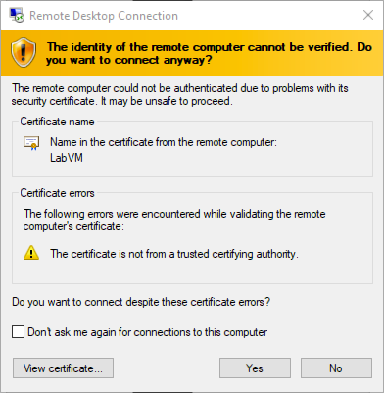

#### Task 5: Install an SSH client

In this task, you will download, and install the Git Bash SSH client. This will be used to interact with the Jenkins Linux VM, as well as with GitHub.

1. On your Lab VM, open a browser, and navigate to <https://git-scm.com/downloads> to download Git Bash. 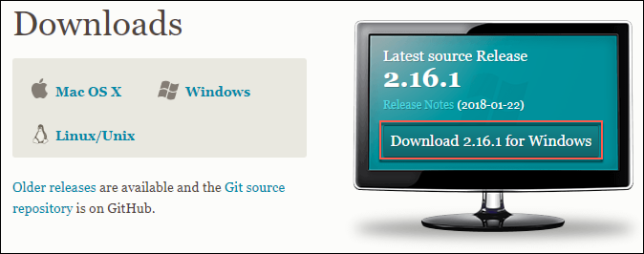
2. Select the **Download 2.16.x for Windows** button.
3. Run the downloaded installer, selecting **Next** on each screen to accept the defaults.
4. On the last screen, select **Install** to complete the installation.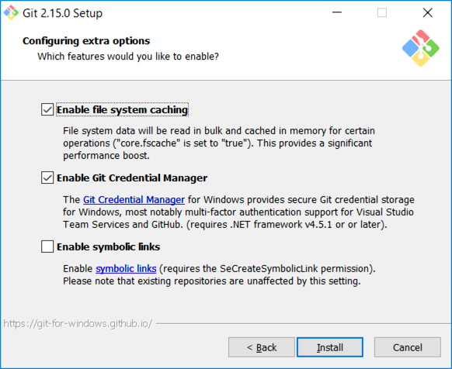
5. When the install is complete, uncheck **View Release Notes**, and select **Finish**.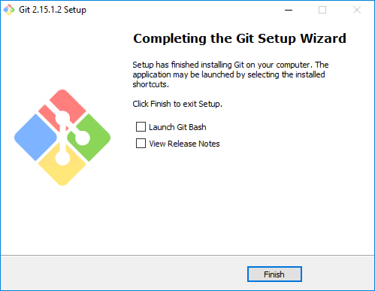

#### Task 6: Install Visual Studio Code

In this task, you will download and install Visual Studio Code (VS Code) to use as a code editor for making changes to the MERN project used throughout this lab. You will also install the GitHub extension into VS Code. Other code editors, such as WebMatrix and IntelliJ, could also be used to complete the exercises in this hands-on lab, but installing and configuring those editors is outside the scope of this document.

1. From your Lab VM, navigate to <https://code.visualstudio.com/download> in a web browser, and select the appropriate download link for your operating system. For this lab, we will outline the steps for installing VS Code on Windows. 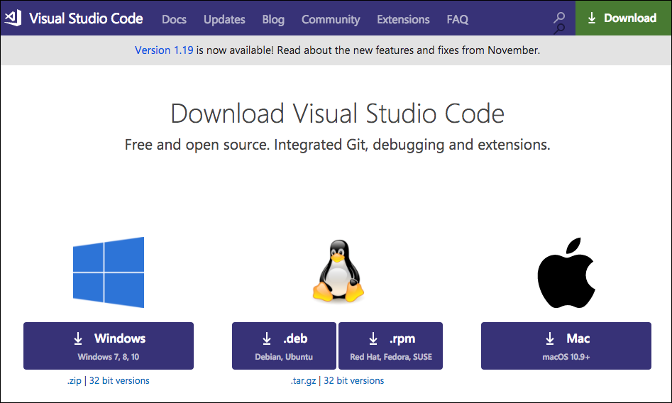
2. Run the downloaded installer.
3. Select **Next** on the Welcome to theVisual Studio Code Setup Wizard dialog. 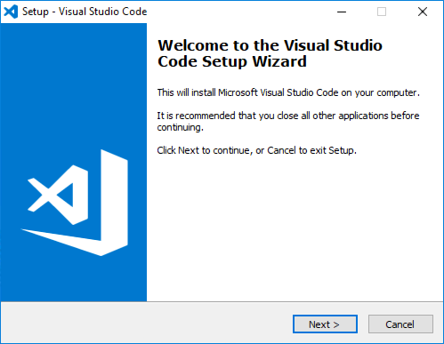
4. Accept the **License Agreement**, and select **Next**. 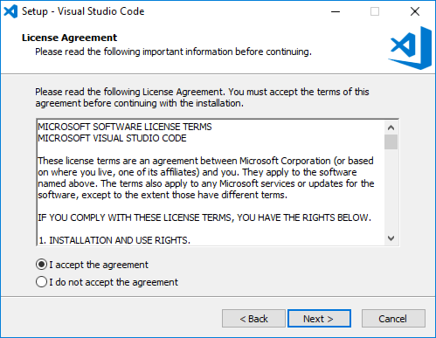
5. Accept the default install location, and select **Next**. 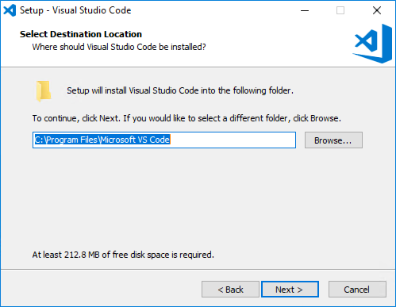
6. Leave the default start menu folder, and select **Next**. 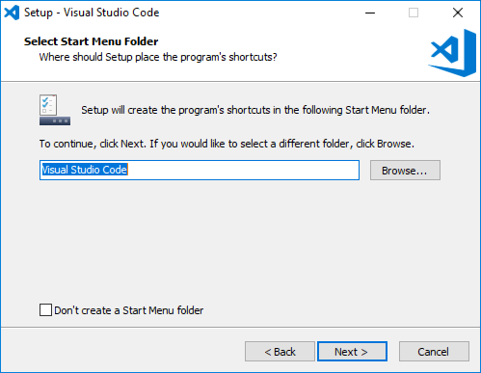
7. On the Select Additional Tasks dialog, check all the boxes, and select **Next**. 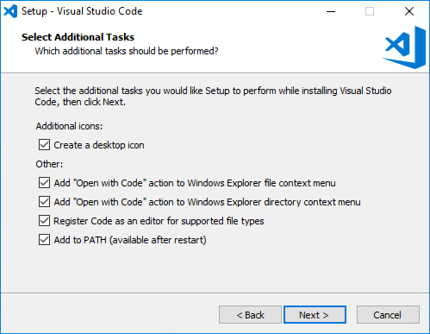
8. Select **Install** on the **Ready to Install** dialog. 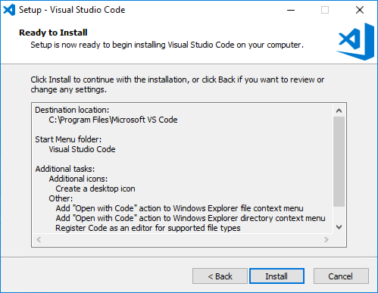
9. Leave **Launch Visual Studio Code** checked, and select **Finish** when the installation is complete. 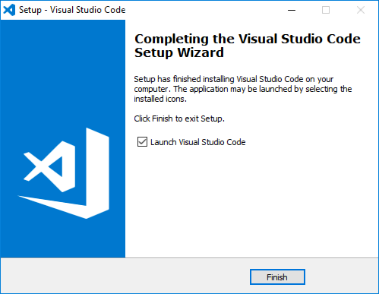
10. After VS Code opens, select the **Extensions** icon from the left-hand menu, enter “github”into the **Extensions** search box, and select the the **GitHub** extension.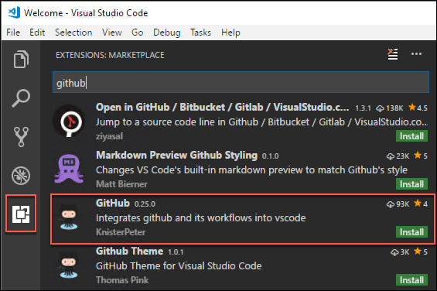
11. Select **Install** in the Extension: GitHub window. 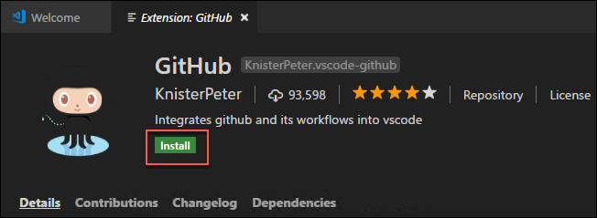
12. In VS Code, select **View** from the menu, select **Command Palette…** 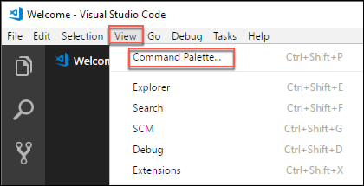
13. At the **Command Palette** prompt, enter “select default shell” and select **Terminal: Select Default Shell** from the list.

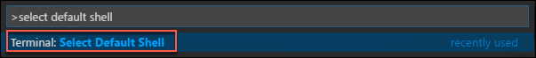

1. Select **Git Bash** from the list of terminal shells, to change the default shell for the integrated terminal to bash.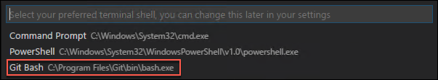
2. Close VS Code. Note: VS Code must be restarted to enable the extension and change the default shell.

#### Task 7: Install Node.js and NPM

In this task, you will download and install Node.js and NPM on your LabVM.

1. From your Lab VM, open a browser, and navigate to <https://nodejs.org/>.
2. Select the **LTS installation** option.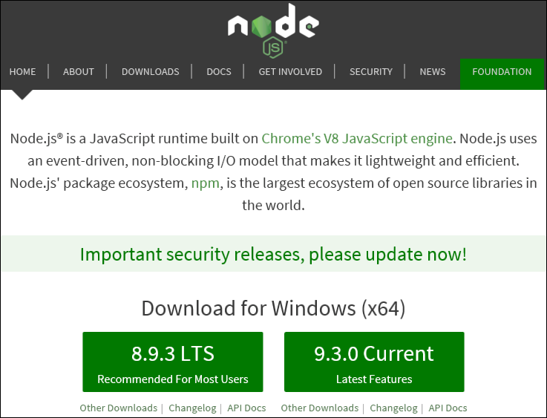
3. Run the downloaded installer.
4. On the Welcome screen, select **Next**. 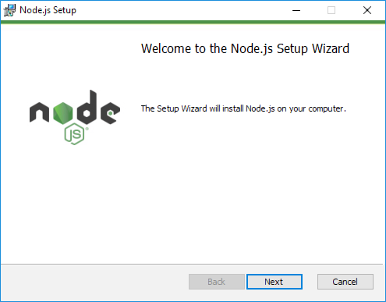
5. Accept the terms of the **License Agreement**, and select **Next**. 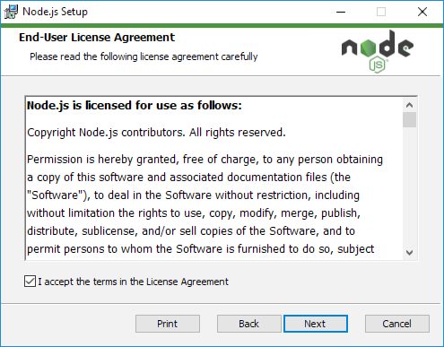
6. Accept the default destination folder, and select **Next**. 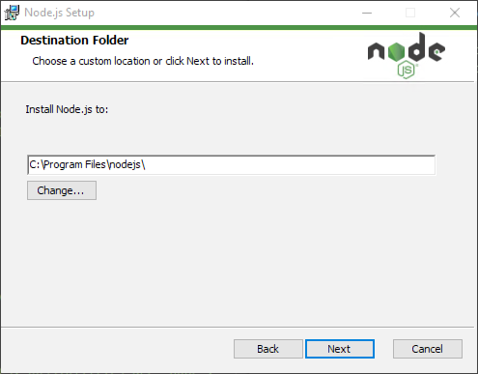
7. On the Custom Setup screen, accept the defaults, and select **Next**. 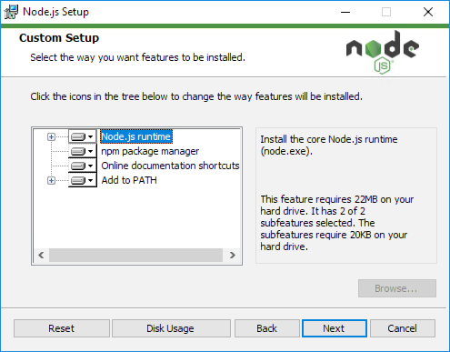
8. Select **Install** on the Ready to install Node.js screen. 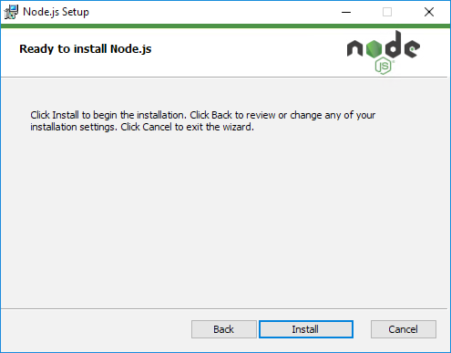
9. When the installation is complete, select **Finish**. 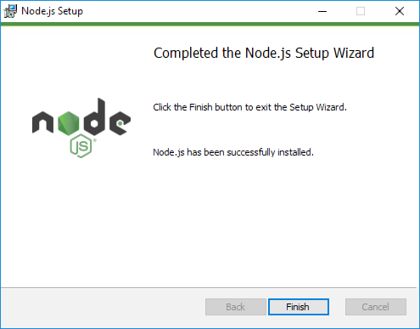

#### Task 8: Install MongoDB Community Edition

In this task, you will download and install the community edition of MongoDB on your Lab VM.

1. On your Lab VM, open a web browser, and navigate to <https://www.mongodb.com/download-center>, select the **Community Server** tab, then select the **Windows** tab, and select **Download**. 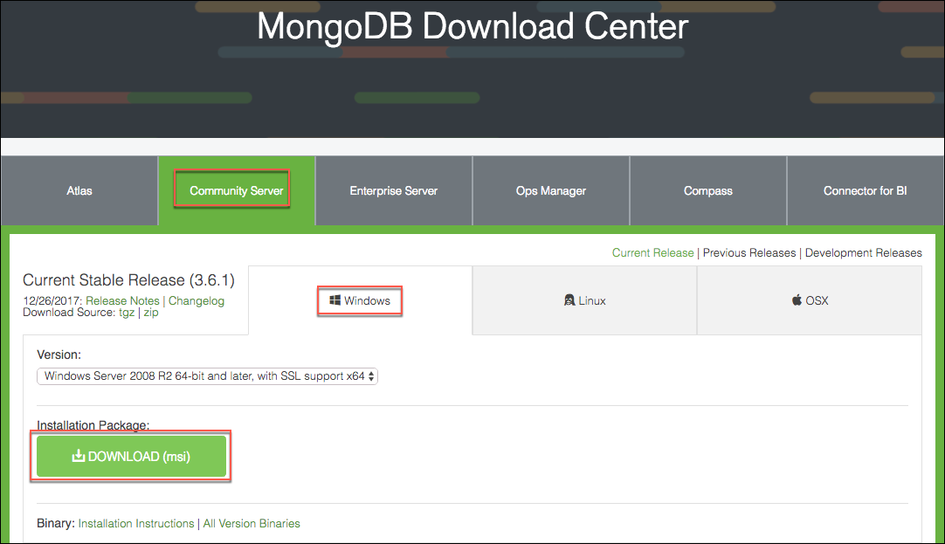
2. Run the downloaded installer.
3. Select **Next** on theWelcome screen. 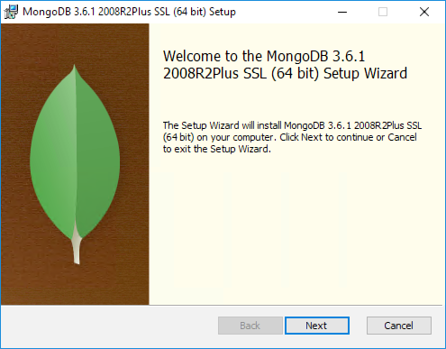
4. Accept the **License Agreement**, and select **Next**. 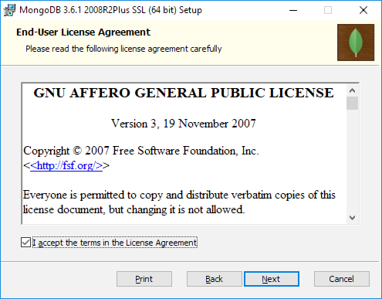
5. Select **Complete** on the Choose Setup Type screen. 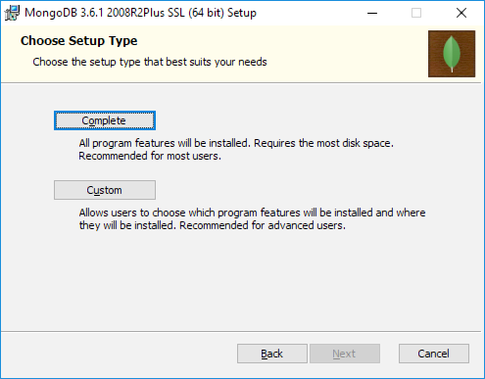
6. Uncheck **Install****MongoDB Compass**, and select **Next**. 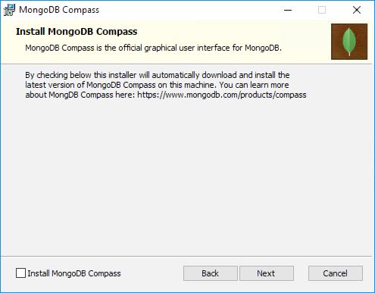
7. Select **Install** on the Ready to install screen. 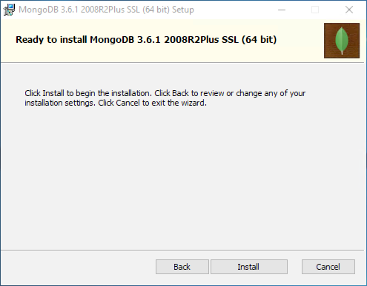
8. Select **Finish** when the install is complete. 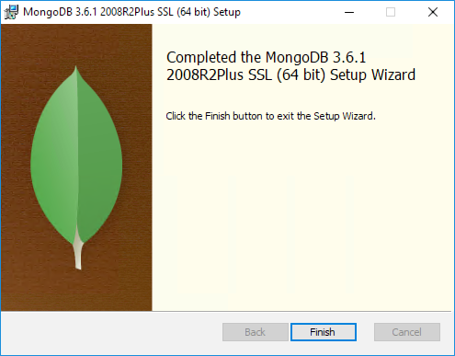

#### Task 9: Install Docker

In this task, you will add the Containers and Hyper-V features to your Windows installation, and install Docker.

1. Prior to running the Docker installation on your Lab VM, you need to enable the Containers and Hyper-V windows features. In the Search Windows box on the task bar, enter “features,” and select **Turn Windows features on or off**.

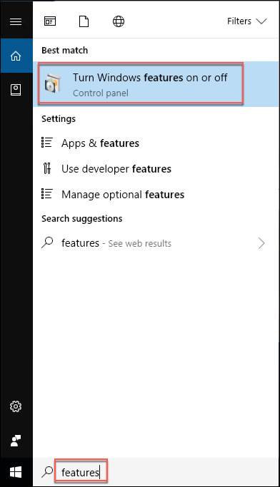

1. In the Windows Features dialog, select **Containers** and **Hyper-V**. Ensure all **Hyper-V** components are selected, and select **OK** to install the Windows Features. 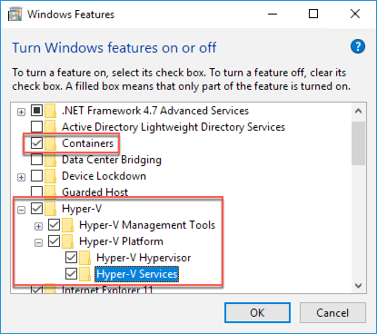
2. When the install completes, select **Restart** now to complete the installation. 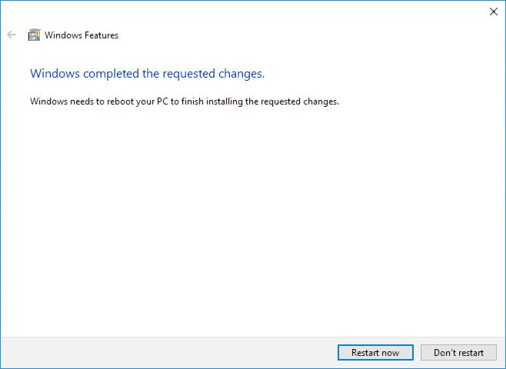
3. Reconnect to your Lab VM.
4. Once connected, open a web browser, navigate to <https://store.docker.com/editions/community/docker-ce-desktop-windows>, and select **Get Docker**. 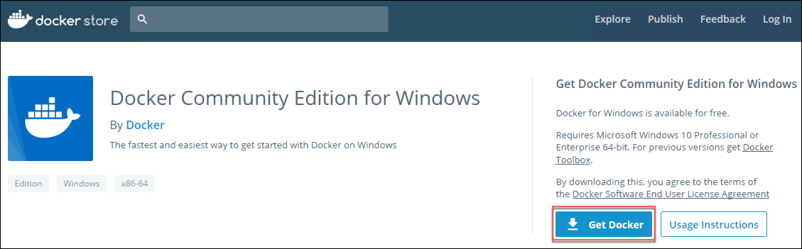
5. Run the downloaded installer.
6. The Docker installation will begin immediately, without user interaction.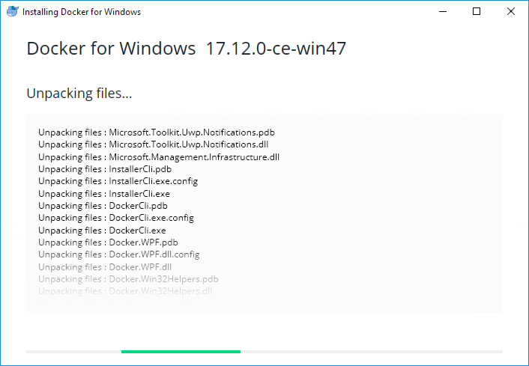
7. When the installation completes, select **Close and log out**, which will terminate your VM session.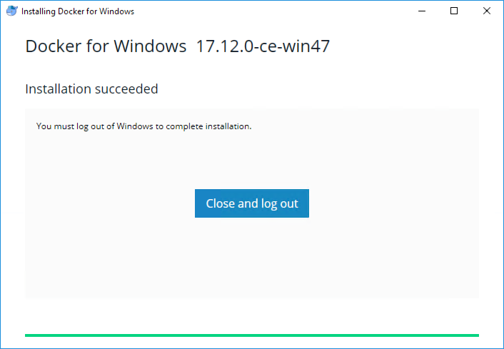
8. Reconnect to your Lab VM.
9. You will receive a message that Docker is starting which may take a couple of minutes to complete.
10. Once Docker has started, you will get a popup letting you know it is up and running. 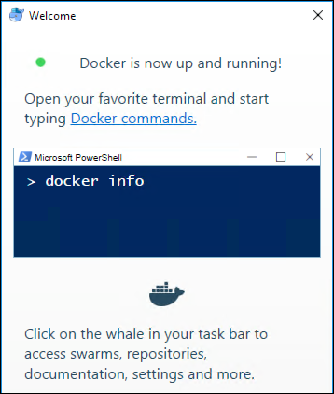

#### Task 10: Create GitHub account

In this task, you will sign up for a free GitHub account, which will be used for hosting a copy of the sample application used throughout this lab. This account will be integrated into the CI/CD workflow for pushing updates to the application into Azure. If you already have a GitHub account, you can skip this task.

1. On your Lab VM, open a browser, and navigate to <https://github.com>.
2. In the form on the page, enter a **username**, your **email** address, and a **password**, then select **Sign up for GitHub**. 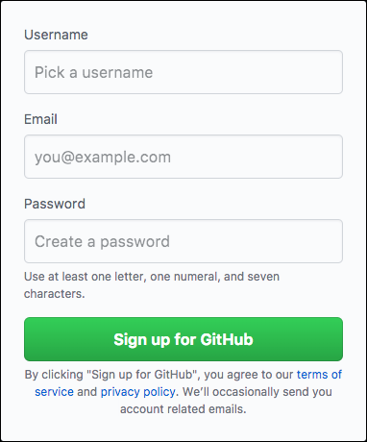
3. On the Welcome to GitHub screen, select **Unlimited public repositories free** under **Choose your personal plan**, and select **Continue**. 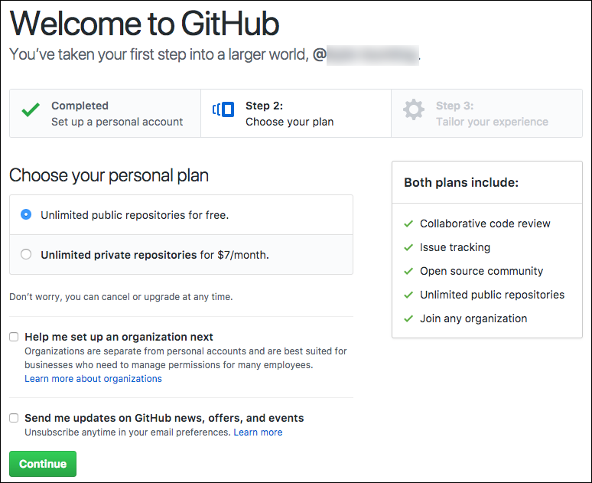
4. On the next screen, you can select options to tailor your experience and select **Submit**, or select **skip this step**, next to **Submit,** to complete your registration. 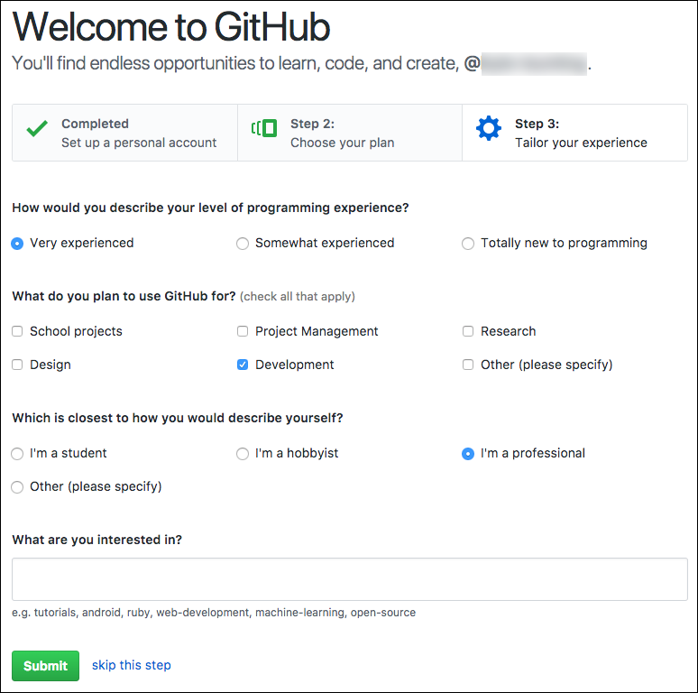

#### Task 11: Fork the starter app

In this task, you will fork the starter application to create a copy in your GitHub account.

1. Log into your GitHub account, then navigate to the GitHub repository for the mcw-oss-paas-devops starter app, <https://github.com/ZoinerTejada/mcw-oss-paas-devops>.
2. At the top right of the projects GitHub page, select **Fork**.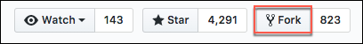
3. If you have more than one GitHub account, select the account to which the project should be forked.
4. This will start the process of making a copy of the starter application into your GitHub account, in a repository named **mcw-oss-paas-devops**.

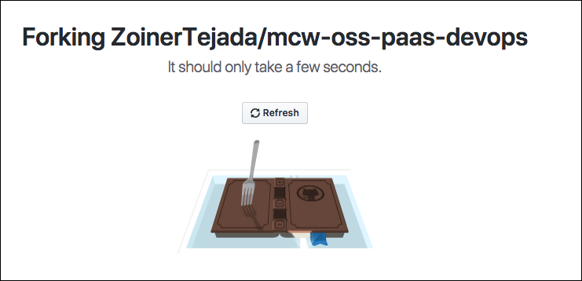

1. Once completed the project page will open. Remain on this page for the following task. 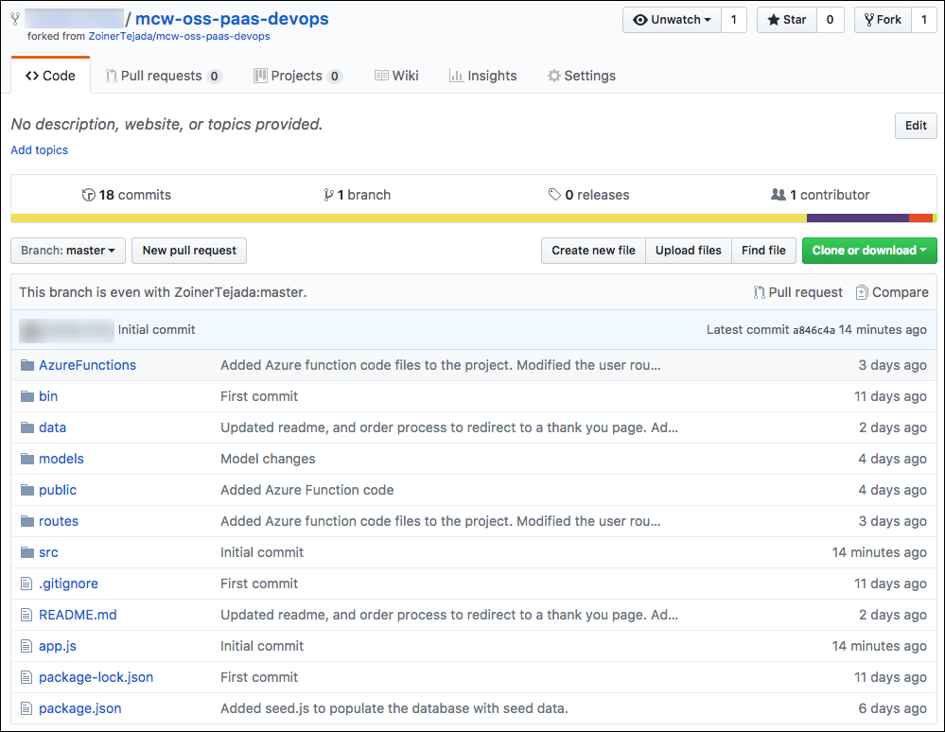

#### Task 12: Prepare GitHub account for VS Code integration

In this task, you will be preparing your GitHub account for integration with VS Code, which will include generating a Personal Access Token to be added into VS code. These integrations will allow you to push your code changes to GitHub directly from VS Code.

1. To connect VS Code with your GitHub account, you are going to generate a Personal access token.
2. In the browser window with your GitHub account displayed, select **your user profile icon** in the top left, and select **Settings** from the flyout menu.

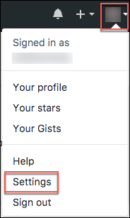

1. On theSettingsscreen, select **Developer settings** at the bottom of the Personal settings menu on the left-hand side of the screen.

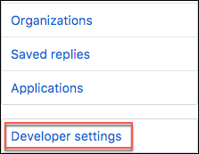

1. On the Developer settings page, select **Personal access tokens** from the left-hand menu. 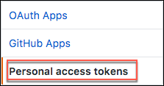
2. Select **Generate new token**. 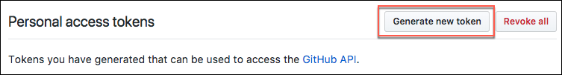
3. Enter a token description, such as “VS Code Integration”, and check the box next to **repo** under **Select scopes**. This will select all the boxes under it. 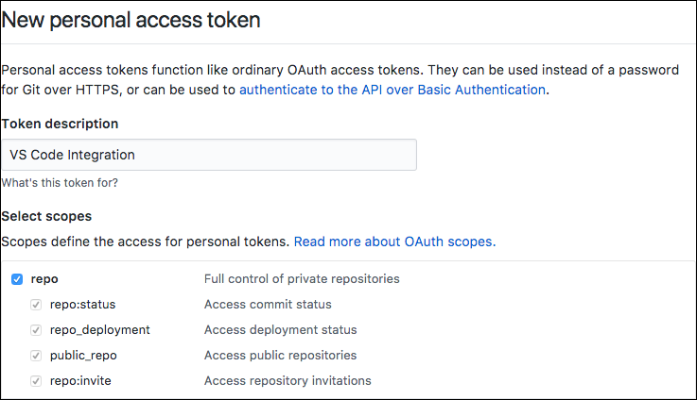
4. Select **Generate token** near the bottom of the screen.



1. Select the **copy** button next to the token that is generated. Make sure you copy the new personal access token before you navigate away from the screen, or you will need to regenerate the token. 
2. Open **VS Code**.
3. Select the **View** menu, then select **Command Palette…** from the menu. 
4. In the box that appears at the top center of the VS Code window, enter “Set Personal Access Token,” then select **GitHub: Set Personal Access Token**, when it appears. 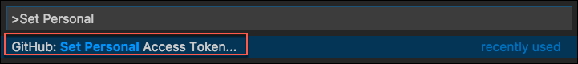
5. Paste the Personal access token you copied from GitHub into the box, and press **Enter**.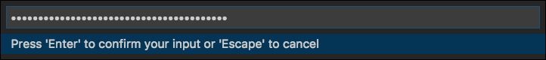
6. VS Code is now connected to your GitHub account.

## Exercise 2: Run starter application

Duration: 10 minutes

In this exercise, you will create a local copy of the starter application, add some sample data to the local MongoDB database, and run the application.

#### Task 1: Clone the starter application

In this task, you will clone the starter application, creating a local copy on your Lab VM.

1. Connect to your Lab VM, open a browser, and navigate to your GitHub account. (<https://github.com>)
2. Within your GitHub account, navigate to the forked copy of the *mcw-oss-paas-devops* application page, select **Clone or download**,then select the **copy** link next to the web URL.

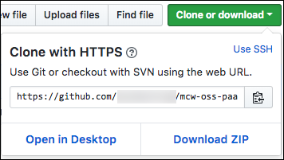

1. Open a new Git Bash terminal from the Start menu programs list, and ensure you are in your user directory which should be displayed at the top of the window. 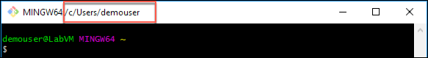
2. If your user directory path is missing, enter the following at the command prompt to change directories.

cd $USER

1. Enter the following command, replacing [EMAIL] with the email address you used when creating your GitHub account. This will associate your git username with the commits made from the Lab VM.

git config –-global user.email “[EMAIL]”

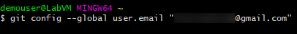

1. At the prompt, enter the following command, replacing [CLONE_URL] with URL you copied from GitHub in step 2 above:

git clone [CLONE_URL]

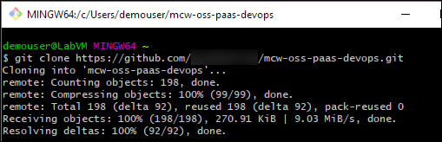

1. Now, change the directory to the cloned project by entering the following at the prompt:

cd mcw-oss-paas-devops

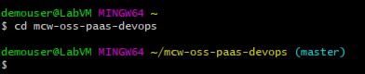

1. Finally, issue a command to open the starter project in VS Code by typing:

code .

1. A new VS Code window will open, with the mcw-oss-paas-devops folder opened. 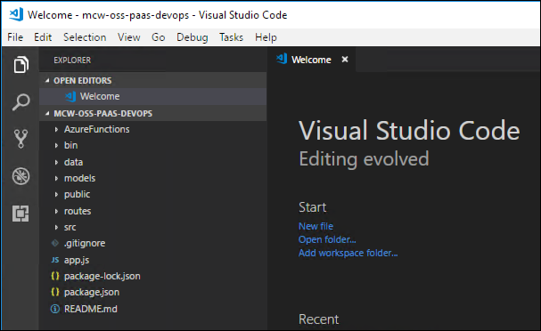
2. You are now ready to begin working with the project in VS Code.

#### Task 2: Start MongoDB

In this task, you will start the MongoDB instance running on your Lab VM.

1. On your Lab VM, launch a Windows command prompt by selecting Search Windows from the task bar, entering “cmd” in the search box, and selecting **Command Prompt**.

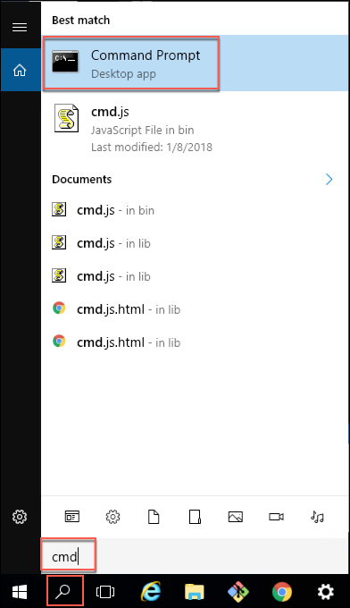

1. Before MongoDB can be started, it needs a data directory created. Create this by entering the following command at the prompt:

md c:\data\db

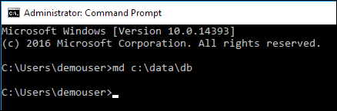

1. Start the Mongo DB service by entering the following at the prompt (make sure to include the quotes):

"c:\program files\mongodb\server\3.6\bin\mongod.exe"

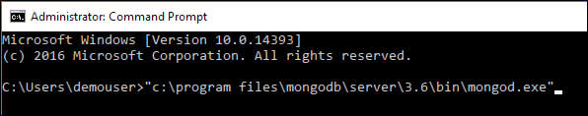

1. The screen will scroll as MongoDB is started, and you should see a message at the end that the MongoDB instance is waiting for connections on port 27017. 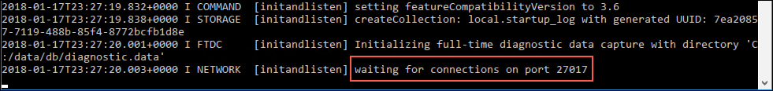
2. Leave this command prompt terminal open until instructed to close it at the end of Exercise 2.

#### Task 3: Launch the starter application

In this task, you will seed the MongoDB with sample data, then run the application locally, connected to your MongoDB instance. This task is to verify the connection to MongoDB and that it contains the seeded plan data, before we migrate the application and data to Azure Cosmos DB.

1. Return to VS Code, select **View** from the menu, and select **Integrated Terminal**. 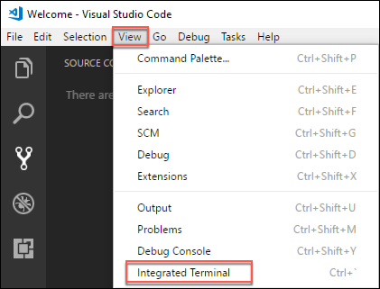
2. This will open a new bash terminal window at the bottom of the VS Code dialog. 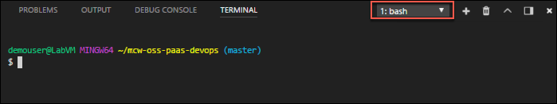
3. At the bash prompt, enter: npm install
4. Next at the bash prompt, enter the following to seed the local MongoDB database with plans, user accounts, and orders.

node data/seed.js

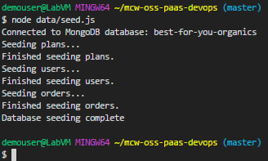

1. Next, build the application using the following:

npm run build

1. Finally, enter the following to launch the application.

npm start

1. If you receive a Windows Defender Firewell security prompt, check both boxes to allow Node.js server-side Javascript to communicate on these networks, and select **Allow access**.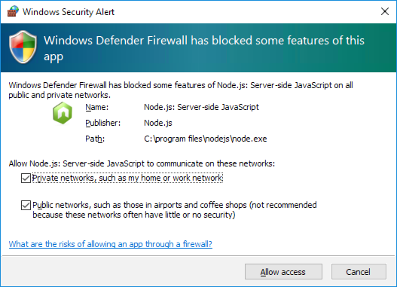
2. Open a browser, and navigate to <http://localhost:3000>.
3. If everything is running properly, you will see three plans listed on the application home page, which were pulled from your local MongoDB database.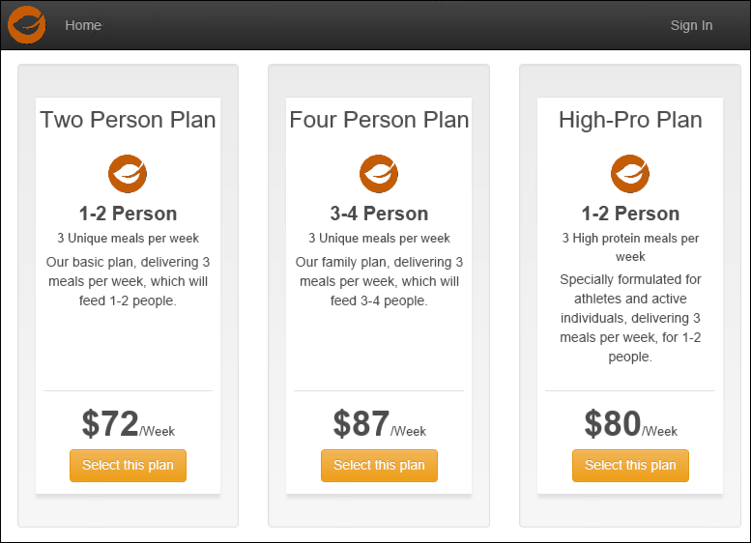
4. Return to the VS Code integrated terminal window, and press **CTRL+C** to stop the application.

## Exercise 3: Migrate the database to Cosmos DB

Duration: 20 minutes

In this exercise, you will provision an Azure Cosmos DB account, and then update the starter application’s database connection string to point to your new Azure Cosmos DB account. You will then, use *mongoimport.exe* to migrate the data in your MongoDB database into Cosmos DB collections, and verify with the application that you are connected to your Cosmos DB database.

#### Task 1: Provision Cosmos DB using the MongoDB API

In this task, you will provision a new Azure Cosmos DB account using the MongoDB API.

1. In the Azure portal, select **+New**, **Databases**, the select **Azure Cosmos DB**. 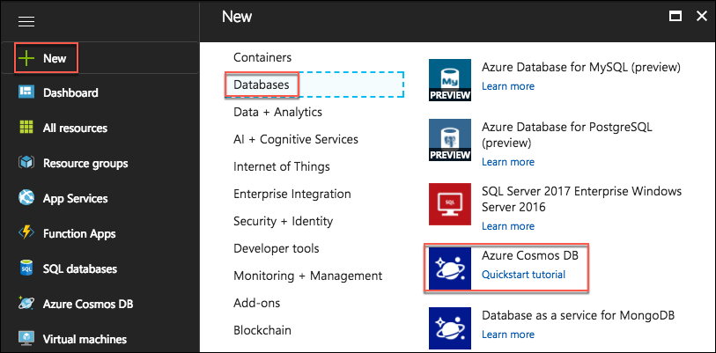
2. On the **Azure Cosmos** *DB* blade, enter the following:
   1. **ID**: Enter “best-for-you-db-SUFFIX,” where SUFFIX is your Microsoft alias, initials, or another value to ensure the name is unique (indicated by a green check mark).
   2. **API:** Select **MongoDB**.
   3. **Subscription:** Select the subscription you are using for this hands-on lab.
   4. **Resource Group:** Select **Use existing**, and choose the **hands-on-labs-SUFFIX resource group** you created previously.
   5. **Location:** Select a location near you from the list (Note: not all locations are available for Cosmos DB)
   6. **Enable geo-redundancy:** Leave this checked
   7. Select **Create** to provision the new Azure Cosmos DB account 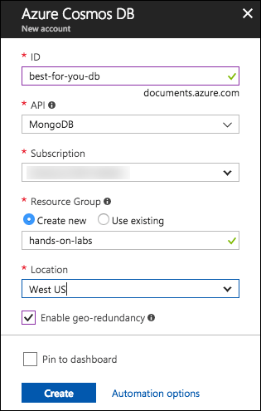

#### Task 2: Update database connection string

In this task, you will retrieve the connection string for your Azure Cosmos DB database, and update the starter application’s database connection string.

1. When your Cosmos DB account is provisioned, navigate to it in the Azure portal.
2. On the **Azure Cosmos DB account** blade, select **Connection String** under **SETTINGS** in the left-hand menu, and copy the **PRIMARY connection string**. 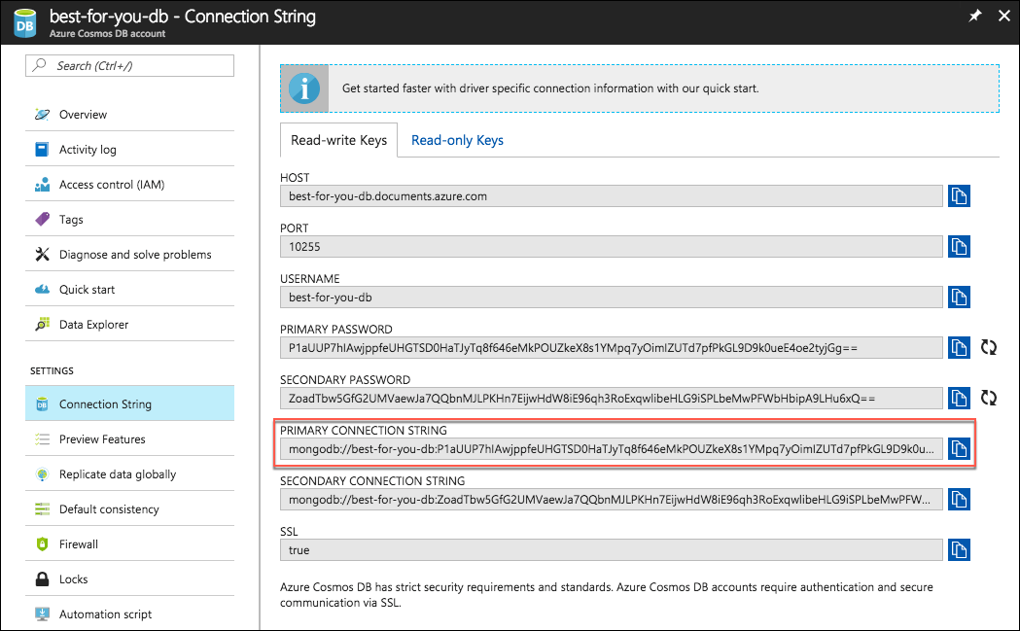
3. Return to VS Code.
4. Open app.js from the root directory of the application, and locate the line that starts with var **databaseUrl**. 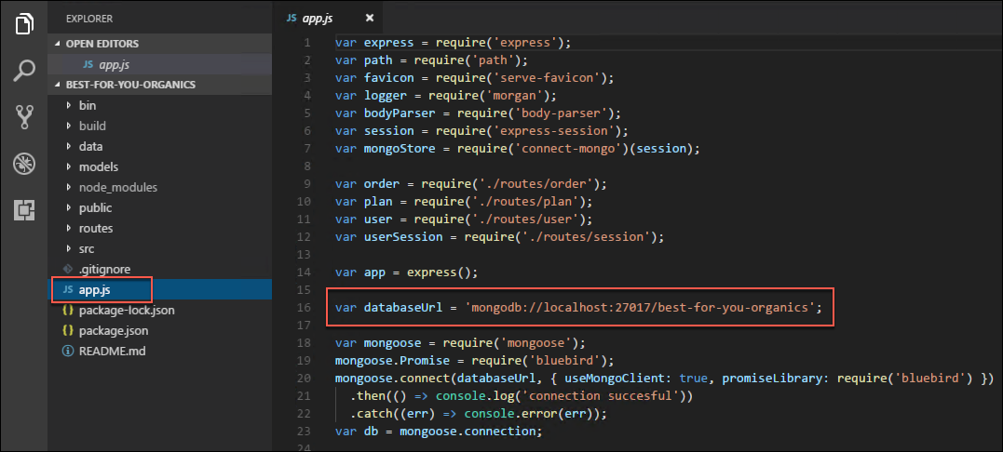
5. Replace the value of the **databaseUrl** variable with the Cosmos DB connection string you copied from the Azure portal.
6. Scroll to the end of the value you just pasted in, and locate **10255/?ssl=** in the string. 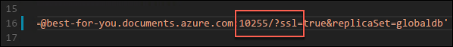
7. Between the “/” and the “?” insert **best-for-you-organics** to specify the database name. 
8. Save **app.js**.
9. In the VS Code integrated terminal, enter the following command to rebuild the application.

npm run build

1. When the build completes, start the application by typing the following:

npm start

1. Return to your browser, and refresh the application page. Note: You may need to press **CTRL+F5** in your browser window to clear the browser cache while refreshing the page.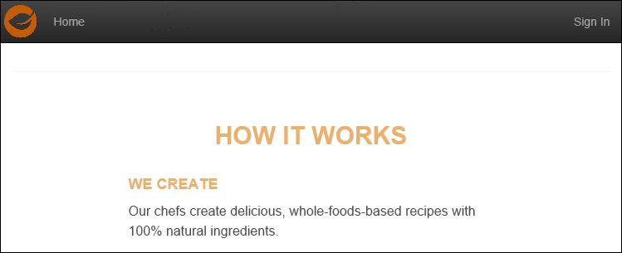
2. Notice the three plans that were displayed on the page previously are no longer there. This is because the application is now pointed to your Azure Cosmos DB, and there is no plan data in that database yet.
3. Let’s move on to copying the data from the local MongoDB instance into Cosmos DB.

#### Task 3: Pre-create and scale collections

In this task, you will create the collections needed for your database migration. For this workshop, we will leave the throughput at the default value of 500. In a real-world scenario, you would want to increase each collections’ throughput from the default 500 RUs to 2,500 Rus or more, depending on the size of the database being migrated. This is done to avoid throttling during the migration, and reduce the time required to import data.

1. In the Azure portal, navigate to your Azure Cosmos DB account, select **Browse** from the left-hand menu, under **COLLECTIONS**, and select **+Add Collection**.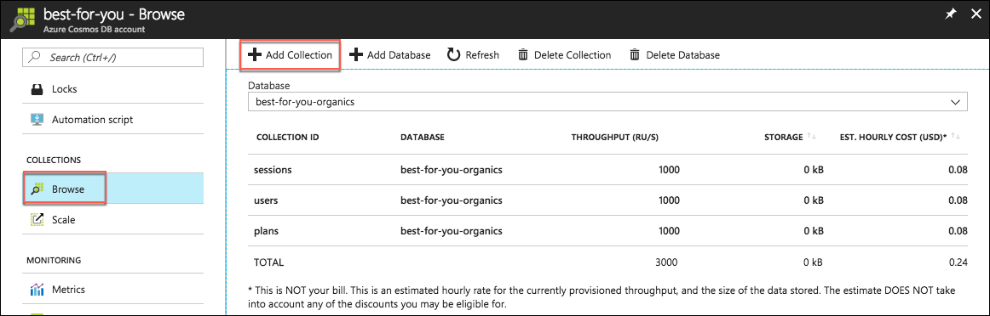
2. In the **Add Collection** dialog, enter the following:
   1. **Database id:** Enter “best-for-you-organics.”
   2. **Collection Id:** Enter “orders.”
   3. **Storage capacity:** Select **Fixed (10 GB)**.
   4. **Throughput:** Enter “500.”
   5. Select **OK** to create the collection. 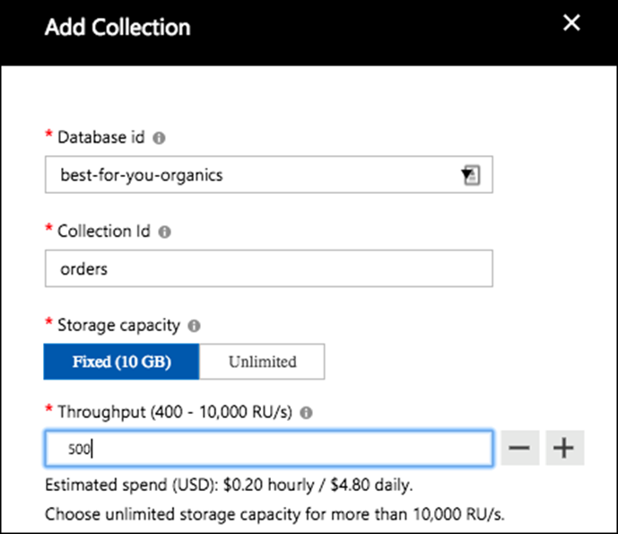
3. If they don’t already exist, repeat steps 1 and 2 to create collections for:
   1. users
   2. plans
4. If the users and plans collections already exist from your application connecting, you can leave the default values and move on.

#### Task 4: Import data to the API for MongoDB using mongoimport

In this task, you will use **mongoimport.exe** to import data to your Cosmos DB account.

1. On your Lab VM open a Windows command prompt by selecting **Search Windows** from the task bar, entering “cmd” in the search box, and selecting **Command Prompt**.



1. At the command prompt, change directories to your MongoDB install location.

cd c:\Program Files\MongoDB\Server\3.6\bin

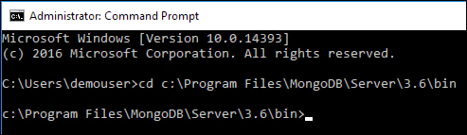

1. Next, you will execute a batch file, included in the project files you downloaded, to handle exporting the data out of your MongoDB into .JSON files on the local file system. These files will be used for the import into Cosmos DB.
2. At the command prompt, enter:

c:\Users\demouser\mcw-oss-paas-devops\data\mongo-export.bat

1. The batch file creates the folder c:\MongoExport, and exports each of the collections in your MongoDB to JSON files. 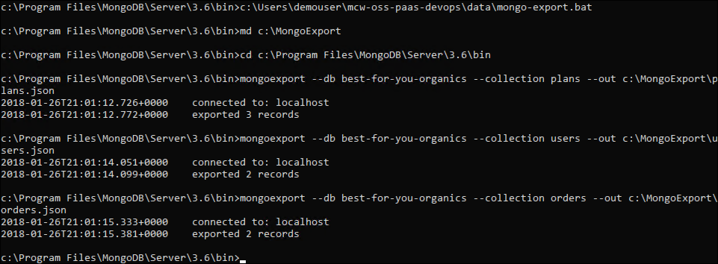
2. You are now ready to import the data using mongoimport.ex*e*. You will use the following template for executing the data import into Azure Cosmos DB:

mongoimport.exe --host <your_hostname>:10255 -u <your_username> -p <your_password> --db <your_database> --collection <your_collection> --ssl --sslAllowInvalidCertificates --type json --file C:\MongoExport\<your_collection>.json

1. To get the values needed for the template command above, return to the **Connection string** blade for your Azure Cosmos DB account in the Azure portal. Leave this window up, as will need the **HOST, USERNAME**, and **PRIMARY PASSWORD** values from this page to import data to your Cosmos DB account. 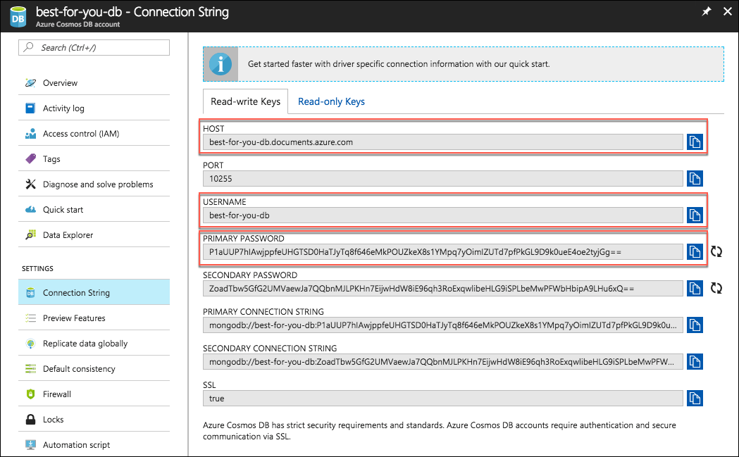
2. Replace the values as follows in the template command above:
   1. <your_hostname>: Copy and paste the **Host** value from your **Cosmos DB Connection String** blade.
   2. <your_username>: Copy and paste the **Username** value from your **Cosmos DB Connection String** blade.
   3. <your_password>: Copy and paste the **Primary Password** value from your **Cosmos DB Connection** **String** blade.
   4. <your_database>: Enter “best-for-you-organics.”
   5. <your_collection>: Enter “plans” (Note there are two instances of <your-collection> in the template command).
3. Your final command should look something like:

mongoimport.exe --host best-for-you-db.documents.azure.com:10255 -u best-for-you-db -p miZiDmNrn8TnSAufBvTQsghbYPiQOY69hIHgFhSn7Gf10cvbRLXvqxaherSKY6vQTDrvHHqYyICP4OcLncqWew== --db best-for-you-organics --collection plans --ssl --sslAllowInvalidCertificates --type json --file C:\MongoExport\plans.json

1. Copy and paste the final command at the command prompt to import the plans collection into Azure Cosmos DB. 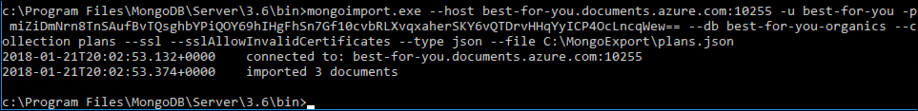
2. You will see a message indicating the number of documents imported, which should be 3 for plans.
3. Verify the import by selecting **Data Explorer** in your Cosmos DB account in the Azure portal, expanding plans, and selecting **Documents**. You will see the three documents imported listed.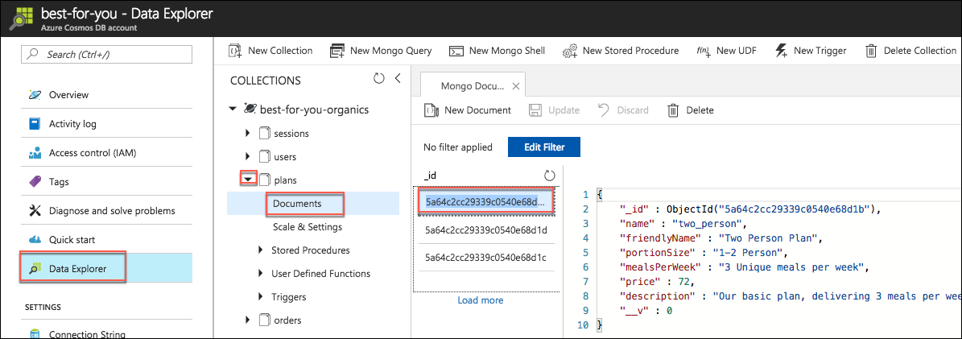
4. Repeat step 8 for the users and orders collections, replacing the **<your_collection>** values with:
   1. users

mongoimport.exe --host best-for-you-db.documents.azure.com:10255 -u best-for-you-db -p miZiDmNrn8TnSAufBvTQsghbYPiQOY69hIHgFhSn7Gf10cvbRLXvqxaherSKY6vQTDrvHHqYyICP4OcLncqWew== --db best-for-you-organics --collection users --ssl --sslAllowInvalidCertificates --type json --file C:\MongoExport\users.json

* 1. orders

mongoimport.exe --host best-for-you-db.documents.azure.com:10255 -u best-for-you-db -p miZiDmNrn8TnSAufBvTQsghbYPiQOY69hIHgFhSn7Gf10cvbRLXvqxaherSKY6vQTDrvHHqYyICP4OcLncqWew== --db best-for-you-organics --collection orders --ssl --sslAllowInvalidCertificates --type json --file C:\MongoExport\orders.json

1. To verify the starter application is now pulling properly from Azure Cosmos DB, return to your browser running the starter application (<http://localhost:3000>), and refresh the page. You should now see the three plans appear again on the home page. These were pulled from your Azure Cosmos DB database. 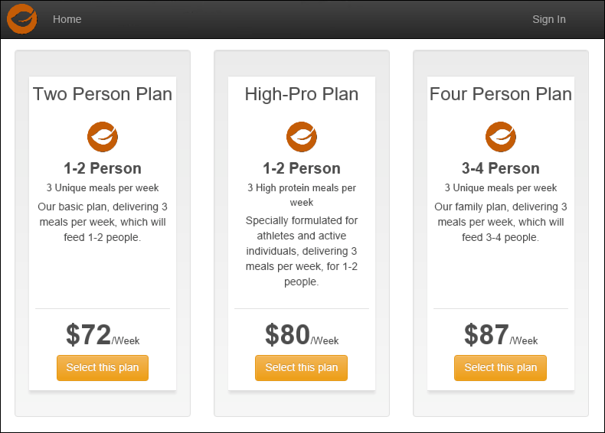
2. You have successfully migrated the application and data to use Azure Cosmos DB with MongoDB APIs.
3. In the Integrated terminal window of VS Code, press **CTRL+C** to stop the application.

## Exercise 4: Containerize the app

Duration: 30 minutes

This exercise walks you through containerizing an existing MERN application using Docker, pushing the image to an **Azure Container Registry**, then deploying the image to **Web App for Containers** directly from VS Code.

#### Task 1: Create an Azure Container Registry

In this task, you will be creating a private Docker registry in the Azure portal, so you have a place to store the custom Docker image you will create in later steps.

1. In the Azure portal, select **+New**, **Containers**, and select **Azure Container Registry**. 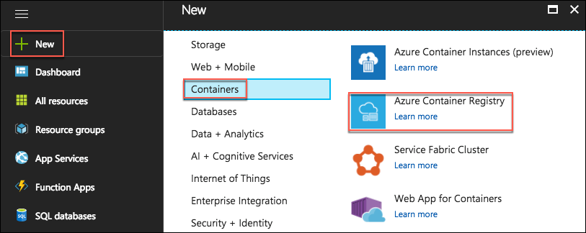
2. On the **Create container registry** blade, enter the following:
   1. **Registry name:** Enter “bestforyouregistrySUFFIX,” where SUFFIX is your Microsoft alias, initials, or another value to ensure the name is unique (indicated by a green check mark).
   2. **Subscription:** Select the subscription you are using for this hands-on lab.
   3. **Resource group:** Select **Use existing**, and select the **hands-on-labs-SUFFIX** resource group created previously.
   4. **Location:** Select the location you are using for resources in this hands-on lab.
   5. **Admin user:** Select **Enable**.
   6. **SKU:** Select **Basic**.
   7. Select **Create** to provision the new Azure Container Registry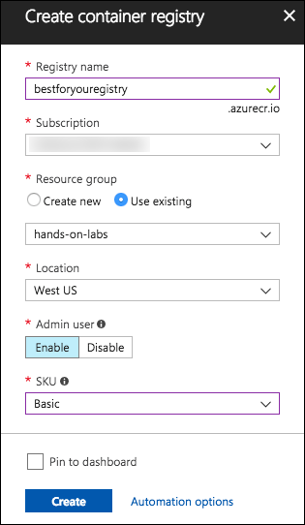

#### Task 2: Install Docker extension in VS Code

The Docker extension for VS Code is used to simplify the management of local Docker images and commands, as well as the deployment of a built app image to Azure.

1. On your Lab VM, return to VS Code, and the open starter project.
2. Select the **Extensions icon** from the left-hand menu, enter “Docker” into the search box, select the **Docker** extension, and in the **Extension: Docker** window, select **Install**. 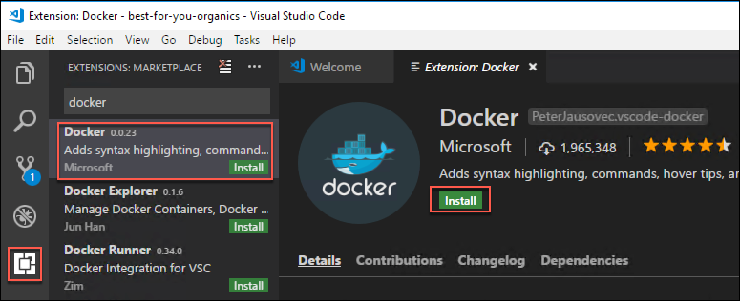
3. Close and reopen VS Code, and the **mcw-oss-paas-devops** project.
4. Expand the **DOCKER** extension block, then expand **Registries** and **Azure**.
5. Expand that, and select **Sign in to Azure**…
6. An info banner will pop up at the top of your VS Code window. Select **Copy & Open**. 
7. In the browser window that opens, paste the copied code into the **Code** box, and select **Continue**. 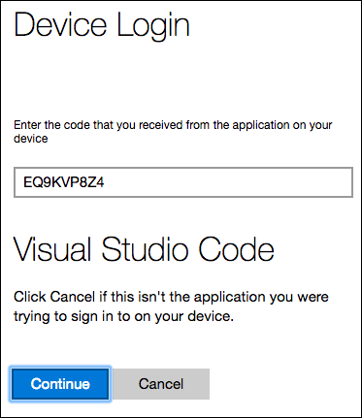
8. On the following screens, log in with your Azure account credentials.
9. Once you’ve signed in, you will be taken to a new page in the browser. You can close the browser window. 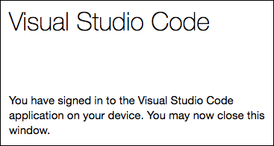
10. Back in VS Code, you should see your Azure Container Registry listed.

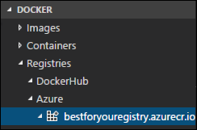

#### Task 3: Create Docker image and run the app

In this task, you will use VS Code, and the Docker extension, to add the necessary files to the project to create a custom Docker image for the **mcw-oss-paas-devops** app.

1. On your Lab VM, return to VS Code, and the mcw-oss-paas-devops project.
2. Open the VS Code Command Palette, by selecting **View** from the menu, then **Command Palette**.
3. Enter “add docker” into the Command Palette, and select **Docker: Add docker files to workspace**. 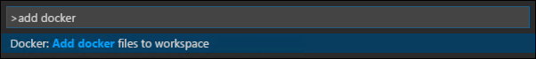
4. At the **Select Application Platform** prompt, select **Node.js**. 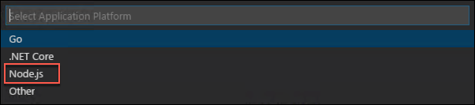
5. Ensure port “3000” is entered on the next screen, and press **Enter**. 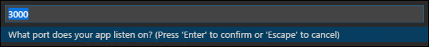
6. This will add Dockerfile, along with several configuration files for Docker compose to the project.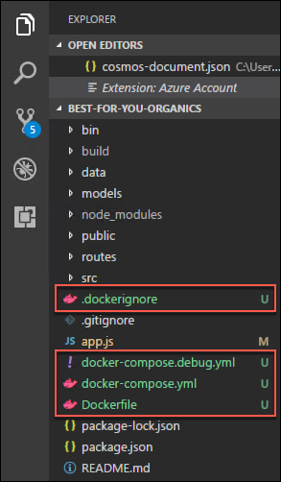
7. Select **Dockerfile** from the file navigator, and observe the contents. This file provides the commands required to assemble a Docker image for the mcw-oss-paas-devops application. 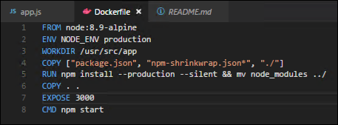
8. Next, you will tell Docker to build an image for your app. Open the **VS Code Command Palette** again, and run **Docker: Build Image** to build the image you just created. 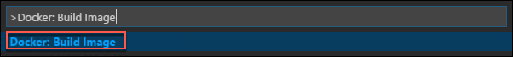
9. In the **Choose Dockerfile to build** box, select **Dockerfile** (the Dockerfile that was just created). 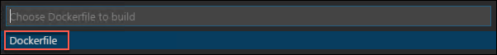
10. In the next box, you will provide a **registry**, **image name**, and **tag**, using the following format. This format will allow the image to be pushed to your container registry.

[registry]/[image name]:[tag]

1. For this, you will need the Login server value from your Azure Container registry’s **Access keys** blade. 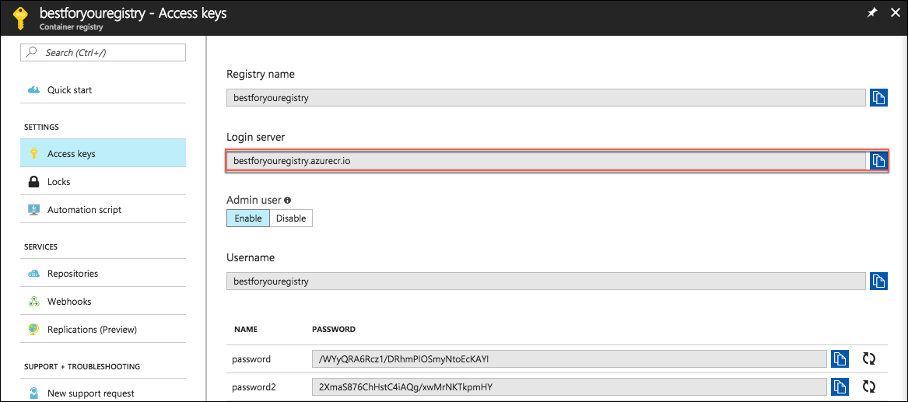
2. Entry the following into the **Tag image as…** box, where [Login server] is the Login server value from Azure:

[Login server]/best-for-you-organics:latest

1. For example:

bestforyouregistry.azurecr.io/best-for-you-organics:latest

1. Enter your value, and press **Enter**, which will trigger the build of the image. 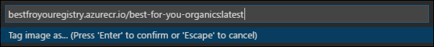
2. In the terminal window, you will see the following docker build commands execute: 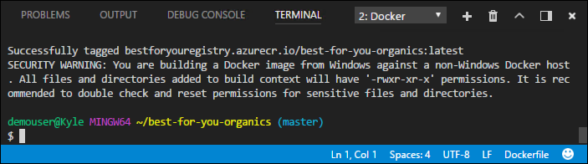
3. Once the build completes, you will see the image show up in the**DOCKER** extension explorer, under **Images**. 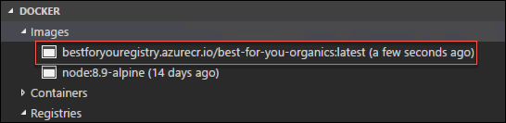
4. You can also use the docker images command in the Integrated terminal to list the images.

#### Task 4: Run the containerized App

In this task, you will run the app from the container you built in the previous task.

1. In the **Images** area of the Docker extension in VS Code, right-click your image, and select **Run Interactive**. 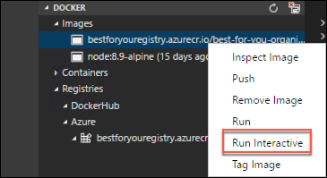
2. Notice in the Interactive terminal that a docker run command is issued. Using the VS Code Docker extension, you can issue some docker commands, without needing to work from the command line. 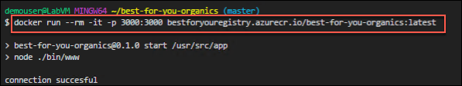
3. If you receive a Windows Defender Firewall alert, check to allow communication on both **Private** and ***Public* networks**, and select **Allow Access**.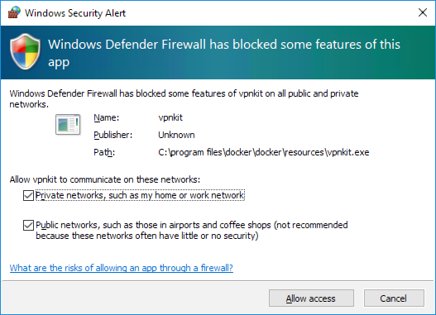
4. Verify the web app and container are functioning by opening a browser window, and navigating to <http://localhost:3000>. 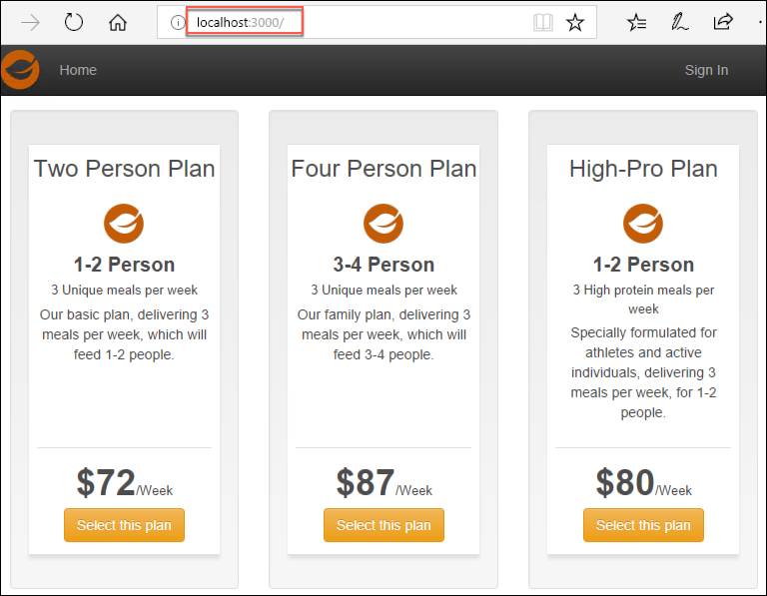
5. In the Integrated terminal of VS Code, for the interactive session, press **CTRL+C** to stop the container.

#### Task 5: Push image to Azure Container Registry

In this task, you are going to push the image to your Azure Container Registry.

1. In the Azure portal, navigate to the hands-on-labs-SUFFIX resource group, and select the **bestforyouregistrySUFFIX** Container registry from the list of resources. 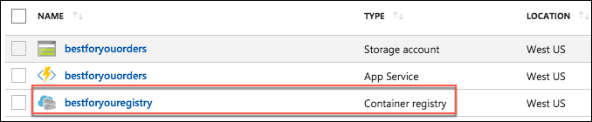
2. On the **bestforyouregistrySUFFIX** blade, select **Access keys** under settings in the left-hand menu, and leave this page up as you will be referencing the **Login server**, **Username**, and **password** in the next task.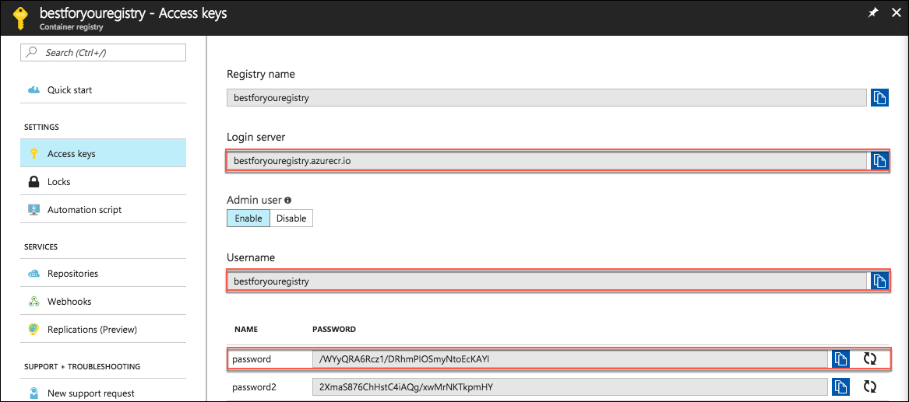
3. Return to the Integrated terminal window in VS Code, and enter the following command to log in to your Azure Container registry, replacing the bracketed values with those from the container registry access keys page.

docker login [Login Server] -u [Username]

1. For example:

docker login bestforyouregistry.azurecr.io -u bestforyouregistry

1. Enter the password when prompted to complete the login process. 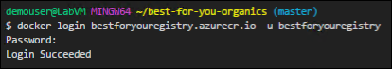
2. Once you’re successfully logged in, find your image in the Docker extension section of the VS Code, right-click your image, and select **Push.**

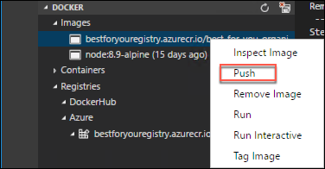

1. Note the “docker push” command issued in the terminal window. 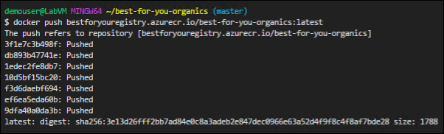
2. To verify the push, return to the **bestforyouregistry** blade in the Azure portal, and select **Repositories** under **SERVICES** on the left-hand side, and note the **best-for-you-organics** repository. 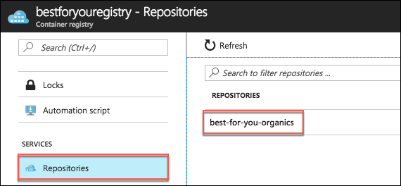

## Exercise 5: Set up Web App for Containers

Duration: 10 minutes

In this exercise, you will deploy the containerized app to a Web App for Containers instance from the image stored in your Azure Container Registry.

#### Task 1: Provision Web App for Containers

1. In the Azure portal, select **+New**, **Web + Mobile**, and select **Web App for Containers**. 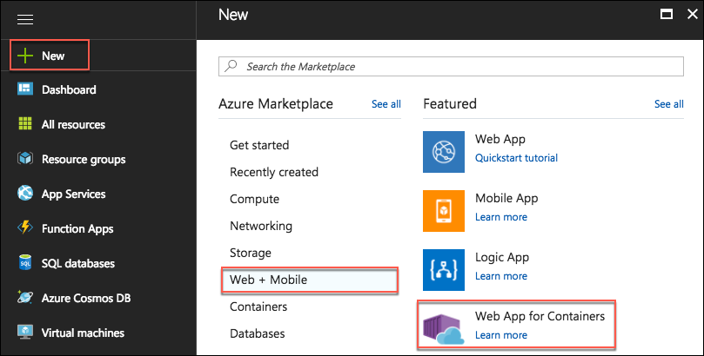
2. On the **Create**blade, enter the following:
   1. **App name**: Enter “best-for-you-app-SUFFIX” (the name must be unique).
   2. **Subscription**: Select the subscription you are using for this lab.
   3. **Resource group**: Select **Use existing**, and choose the hands-on-labs-SUFFIX resource group.
   4. **App Service plan/Location**: Accept the default assigned value, which will create a new App Service plan.
   5. Select **Configure container**, and enter the following:
      1. **Image source:** Select **Azure Container Registry**.
      2. **Registry**: Select **bestforyouregistrySUFFIX**.
      3. **Image**: Select **best-for-you-organics**.
      4. **Tag**: Select **latest**.
      5. **Startup File**: Leave blank.
      6. Select **OK**.
   6. Select **Create**. 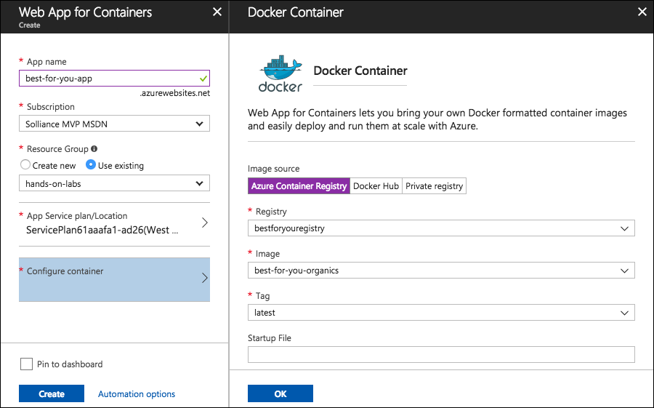

#### Task 2: Navigate to the deployed app

In this task, you will navigate to the deployed app, and log in to verify it is functioning correctly.

1. When you receive the notification that the Web App for Containers deployment has completed, navigate to the Web App by selecting the **notifications icon**, and selecting **Go to resource**. 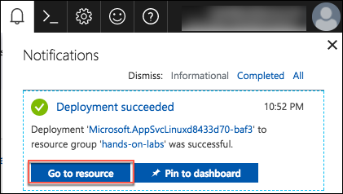
2. On the **Overview** blade of **App Service**, select the URL for the App Service. 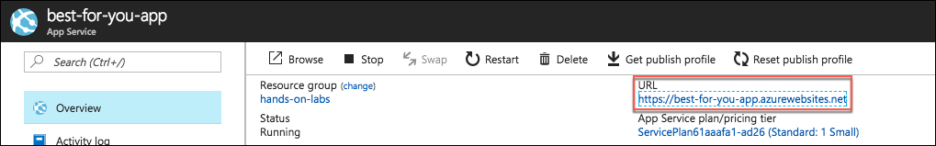
3. A new browser page or tab will open, and you should see the mcw-oss-paas-devops home page displayed.
4. Sign in to the site with the following credentials to verify everything is working as expected.
   1. [demouser@bfyo.com](mailto:demouser@bfyo.com)
   2. Password.1!! 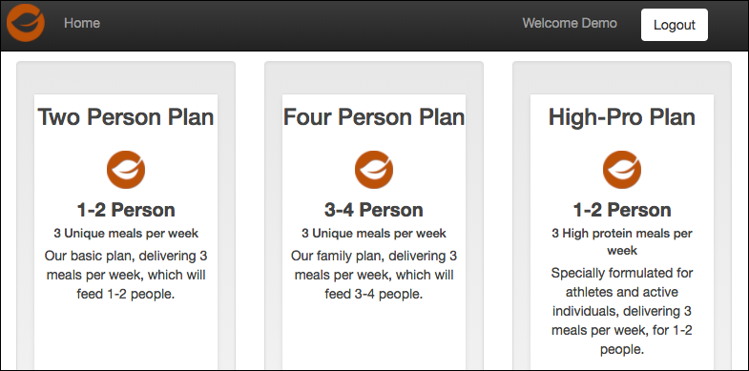
5. You have now successfully deployed a containerized OSS app into Azure PaaS.

## Exercise 6: Create Azure Function for order processing

Duration: 45 minutes

In this task, you will explore how serverless computing can be used to quickly expand application functionality, with little to no development resources, by create an Azure Function that will be triggered by orders being added to the Orders collection in Azure Cosmos DB. This Function will trigger whenever a document in the orders collection is inserted or updated. The function checks the processed field on the order document, ensuring only unprocessed orders are sent to the processing queue.

#### Task 1: Provision a Function App

In this task, you will create a Function App in Azure, which will host your Functions.

1. In the Azure portal, select **+New**, enter “Function App” in to the **Search the marketplace** box, and select **Function App** from the results. 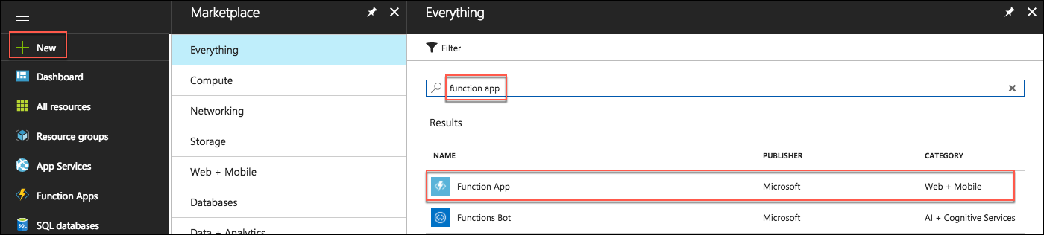
2. On the **Function App** blade, select **Create**.
3. On the **Create Function App** blade, enter the following:
   1. **App name:** Enter a unique name, such as “bestforyouordersSUFFIX.”
   2. **Subscription:** Select the subscription you are using for this hands-on lab.
   3. **Resource group:** Select **Use existing**, and choose the **hands-on-labs-SUFFIX** resource group.
   4. **OS:** Select Windows.
   5. **Hosting Plan:** Choose Consumption Plan.
   6. **Location:** Select the location you’ve been using for resources in this hands-on lab.
   7. **Storage:** Select **Create new**, and enter “bestforyouorders” for the name.
   8. Select **Create** to provision the new Function App. 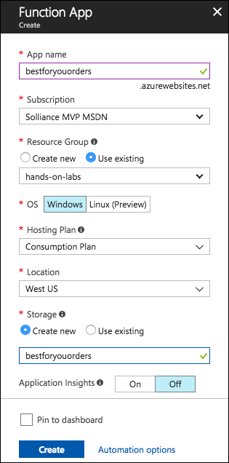

#### Task 2: Configure storage queues

In this task, you will add two storage queues to the storage account provisioned when you created your Function App. These queues will be used to store orders and notifications needing to be processed.

1. In the Azure portal, navigate to the new **bestforyouorders storage account** that was created when you provisioned your Function App, by selecting **Resource groups** from the left-hand menu, selecting your **hands-on-labs-SUFFIX** resource group from the list, and then selecting the **bestforyouorders storage account**. 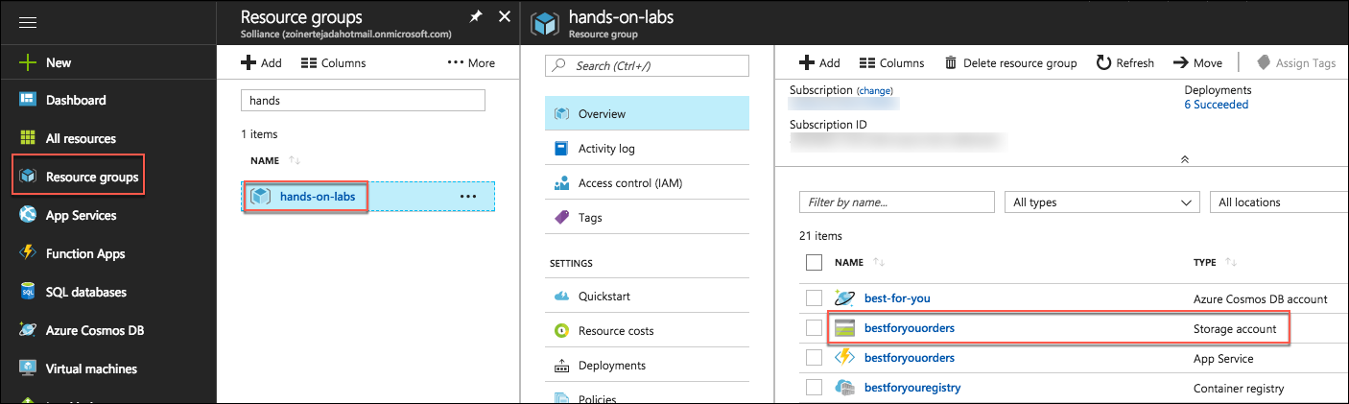
2. Select **Queues** from the **Services** area of the **Overview** blade.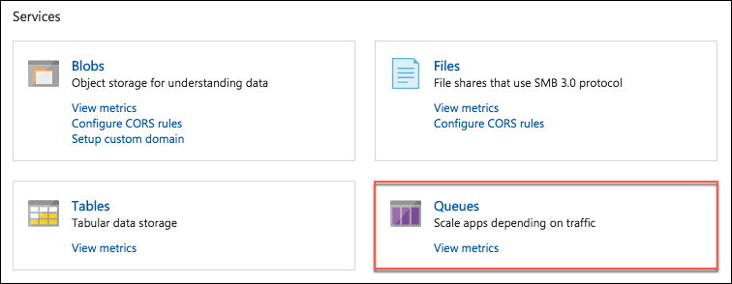
3. On the **Queue service** blade, select **+Queue** to add a new queue. 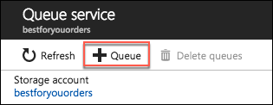
4. In the **Add** queue dialog, enter **orderqueue** for the **Queue name**, and select **OK**.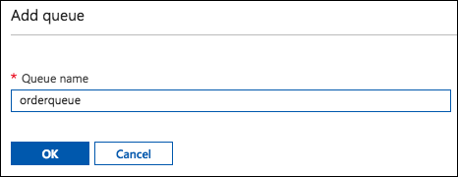
5. Select **+Queue** again, and this time enter “notificationqueue” for the **Queue name**. 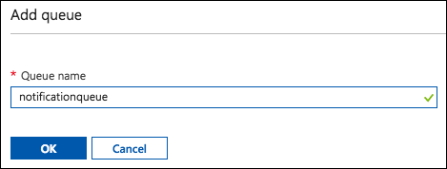

#### Task 3: Create Cosmos DB trigger function

In this task, you will create a function that will be triggered whenever a document is inserted into the orders collection in your Azure Cosmos DB. This function sends all new orders to a queue for processing and shipping. This function will use a Cosmos DB trigger and an output binding to an Azure Storage Queue.

1. When the Function App has deployed, navigate to the new Function App in the Azure portal, by selecting the **notifications icon**, then select **Go to resource** for the Function App notification. 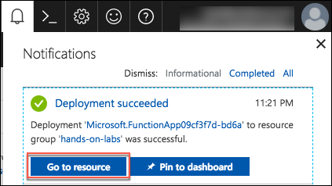
2. From the left-hand menu on your **Function Apps**blade, select **Functions**, then select **+New function**. 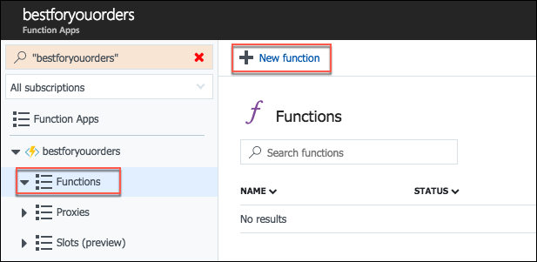
3. In the trigger search box, enter “cosmos,” and select the **Cosmos DB trigger**. 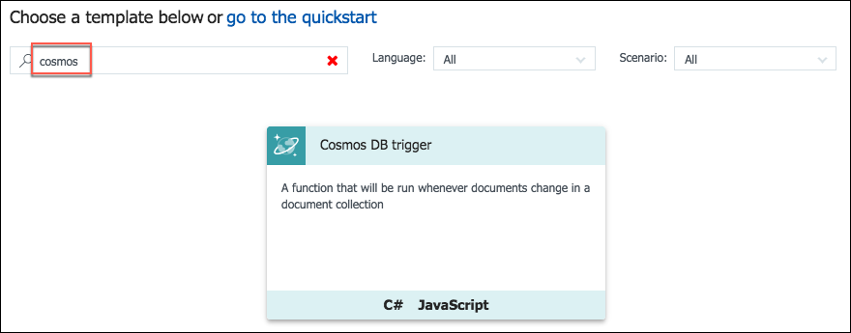
4. In the **Cosmos DB trigger** dialog, enter the following:
   1. **Language**: Select **JavaScript**.
   2. **Name**: Enter “OrdersCosmosTrigger.”
   3. **Azure Cosmos DB account connection**: Select **new**, then select the **best-for-you-db DocumentDB** Account.
   4. **Collection name:** Enter orders (use all lowercase, as case matters).
   5. **Create lease collection if it does not exist:** Leave this checked.
   6. **Database name:** Enter “best-for-you-organics.”
   7. **Collection name for leases:** Leave set to leases.
   8. Select **Create**.

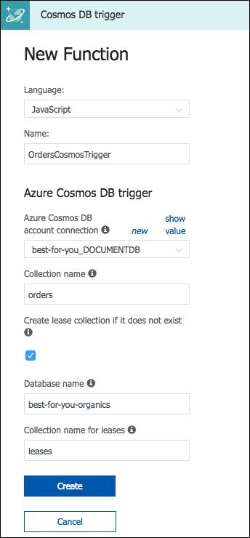

1. After the function is created, select **Integrate** under the new function. 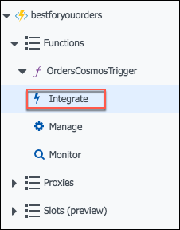
2. Change the Document collection parameter name to “newOrders” for the **Azure Cosmos DB trigger**, and select **Save**. 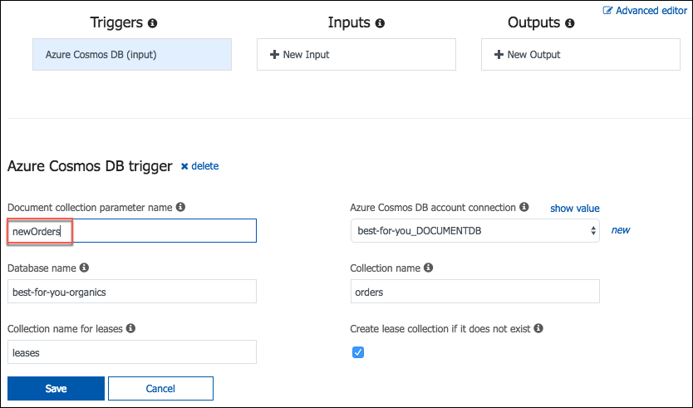
3. Next, select **+New Output**, select **Azure Queue Storage**, and select **Select**.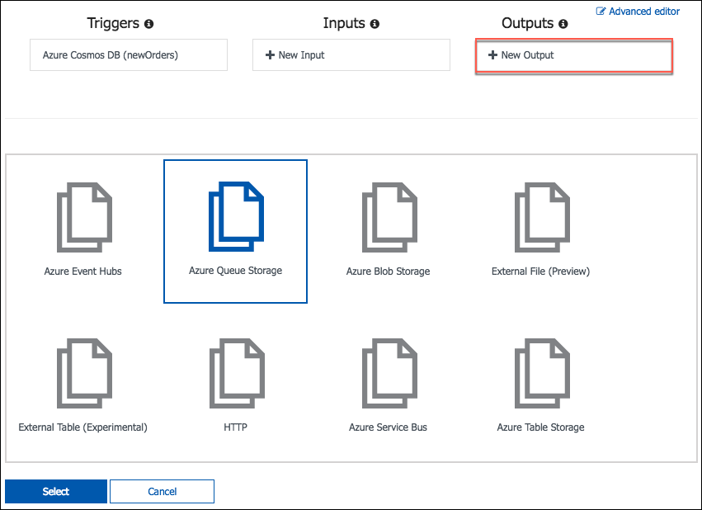
4. For the **Azure Queue Storage output**, enter the following:
   1. **Message parameter name**: outputQueue.
   2. **Queue name:** orderqueue (all lowercase, as casing matters).
   3. **Storage account collection:** Select **AzureWebJobsStorage** from the list (this is the bestforyouorders storage account you created when you provisioned your Function App).
   4. Select **Save.** 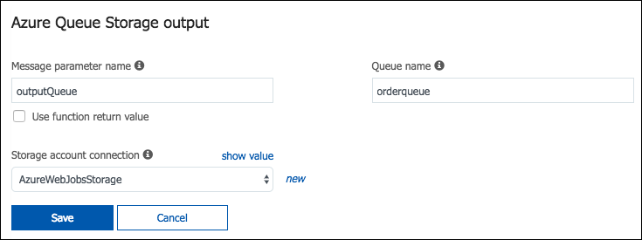
5. Now, select the **OrdersCosmosTrigger** function in the left-hand menu. 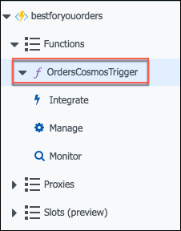
6. To get the code for the OrdersCosmosTrigger function, go into the project is VS Code, expand the AzureFunctions folder, select **OrdersCosmosTrigger.js**, and copy the code, as highlighted in the screen shot below. 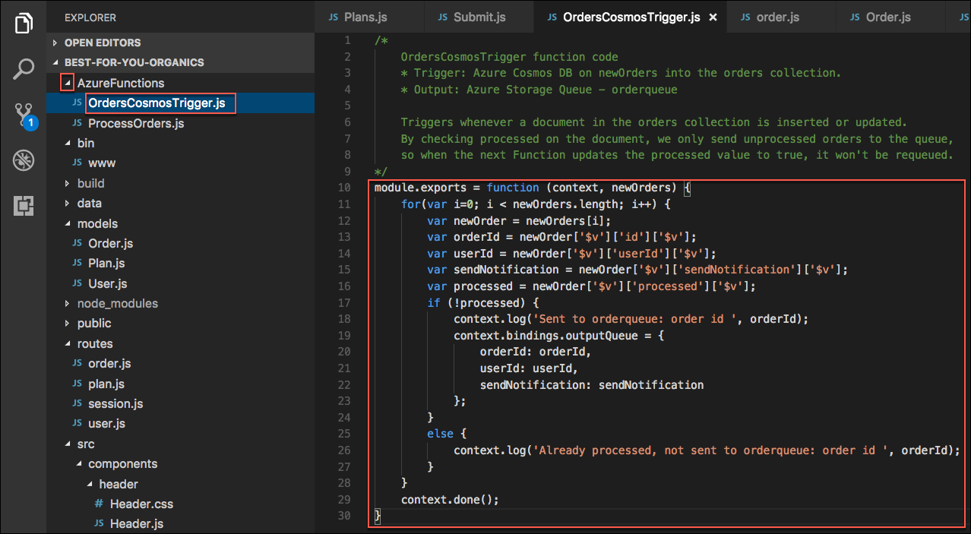
7. Paste the code into the **index.js** block, overwriting all the existing code, and select **Save**. Your index.js file should now look like the following: 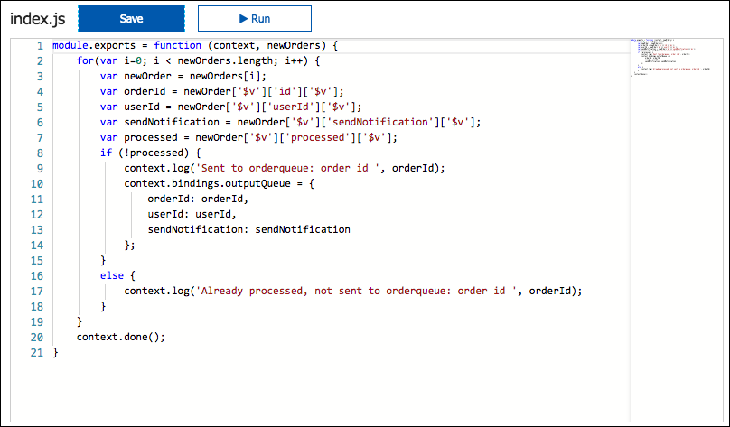
8. Next, select **Logs** below the code block, so you can observe the Function being called during the next steps. 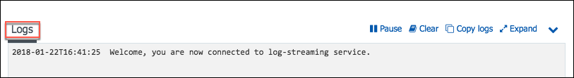
9. To trigger the function, return to the starter application in your browser window, and select **Sign In**. 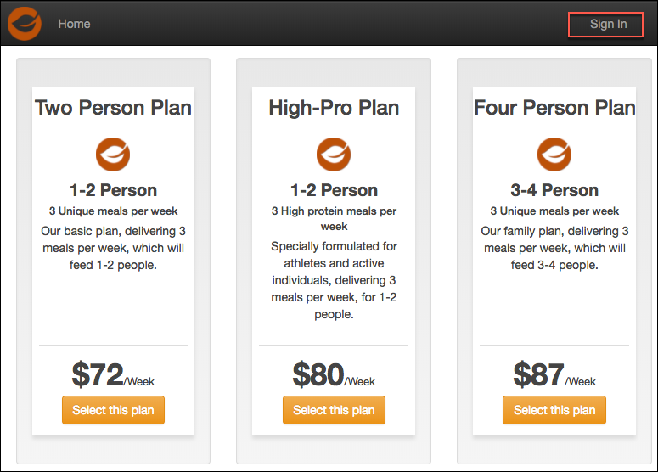
10. On the Login screen, enter the following credentials, and select **Login**.
    1. **Email address:** [demouser@bfyo.com](mailto:demouser@bfyo.com).
    2. **Password:** Password.1!! 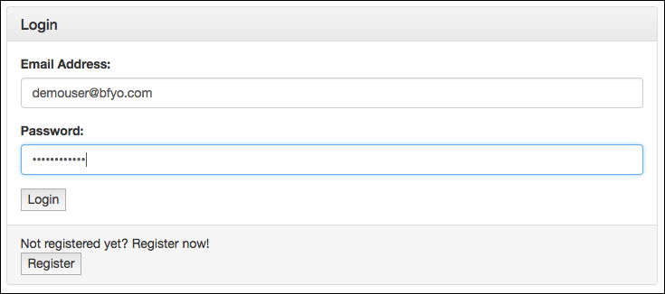
11. After logging in, you will be returned to the home page. Select **Select this plan** for any of the plans. 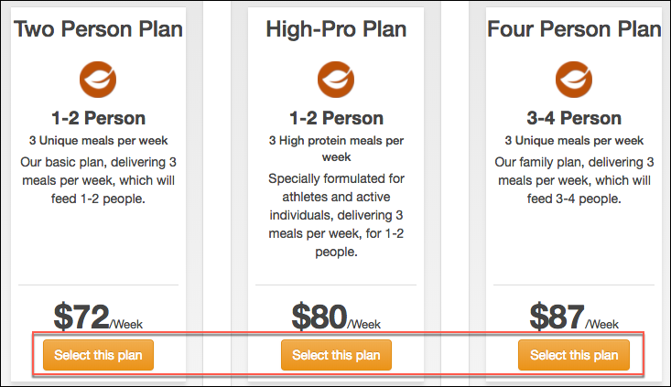
12. On the **Place Order** screen, select **Place Order**. This will create a new order, which will fire the Azure Cosmos DB trigger in your function, and then send the order on to the ordersqueue for processing. 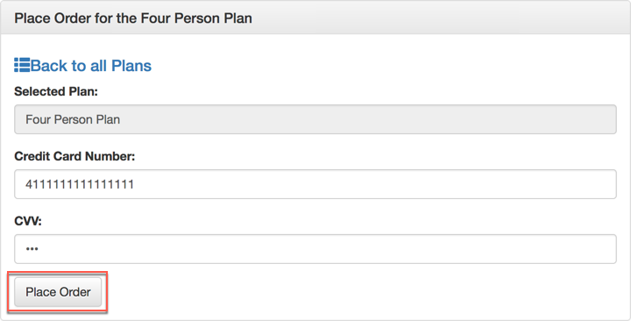
13. Next, you will update an order in the Azure portal, to set the processed value to true. This will be a change that should not be sent into the orderqueue for processing.
14. Navigate to your Cosmos DB account in the Azure portal, select **Data Explorer**, expand the **orders** collection, then select **Documents**.

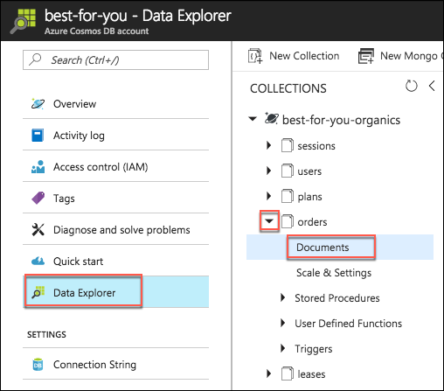

1. Select any order document, and change the processed value to “true,” then select **Update**.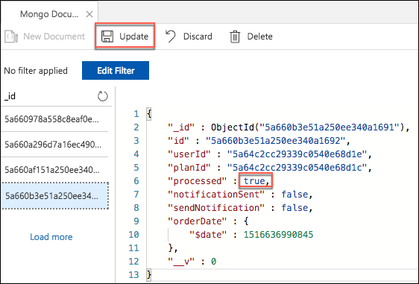
2. Return to the logs pane of your function, and observe that the orders have been processed though the Function, and that the new order was sent to the orderqueue, while the updated order was not. 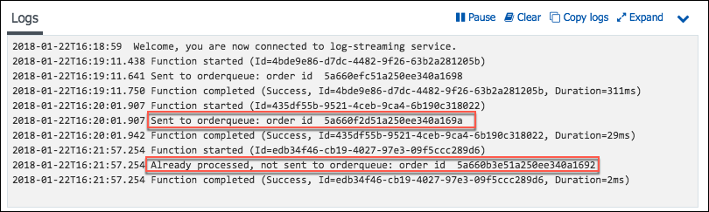
3. Finally, verify items are being written to the order queue, by going to the queue in the Azure Storage account, and observing that items have been added to the queue. 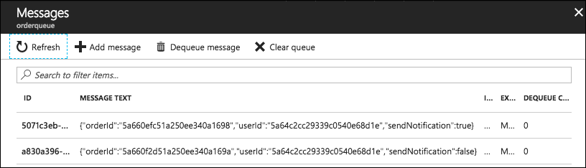

#### Task 4: Create Queue function

In this task, you will create a second function which will be triggered the output of the OrdersCosmosTrigger function. This will simulate the order processing and will add items to the notificationqueu if the order processing is complete and sendNotifications is true for the order.

This will use an Azure Storage Queue trigger, and an input dataset from Cosmos DB, pulling in customers. Output dataset will be Azure Cosmos DB orders table, and an update to set processed = true, and the processedDate to today.

1. Select **Integrate** under the OrdersCosmosTrigger function, then select **Azure Queue Storage (outputQueue)** under **Outputs**. 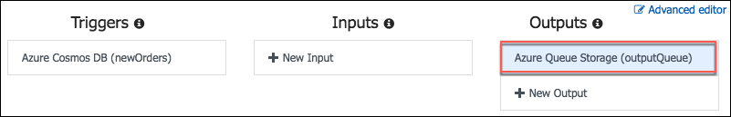
2. Under **Actions** for the output, select **Go** next to **Create a new function triggered by this output**. 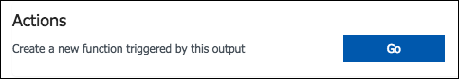
3. Select **Queue trigger** from the list. 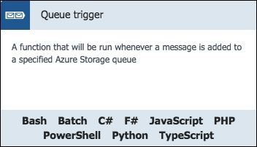
4. On the **Queue trigger New Function** dialog, enter the following:
   1. **Language:** Select **JavaScript**.
   2. **Name:** Enter ProcessOrders.
   3. **Queue name:** orderqueue.
   4. **Storage account connection:** Select **AzureWebJobsStorage**.
   5. Select **Create**.

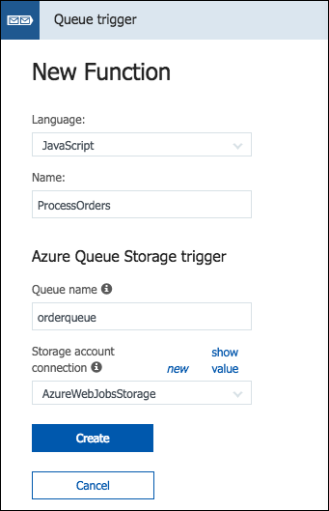

1. When the function has been created, select **Integrate** under the **ProcessOrders** function, change the Message parameter name to “orderToProcess” for the **Azure Queue storage trigger**, and select **Save**. 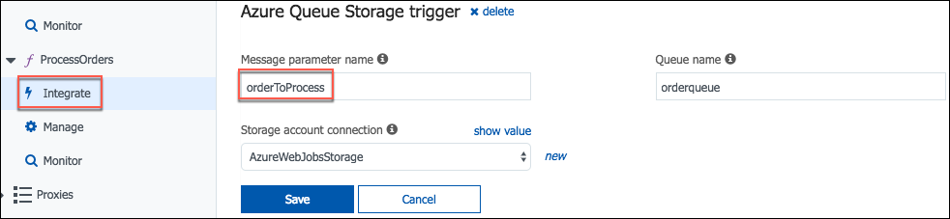
2. Now, select **+New Input**, select **Azure Cosmos DB**, and select **Select**. 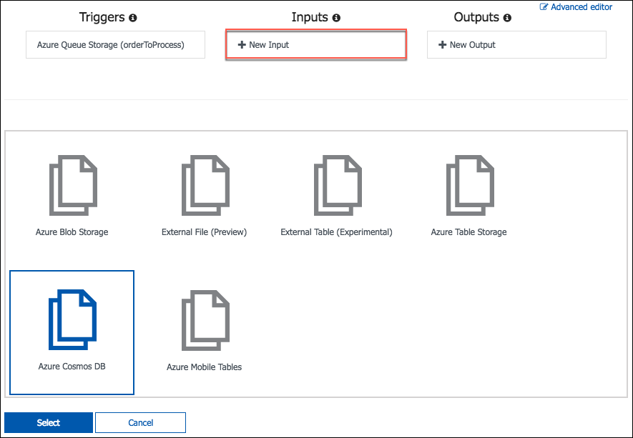
3. On the **Azure Cosmos DB** input screen, enter the following:
   1. **Document parameter name:** Enter “users.”
   2. **Database name:** Enter “best-for-you-organics.”
   3. **Collection name:** Enter “users” (all lowercase, as case matters).
   4. **Azure Cosmos DB account connection:** Select **best-for-you_DOCUMENTDB**.
   5. Select **Save**. 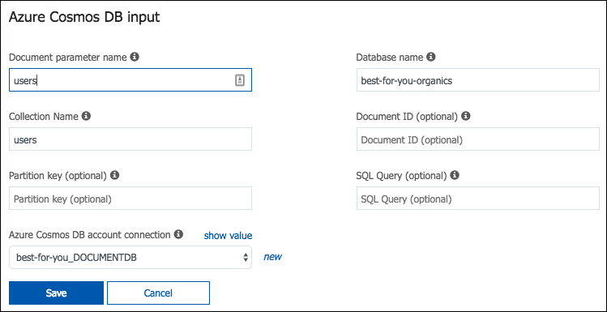
4. Next, select **+New Output**, select **Azure Queue Storage**, and select **Select**. 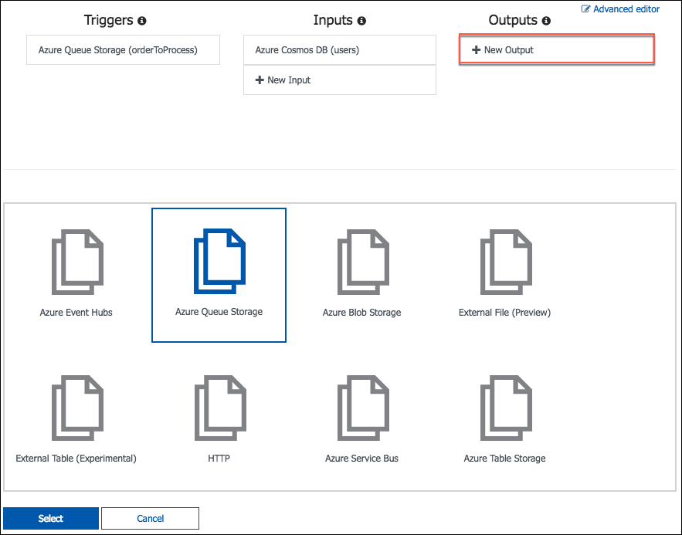
5. For the **Azure Queue Storage output**, enter the following:
   1. **Message parameter name**: “outputQueue.”
   2. **Queue name:** “notificationqueue” (all lowercase, as casing matters).
   3. **Storage account collection:** Select **AzureWebJobsStorage** from the list
   4. Select **Save**.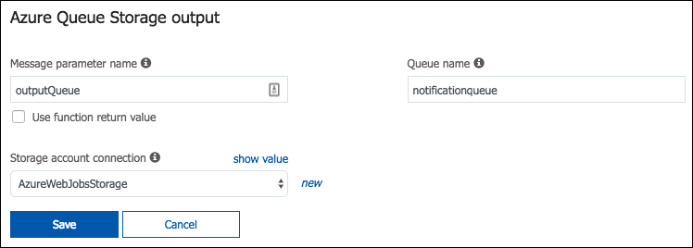
6. Now, select the **ProcessOrders** function in the left-hand menu. 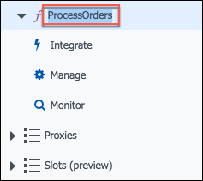
7. To get the code for the **ProcessOrders** function, go into the project is VS Code, expand the **AzureFunctions** folder, select **ProcessOrders.js**, and copy the code, as highlighted in the screen shot below. 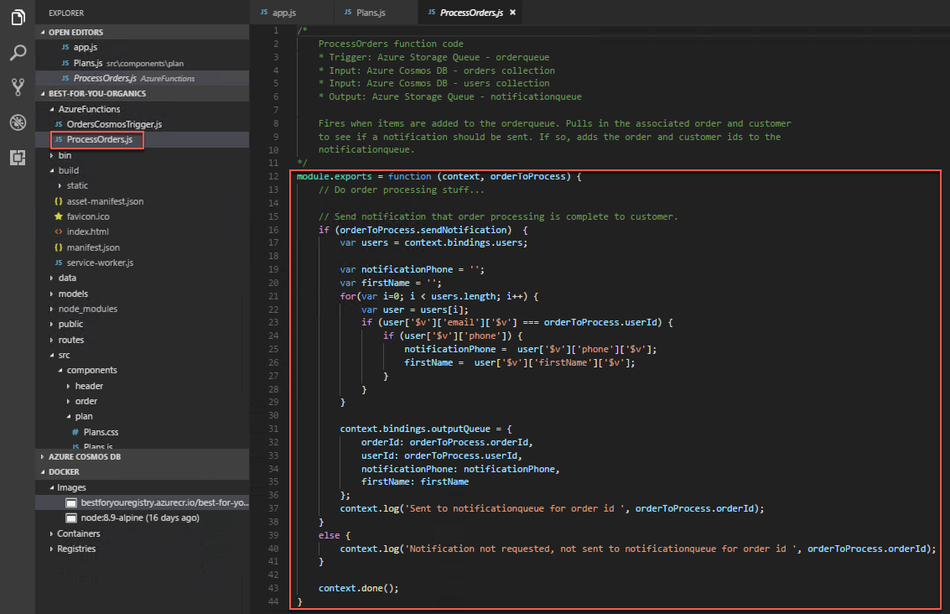
8. Paste the code into the **index.js** block, overwriting all the existing code, and select **Save**. Your index.js file should now look like the following: 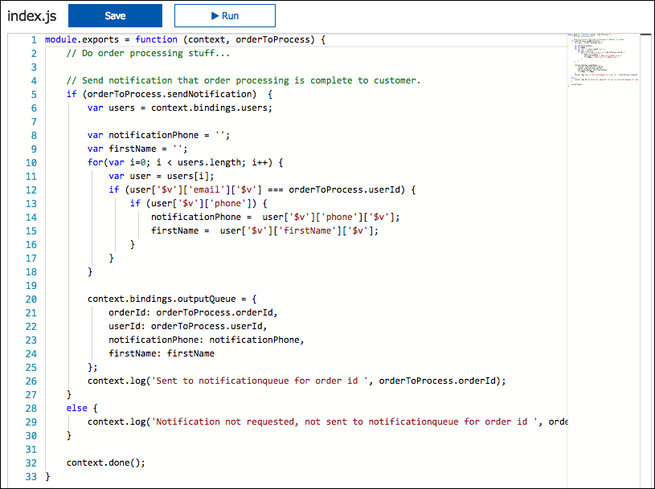
9. Next, select **Logs** below the code block, so you can observe the Function being called during the next steps. 
10. To trigger the function, return to the starter application in your browser window, select **Sign In**, and on the **Sign In** screen, select **Register**. 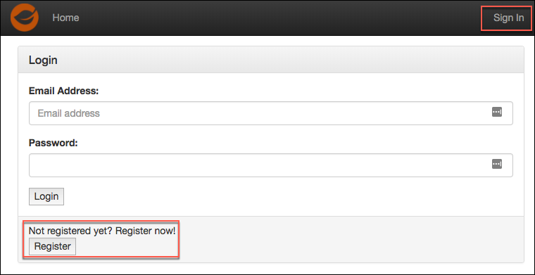
11. Complete the registration form, being sure to include a cell phone number in the Phone field that you can receive text messages on. (If you opt not to enter a phone number, you can still complete the next Exercise, but will not receive the text notifications that your order has been processed.)
    1. You only need to enter data into the **First name**, **Last name**, **email address**, and **phone** fields. All other fields have been pre-populated to save time.
    2. The password has been set to Password.1!!. If you choose to enter a different password, note that when you log into the account.
12. After registering, select **Sign In** from the Home page, enter your email address and password (Password.1!!) on the login screen, and select **Login**.
13. Select the **Select this plan** button for any plan on the home page, and on the Order screen select **Place Order**. 
14. Return to your **ProcessOrders Function** page in the Azure portal, and observe the logs. 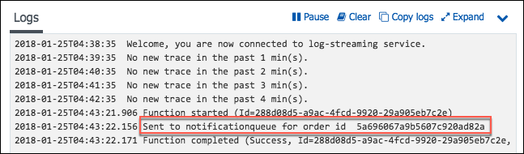
15. The order you placed has been sent to the notificatoinqueue, and is pending the notification being sent to your cell phone via SMS text message.

## Exercise 7: Create Logic App for sending SMS notifications (Bonus)

Duration: 30 minutes

If you have extra time, you can complete this exercise to learn more about Logic Apps, and how they can be used to add application functionality, without the need for developer resources. In this exercise, you will create Logic App which will trigger when an item is added to the notificationqueue Azure Storage Queue. The Logic App will use a Twilio connection to send an SMS message to the phone number included in the notificationqueue message.

You can also skip the exercise and move on to Exercise 8: Configure CI/CI Pipeline or go directly to the After The Workshop exercise to perform resource cleanup in you Azure account.

#### Task 1: Create Free Twilio account

In this task, you will use a free Twilio account to send SMS notifications to customers, informing them that their order has been processed, and is on its way.

1. If you do not have a Twilio account, sign up for one for free at by going to <https://www.twilio.com/try-twilio>.
2. On the **Sign up for free** page:
   1. Enter your personal info, email address, and a 14+ character password.
   2. Select SMS under **Which product do you plan to use first?**.
   3. Select **Order Notifications** under **What are you building?**.
   4. Select **JavaScript** under **Choose your language**.
   5. Select **Not a Production App** under **Potential monthly interactions**.
   6. Check the box next to **I’m not a robot**.
   7. Select **Get Started**.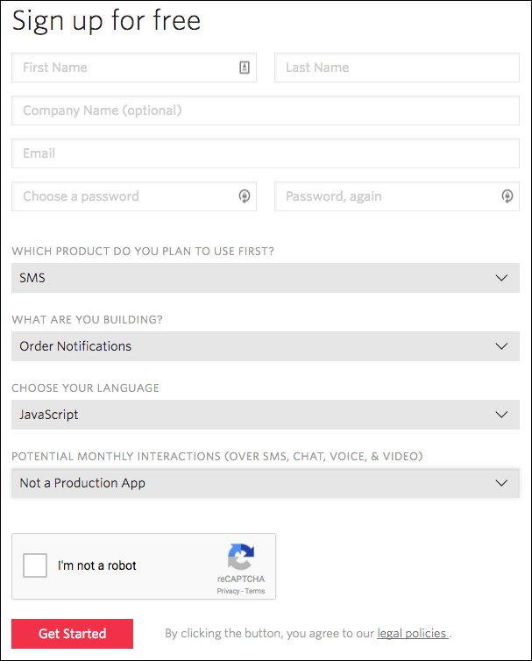
3. Enter your **cell phone number** on the We need to verify you’re a human screen, check the box if you do not wish to be contacted at the number you enter, and select **Verify** via SMS.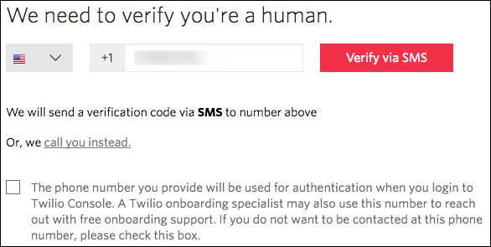
4. Enter the verification code received via text into the box, and select **Submit.** 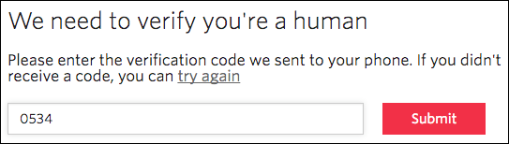
5. From your account dashboard, select the **All Products & Services icon.**  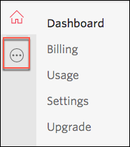
6. Select **#Phone Numbers** under **Super Network**. 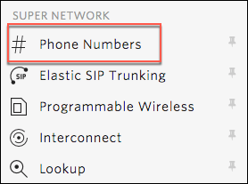
7. Select **Get Started**. 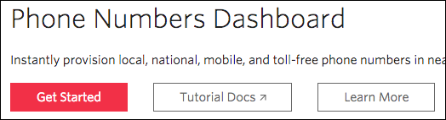
8. Select **Get your first Twilio phone number**. 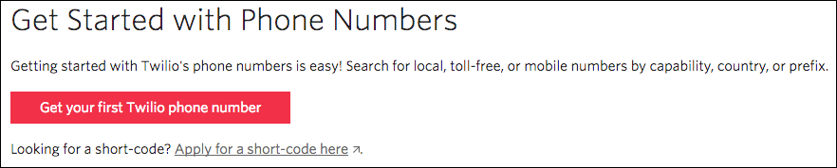
9. Select **Choose this Number** (or search for a different number if you want something different). 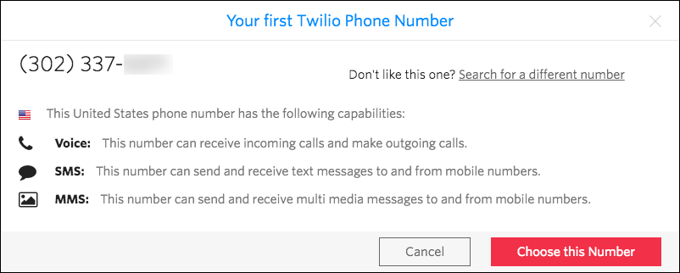
10. Select **Done** on the Congratulations dialog.
11. Select **Home** 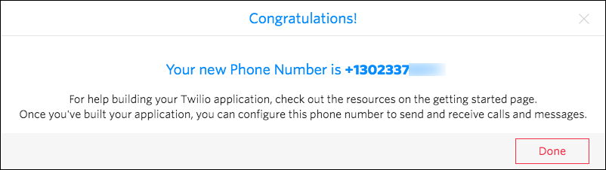on your **Account Dashboard**, and leave this page up, as you will be referencing the **Account SID** and **Auth Token** in the next task to configure the Twilio Connector. 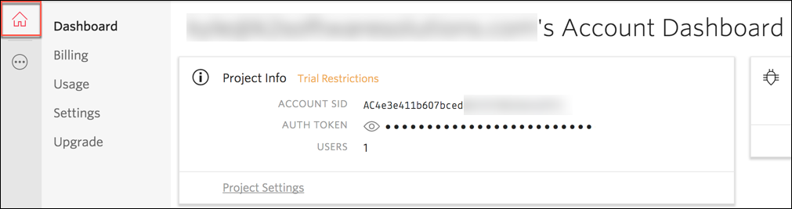

#### Task 2: Create Logic App

In this task, you will create a new Logic App, which will use the Twilio connector to send SMS notifications to users, informing them that their weekly order has processed and shipped.

1. In the Azure portal, select **+New**, select **Web + Mobile**, and select **Logic App**. 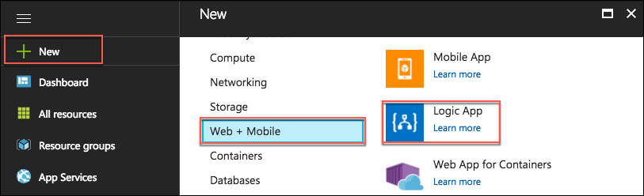
2. In the **Create logic app** blade, enter the following:
   1. **Name:** Enter “OrderNotifications.”
   2. **Subscription:** Select the subscription you are using for this hands-on lab.
   3. **Resource group:** Select **Use existing**, and choose the **hands-on-labs-SUFFIX** resource group.
   4. **Location:** Select the location you’ve been using for resources in this hands-on lab.
   5. Select **Create** to provision the new Logic App.

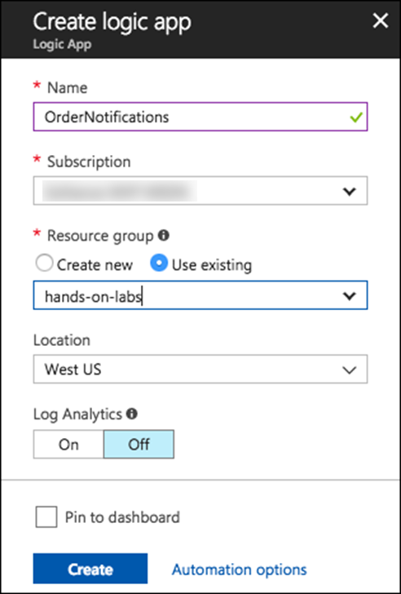

1. Navigate to your newly created Logic App in the Azure portal.
2. Select the **Logic App Designer** under **Development Tools** on the left-hand menu. 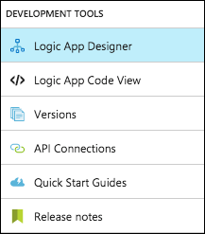
3. In the Logic App Designer, select **Blank Logic App** under **Templates**. 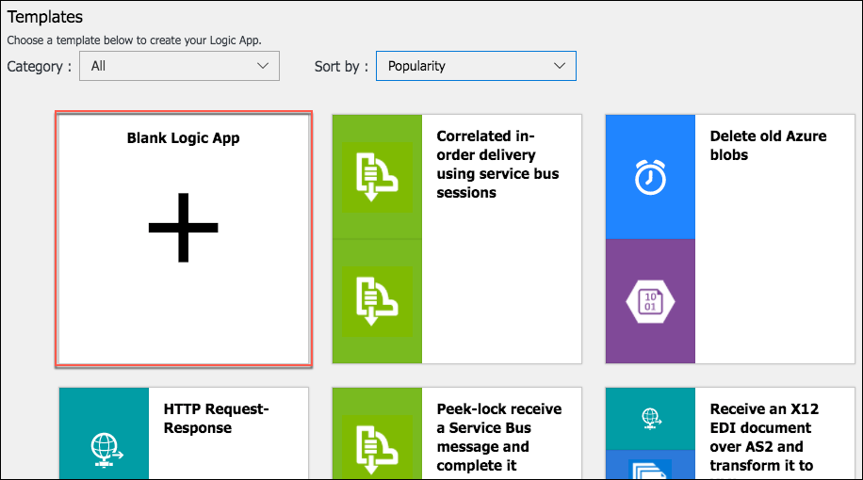
4. Select **Azure Queues** under **Connectors**. 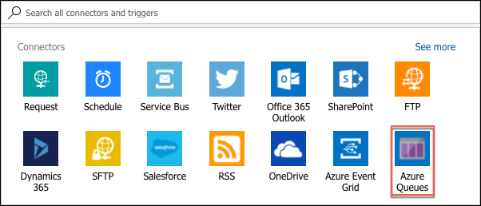
5. Select **Azure Queues** – When there are messages in a queue. 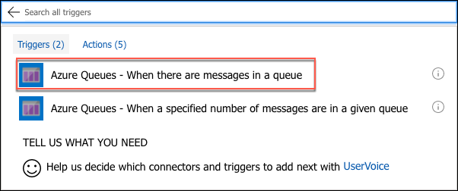
6. On the When there are messages in a queue dialog, enter **bestforyouorders** for the, **Connection Name** select the bestforyouorders **Storage account** from the list and select **Create**. 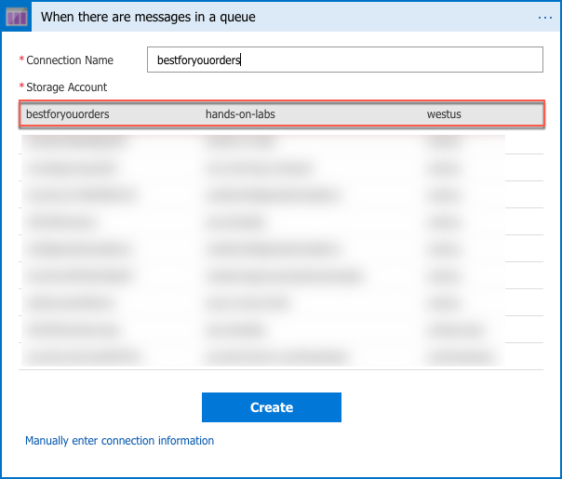
7. In the next When there are messages in a queue dialog, select **notificationqueue** from the **Queue Name** list, and set the interval to **1** **minute**, then select **+New step**, and **Add an action**.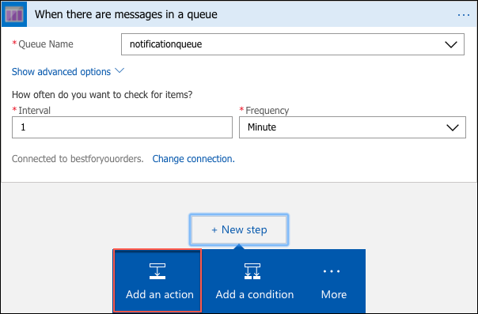
8. In the **Choose an action box**, enter “Parse,” and select **Data Operations** **– Parse JSON** from the list. 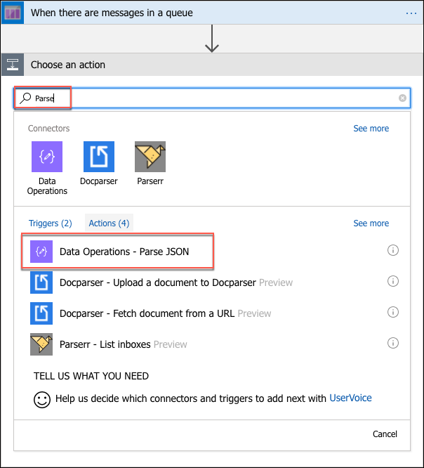
9. Select the **Content** box, and select **Message Text** from the input parameters list that appears. 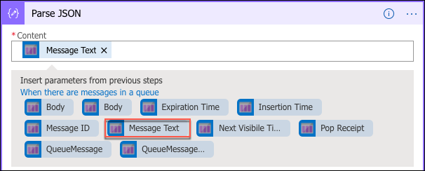
10. Next, select **Use sample payload to generate schema** below the **Schema** box. 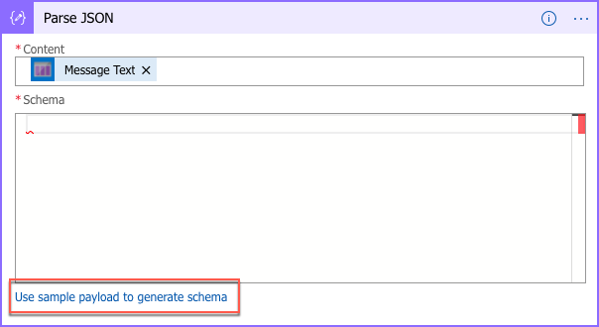
11. In the dialog that appears, paste the following JSON into the sample JSON payload dialog that appears, then select **Done**.

{"orderId":"5a6748c5d0d3199cfa076ed3","userId":"demouser@bfyo.com","notificationPhone":"3175551212","firstName":"Demo"}

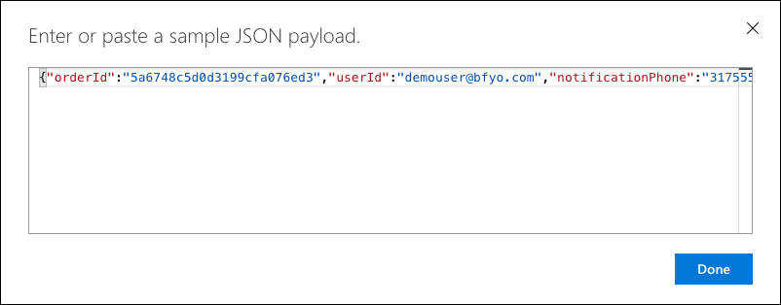

1. You will now see the Schema for messages coming from the notification queue in the Schema box. Select **+New** **step**, and select **Add an action**. 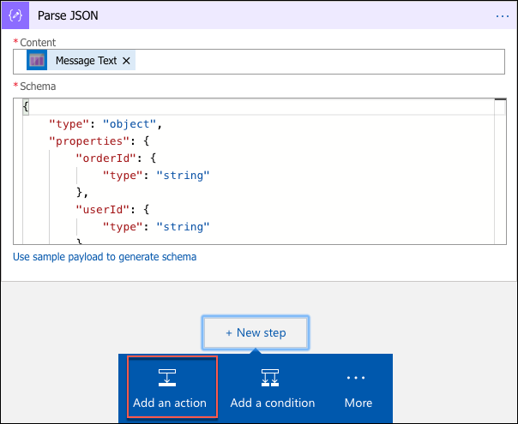
2. In the **Choose an action box**, enter “Twilio,” and select **Twilio – Send Text Message (SMS)** under Actions. 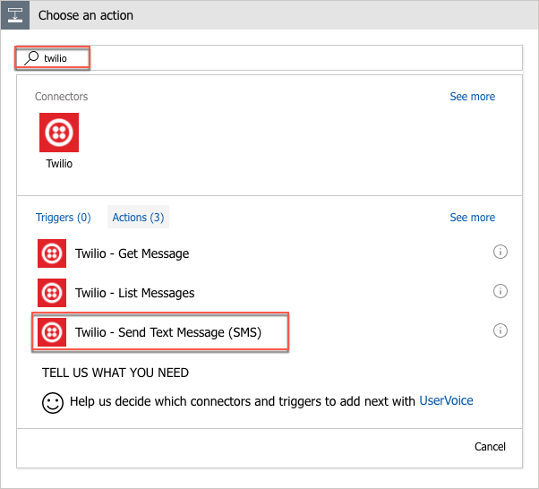
3. In the **Twilio – Send Text Message (SMS)** dialog, enter the following (You will need the details from Project Info block on the dashboard of your Twilio account for this step):
   1. **Connection Name:** Twilio
   2. **Twilio Account Id:** Enter your Twilio account SID.
   3. **Twilio Access Token:** Enter your Twilio auth token.
   4. Select **Create**.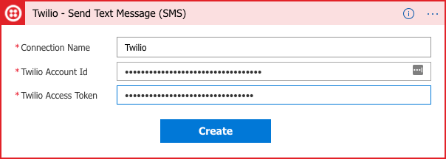
4. On the next **Send Text Message (SMS)** dialog, enter the following:
   1. **From Phone Number:** Select your Twilio phone number from the drop down.
   2. **To Phone Number:** Select **notificationPhone** from the **Parse JSON** parameters. 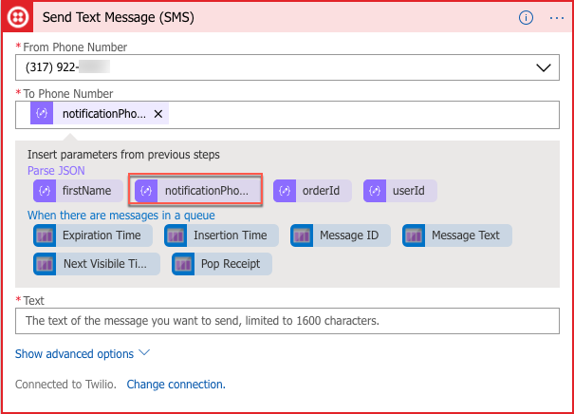
   3. **Text:** Enter a message, such as “Hello [firstName], your Best for You Organics weekly order has shipped!” For [firstName], select the **firstName** parameter from the **Parse JSON** items. 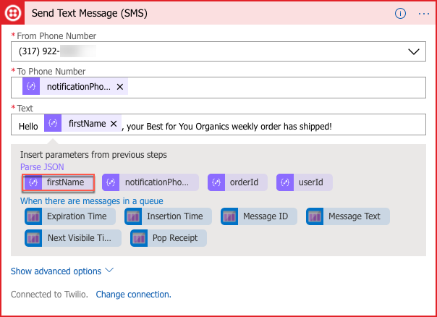
5. Select **+New step**, and **Add an action**.

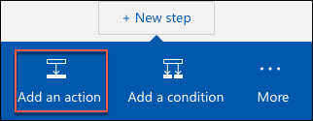

1. In the **Choose an action** dialog, enter “queue” in to the search box, and select **Azure Queues – Delete** **message**. 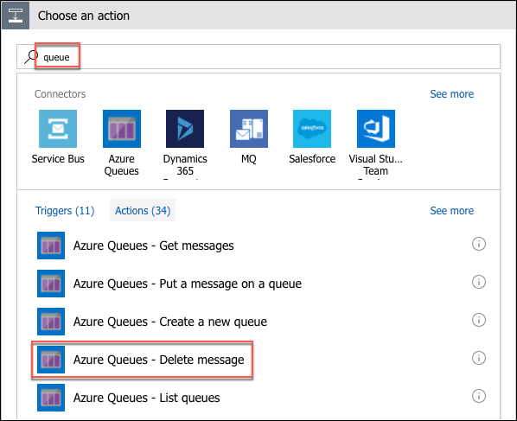
2. Select **notificationqueue** for the Queue Name.
3. For Message ID, select the **Message ID** parameter from the **When there are messages in the queue** parameter list.

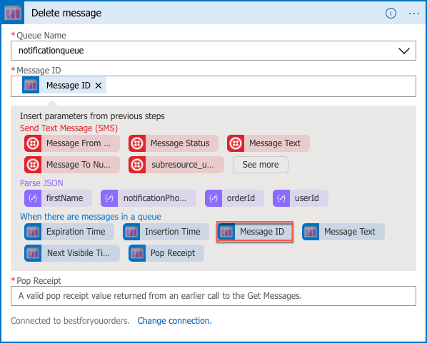

1. For Pop Receipt, select the **Pop Receipt** parameter from the **When there are message is a queue** parameter list. 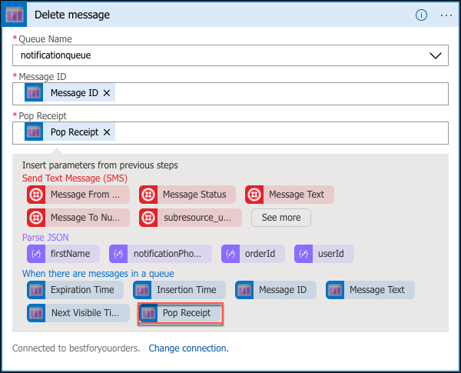
2. Select **Save** on the **Logic Apps Designer** toolbar. 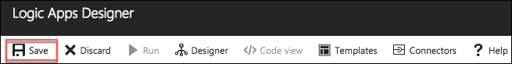
3. The Logic App will begin running immediately, so if you entered your cell phone number when you registered your account in the Best For You Organics starter app, and placed an order, you should receive a text message on your phone within a minute or two of selecting Save.

## Exercise 8: Configure CI/CD pipeline (Bonus)

Duration: 60 minutes

If you still have time and would like to look at how VSTS and Jenkins can be used in a CI/CD pipeline, continue on with the bonus exercise. In this exercise, you are going to add continuous delivery (CD) to a Jenkins continuous integration (CI) using Release Management in VSTS.

#### Task 1: Prepare GitHub account for Jenkins integration

In this task, you will be preparing your GitHub account for integration with Jenkins, which will include adding Jenkins service integrations. These integrations will allow you to enable a Jenkins continuous integration build job to be triggered by push code changes to GitHub.

1. In a new browser tab on your LabVM, navigate to your Jenkins VM in the Azure portal.
   1. Select **Resource groups** from the left-hand menu, then enter “Jenkins” into the search box, and select your **Jenkins-SUFFIX** resource group from the list. 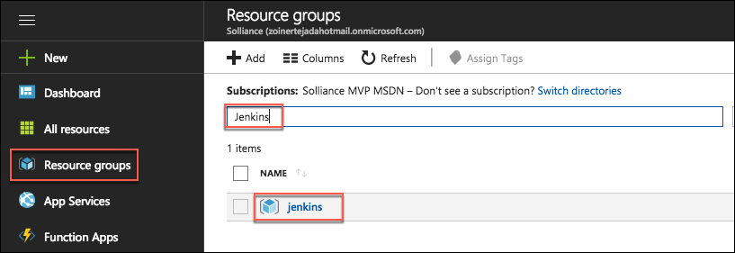
   2. On the Jenkins-SUFFIX Resourcegroupblade, select your **Jenkins** virtual machine. 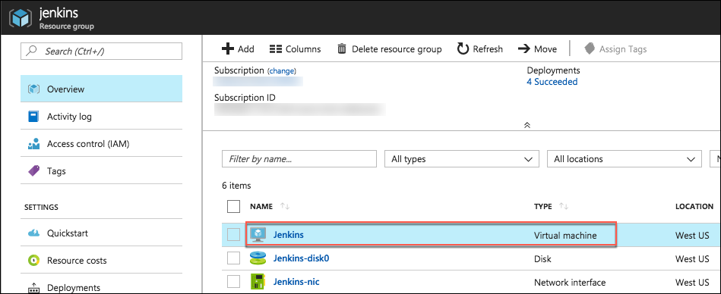
2. On the **Overview** blade of your Jenkins virtual machine, locate the **DNS name**, and copy the value.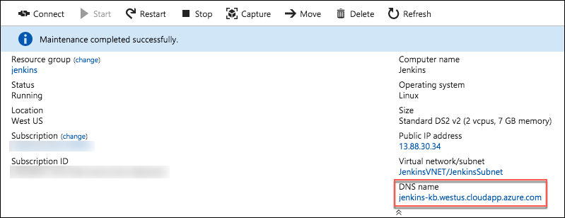
3. Return to your forked **mcw-oss-paas-devops** application page in your GitHub account, select **Settings**, then select **Integrations & services** from the left-hand menu.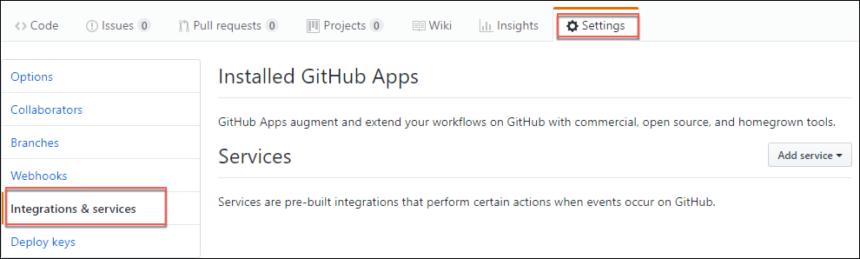
4. Select **Add service**, enter “Jenkins” into the search filter, and select **Jenkins (GitHub plugin)**. 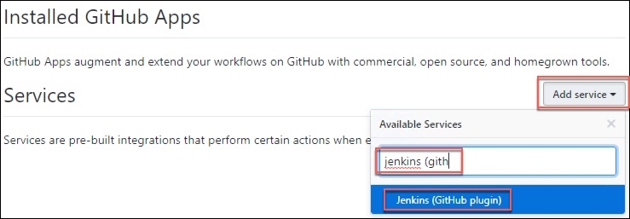
5. When prompted, enter your GitHub account password to continue. 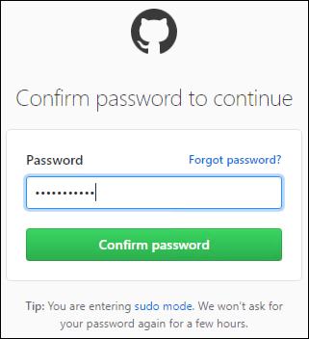
6. In the Jenkins hook URL text box, enter “http://[YOUR_JENKINS_URL]/github-webhook/" replacing **[YOUR_JENKINS_URL]** with the Jenkins DNS name you copied from the Azure portal, and select **Add service**.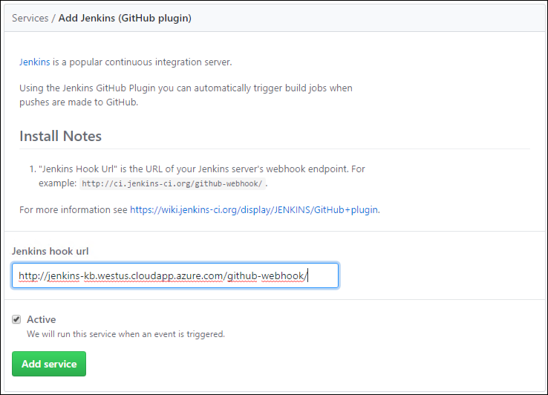
7. You will see the Jenkins (GitHub plugin) under the list of services. 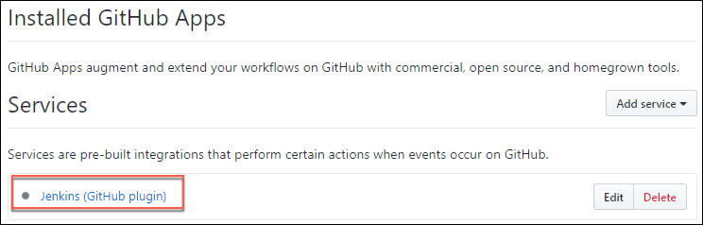
8. Next, you need to grant the Jenkins user access to your GitHub repository by adding a deploy key in the GitHub settings.
9. Return to your Jenkins virtual machine page in the Azure portal, select **Connect**, and copy the SSH command. 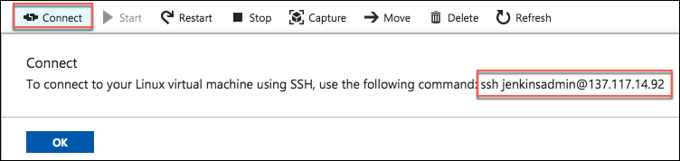
10. Open a new Git Bash terminal, and paste the SSH command you copied above at the prompt. Enter “yes” if prompted about continuing to connect, and enter the jenkinsadmin password, “Password.1!!,” when prompted. 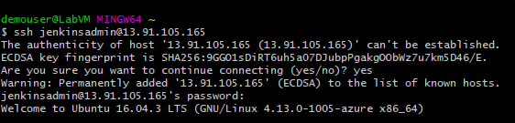
11. At the jenkinsadmin@Jenkins prompt, enter:

ssh-keygen

1. Press **Enter** to accept the default file in which to save the key.
2. Press **Enter** to use an empty passphrase, and re-enter it to confirm. (Note: This is done only for simplicity in this hands-on lab, and is not recommend for actual environments.)
3. Copy the location into which your public key has been saved. 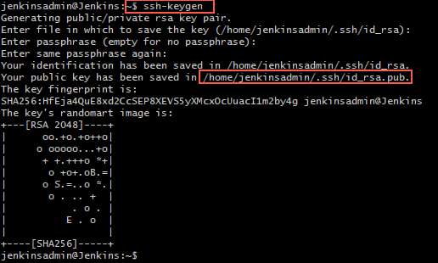
4. Show the public key using the following command, replacing [KEY_PATH] with the location of your public key.

cat [KEY_PATH]

1. Copy the key displayed, so it can be added to GitHub. 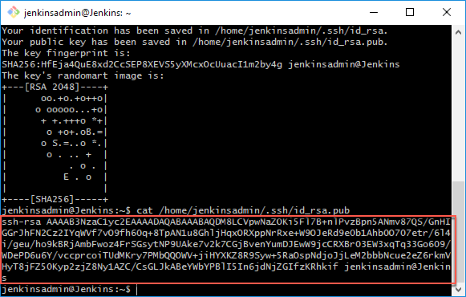
2. Return to you GitHub account in the browser, and select the **Deploy keys** option from the left-hand menu.
3. Enter “Jenkins” for the title, paste the SSH key you copied above into the Key field, removing any trailing spaces, and select **Add key**. 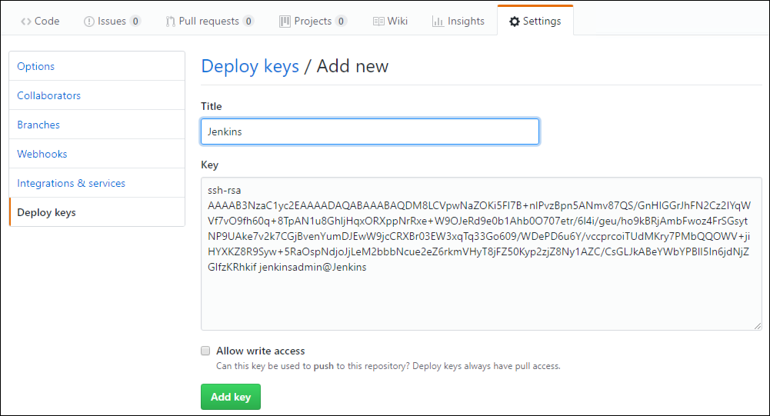
4. To ensure that everything is working, return to the Jenkin’s Git Bash terminal, and enter the below command which will check the connection to GitHub.

ssh git@github.com

1. Enter “yes” when prompted about continuing.
2. You should see a message like the following, indicating a successful connection. 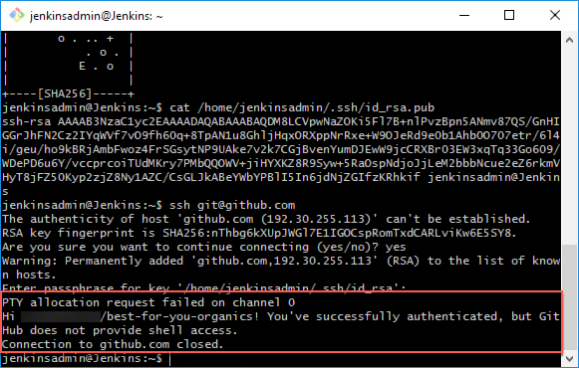
3. The GitHub side of the integration with Jenkins is complete. You will configure Jenkins as part of your CI/CD pipeline in Exercise 8, below.

#### Task 2: Configure Continuous Integration (CI) with Jenkins

In this task, you will set up a simple Jenkins CI pipeline, which will build the **mcw-oss-paas-devops** application with every code commit into GitHub.

1. In Before the hands-on lab, Task 11, you prepared your GitHub account for interaction with Jenkins. Now it is time to configure your Jenkins server.
2. From your Lab VM, open a browser and navigate to your **Jenkins** VM in the Azure portal.
   1. Select **Resource groups** from the left-hand menu, then enter “Jenkins” into the search box, and select your **Jenkins-SUFFIX** resource group from the list. 
   2. On the **Jenkins-SUFFIX** resource group blade, select your **Jenkins** Virtual machine. 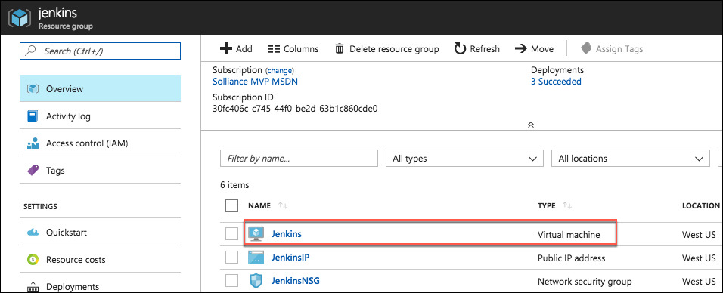
3. On the **Overview** blade of your Jenkins virtual machine, locate the **DNS name**, and copy the value.
4. Open a new browser window or tab, and paste the copied DNS name into the browser’s address bar to navigate to your Jenkins server, then select **Log in**. 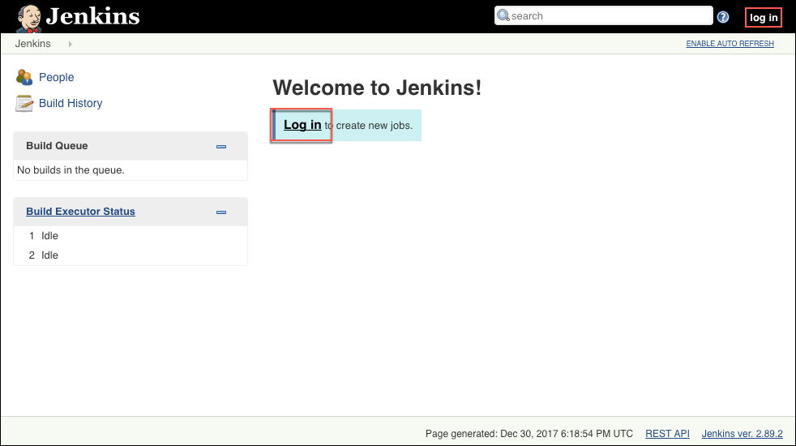
5. On the Jenkins on Azure screen, you will see a message that this Jenkins instance does not support https, so logging in through a public IP address has been disabled. You will need to create an SSH tunnel to securely connect to the Jenkins instance.
6. To set up an SSH tunnel to Jenkins, you will copy the ssh command provided in theJenkinson Azure window, as highlighted in the screen shot below.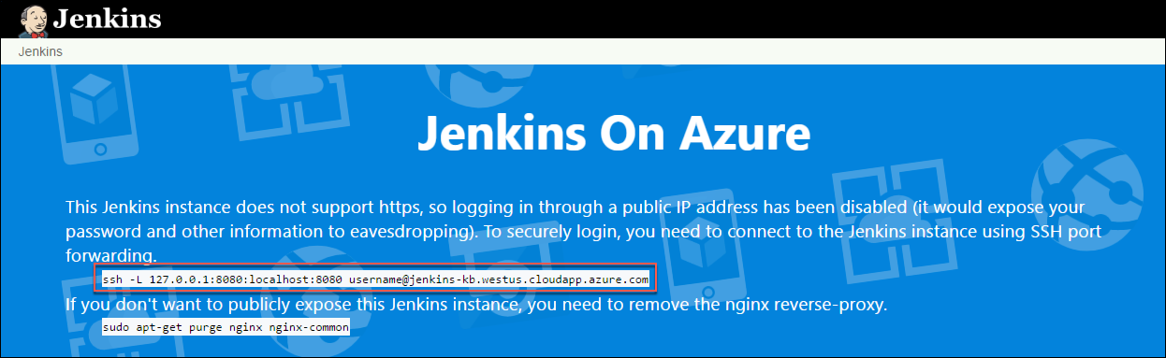
7. Open a new Git Bash window, and at the command prompt paste the copied ssh command, replacing username with **jenkinsadmin**. The command will resemble the following:

ssh -L 127.0.0.1:8080:localhost:8080 jenkinsadmin@jenkins-kb.westus.cloudapp.azure.com

1. If prompted that authenticity of the Jenkins host cannot be established, enter “yes” to continue.
2. Enter the **jenkinsadmin** password, “Password.1!!”. 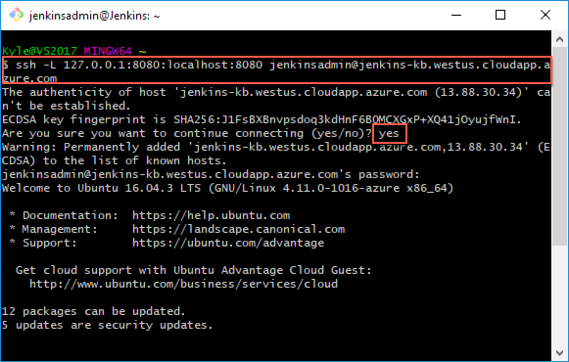
3. After you have started the SSH tunnel, open a new browser tab or window, and navigate to <http://localhost:8080/> on your LabVM, and select **Log in**. 
4. To get the initial password, return to your open Git Bash window, and run the following command:

sudo cat /var/lib/jenkins/secrets/initialAdminPassword

1. Copy the password returned.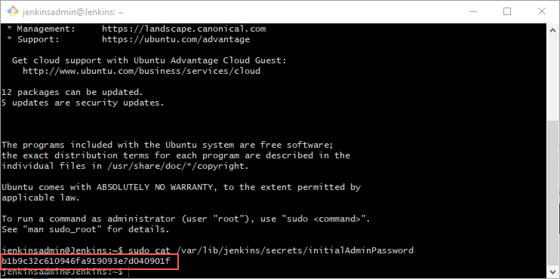
2. On the Jenkins login screen, enter the following credentials:
   1. **User:** “admin”
   2. **Password:** Paste the password copied from the Git Bash window above. 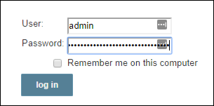
3. Select **log in**.
4. Select **Manage Jenkins** from the left-hand menu, and select **Manage Plugins**. 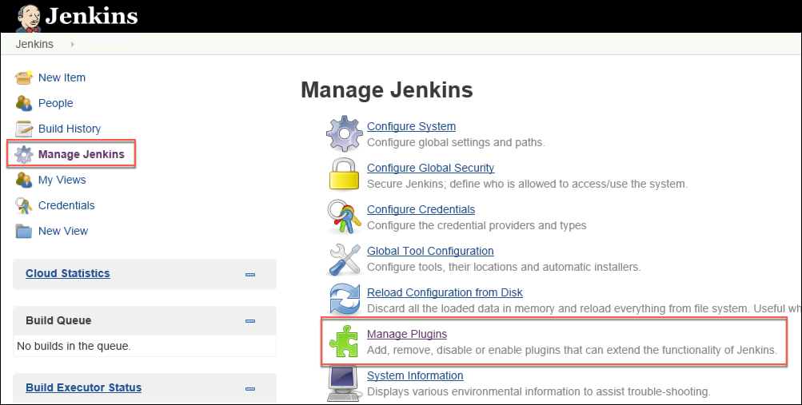
5. On the Manage Jenkins screen, select the **Available** tab, enter “github plugin” into the **Filter** box, check the box next to **GitHub plugin**, and select **Install** without restart.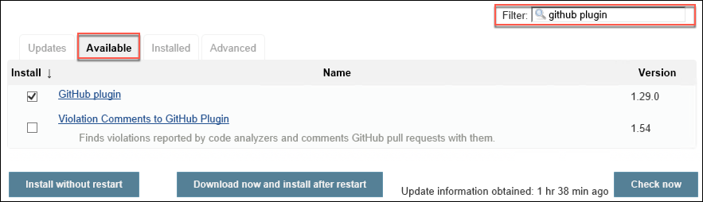
6. You will see a success message when the install is complete. Select **Go back to the top page**.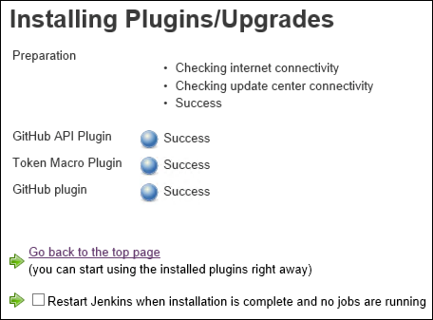
7. The VS Team Services Continuous Deployment plug-in should already be installed (but if it is not repeat the process above to install it). You can verify it is installed by selecting the **Installed** tab on the Mange plug-ins page, and locating it in the list of installed plug-ins.
   1. Change the filter to **vs team services continuous deployment**, select the **VS Team Services Continuous** **Deployment** plug-in, and select **Install without restart**.
8. Now, change the **Filter** on the Manage plug-ins to **nodejs** to locate the NodeJS plugin, check it, and select **Install** **without restart**.
9. Go back to the **Jenkins** dashboard, and select **Manage Jenkins** from the left-hand menu.
10. Select **Global Tool Configuration**.
11. Find **NodeJS**, and select **NodeJS installations**.
12. Enter a name, ensure **Install automatically** is checked.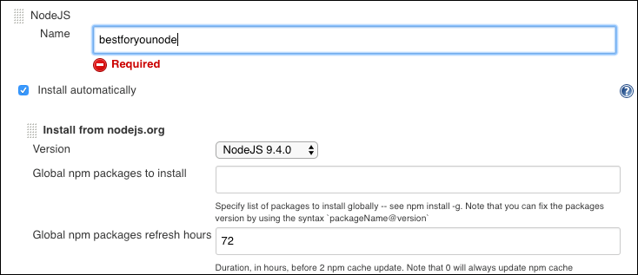
13. Select **Save**.



1. Return to the **Jenkins** dashboard, and select **New Item** from the left-hand menu.
2. Enter “best-for-you-build” as the name, select **Freestyle project**, and select **OK**. 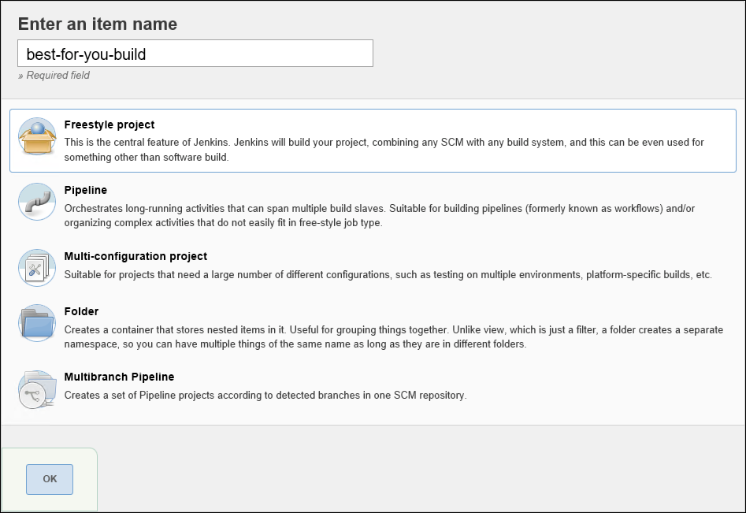
3. On the **General** tab of the project page, select **GitHub project**, and enter the URL for your forked copy of the best-for-you-organics project page in your GitHub account. 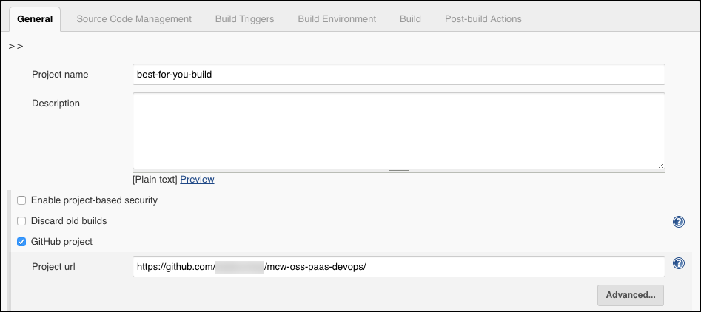
4. Next, scroll down to the **Source Code Management** section, select **Git**, and enter the URL to your project, including the .git extension. 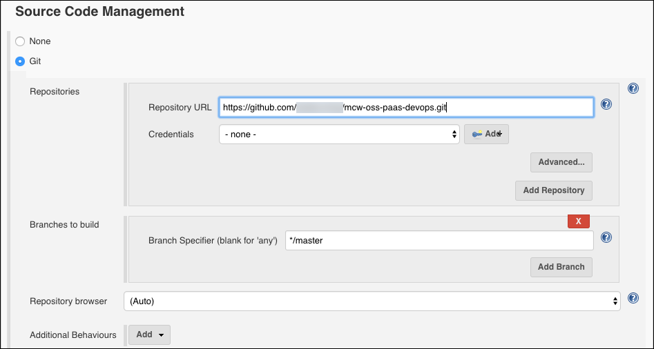
5. Scroll down to the **Build Triggers** section, and select **GitHub hook trigger for GITScm polling**. 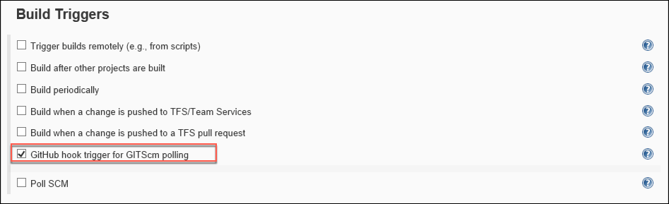
6. Finally, select **Save**.



1. Your Jenkins CI build job should now be triggered whenever a push is made to your repository.

#### Task 3: Trigger CI build

In this task you will commit your pending changes in VS Code to you GitHub repo, and trigger the Jenkins CI build job.

1. Return to VS Code, and the open mcw-oss-paas-devops project.
2. Observe that the **source control icon** on the left-hand navigation bar has a badge indicating you have uncommitted changes. Select the **icon**. 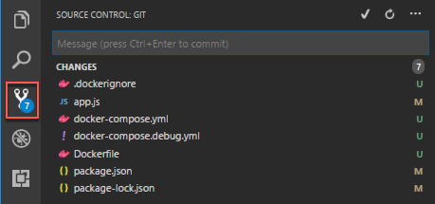
3. In the **SOURCE CONTROL: GIT** pane, enter a commit message, such as “Added Docker configuration,” and select **+** next to **CHANGES** to stage all the pending changes. 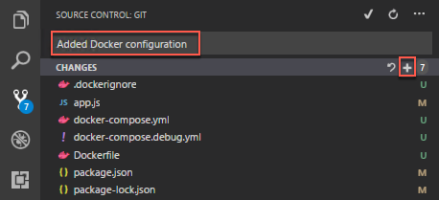
4. Select the **checkmark** to commit the changes. 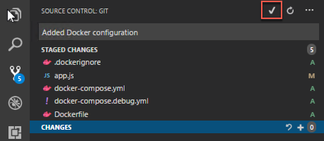
5. Next, select the **ellipsis** to the right of the check mark, and select **Push** from the dropdown.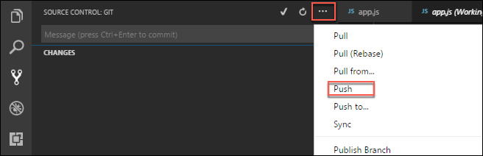
6. If prompted, enter your GitHub account credentials to log into your GitHub account.
7. Return to your **Jenkins** Dashboard, and locate the **Build Queue** block on the left-hand side.
8. You should see **best-for-you-build** job get added into the queue. Select it.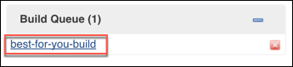
9. On the build page, you can see the changes you committed. 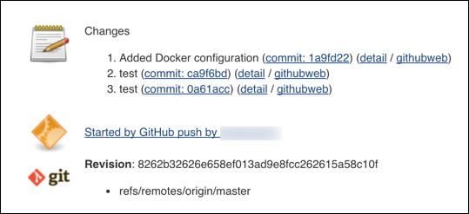
10. You have successfully set up your CI pipeline.

#### Task 4: Create Free Visual Studio Team Services Account

In this task, you will create a free Visual Studio Team Services (VSTS) account. If you already have a VSTS account, you can skip this task.

1. In a browser, navigate to <https://www.visualstudio.com/>, and select **Get started for free** under **Visual Studio Team Services**. 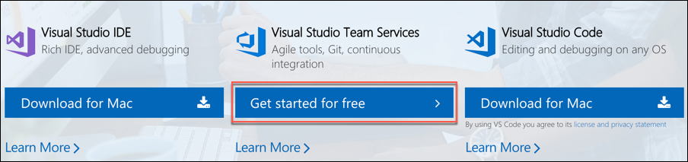
2. Sign into your Microsoft account when prompted.
3. At the **Host my project at:** page, enter a unique name, and select **Continue** to create your VSTS account.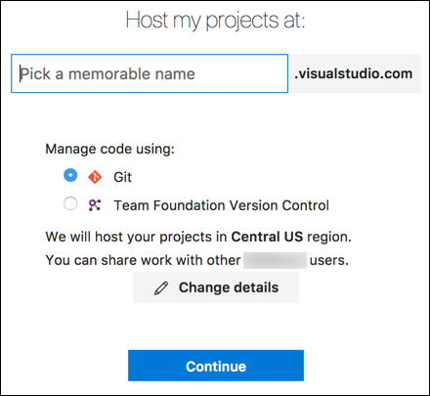
4. In your VSTS account home page, select **New Project**. 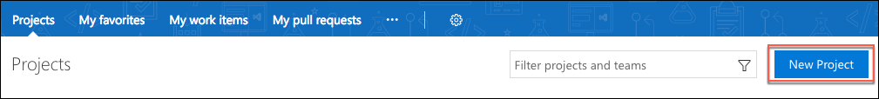
5. On the **Create new project** screen, enter “BestForYouOrganics” for the Project name, and select **Create**. 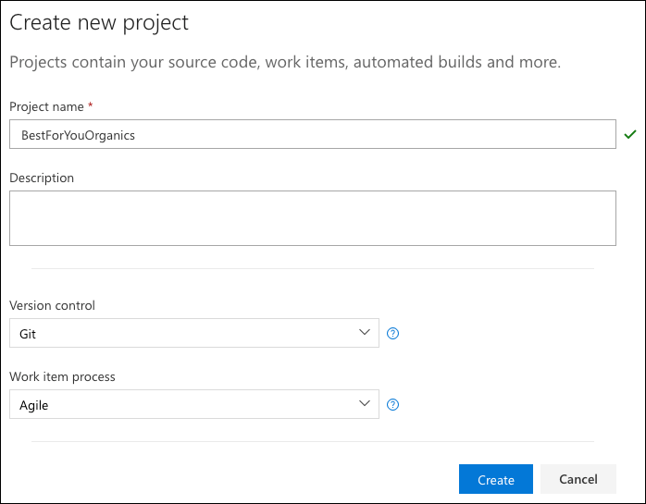

#### Task 5: Create a VSTS personal access token

In this task, you will create a personal access token with the Release (read, write, execute, and manage) permission in VSTS, which will allow Jenkins to communicate with Team Services account.

1. From your VSTS home page, open your profile, and select **Security**. 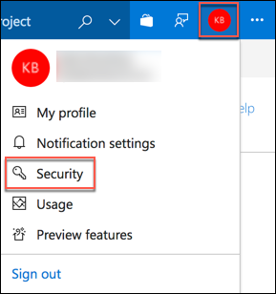
2. On the **Security** page, select **Personal access tokens**, then select **Add**. 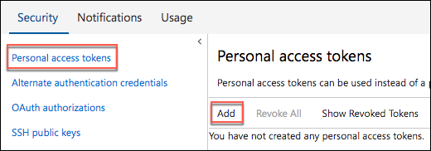
3. On the **Create a personal access token screen**, enter a **description,** such as “best-for-you-organics,” select an **expiration period** for the token, and select your **account**.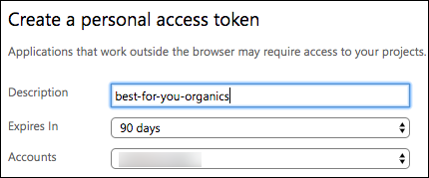
4. Under **Authorized Scopes**, choose **Selected scopes**, and select **Release (read, write, execute and manage)**. 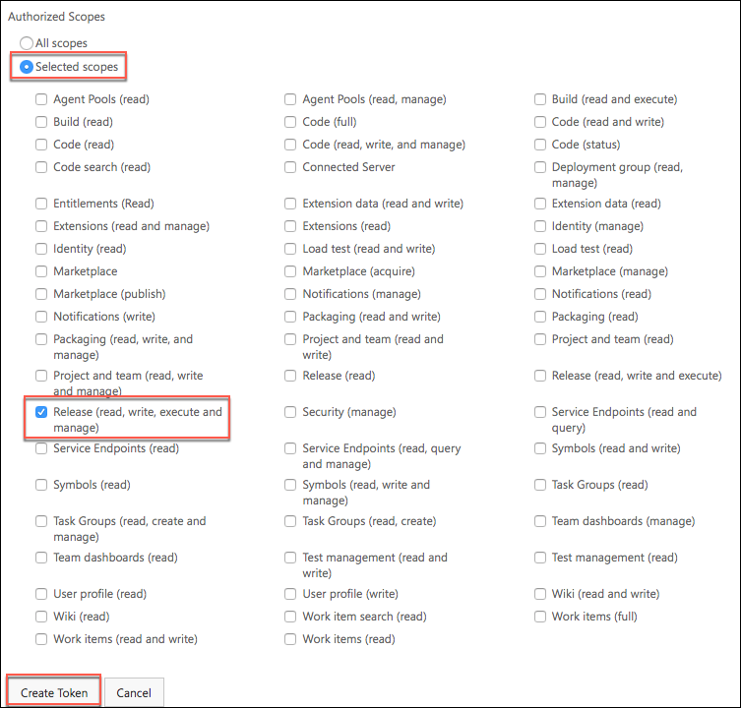
5. Select **Create Token**.
6. Copy the generated token, and paste it into a text editor, such as Notepad, for later use. Make sure you copy the token and save it in a file, as it will no longer be accessible once you navigate away from the screen. 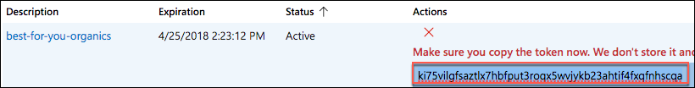

#### Task 6: Configure Jenkins for Team Services integration

In this task, you will add the necessary configuration information to allow Jenkins to send build artifacts to a VSTS release.

1. Return to your **Jenkins** dashboard, and select the **best-for-you-build** project. 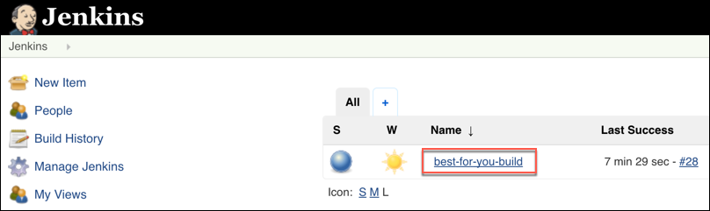
2. Select **Configure** from the left-hand menu.

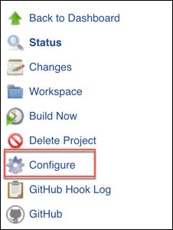

1. Select the **Post-build Actions** tab, then select **Add** **post-build action**, and select **Archive the artifacts** from the list. 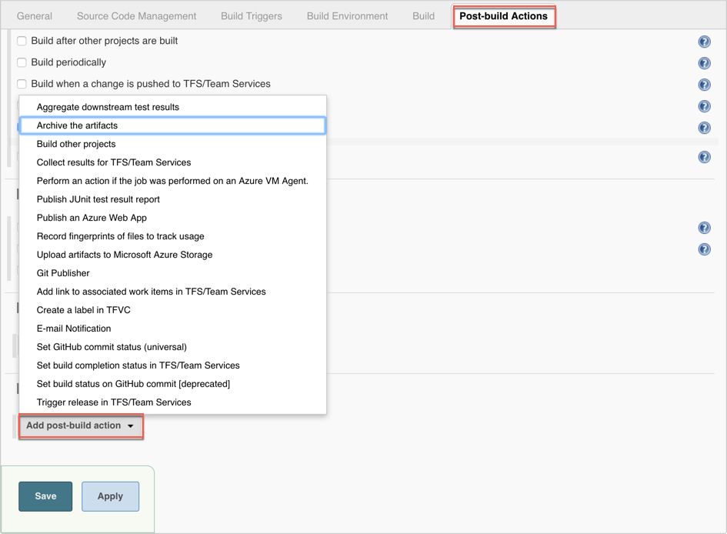
2. Enter “ **/* ” in the Files to archive box. 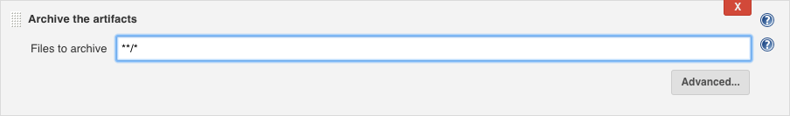
3. Select **Add post-build action** again, and select **Trigger release in TFS/Team Services**. 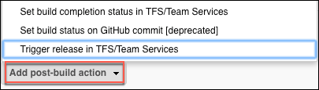
4. In the **Trigger release in TFS/Team Services**, enter the following:
   1. **Collection url**: Enter the URL to your VSTS account, such as https://{your-account-name}.visualstudio.com
   2. **Team project**: Enter “BestForYouOrganics.”
   3. **Release definition**: Enter “BestForYouOrganics CD.”
   4. **Username**: Enter “admin.”
   5. **Password**: Paste the personal access token you copied previously from you VSTS account.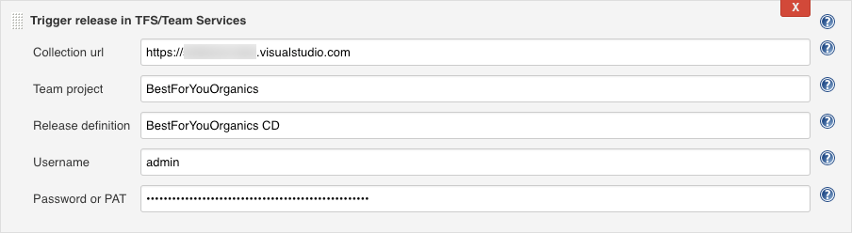
5. Select **Save**.

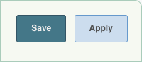

#### Task 7: Create a Jenkins service endpoint is VSTS

In this task, you will configure a service endpoint for your Jenkins server in VSTS.

1. Open the **Services** page from your **BestForYouOrganics** project home page in VSTS, and select **New Service** **Endpoint**, and select **Jenkins**. 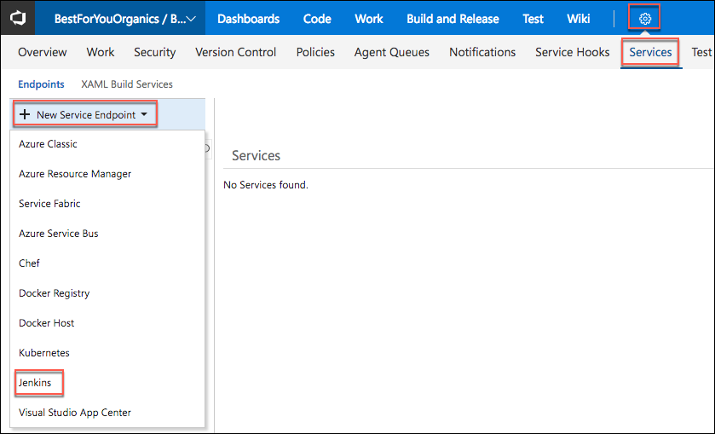
2. In the **Add new Jenkins Connection** dialog, enter the following:
   1. **Connection name**: Enter “BestForYouJenkins.”
   2. **Server URL**: Enter the URL of your Jenkins server, such as “http://{YourJenkinsUrl}.westus.cloudapp.azure.com.”

* You can obtain this by navigating to your Jenkins VM in the Azure portal, and copying the *DNS name* on the VM’s overview blade.
  1. **Accept untrusted SSL certificates**: Check this.
  2. **Username**: Enter “admin.”
  3. **Password**: Use the initial admin password you used to log into the Jenkins dashboard, retrieve in Task 1, Step 11, of this exercise.
  4. Select **Verify connection**, to check that the information is correct.
  5. Select **OK**. 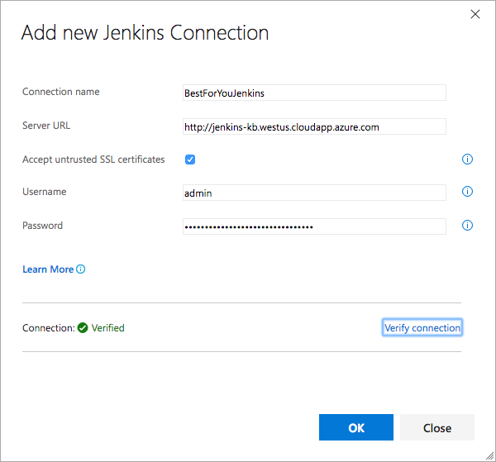

#### Task 8: Create a Team Services release definition

In this task, you will create the release definition in VSTS, which will take the build artifacts from Jenkins, and push them to the Azure Container Registry associated with your Web App for Containers.

1. In VSTS, select **Build and Release**, **Releases**, and select **+New** **definition**. 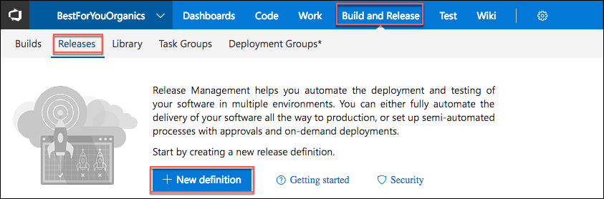
2. In the **Select a Template** dialog that appears, select **start with an** **Empty process**. 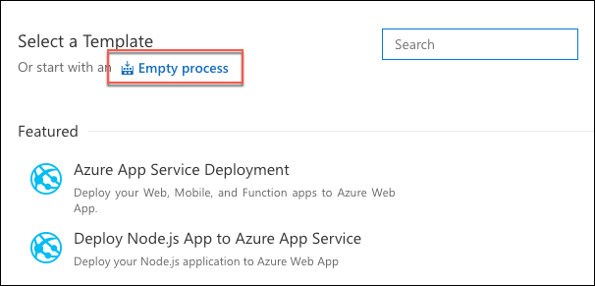
3. In the**Environment** dialog that appears next, select the **X** to close the dialog. 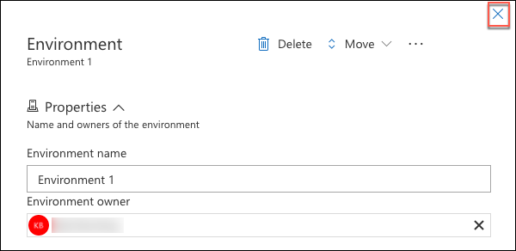
4. Next, select **+Add** **Artifact**. 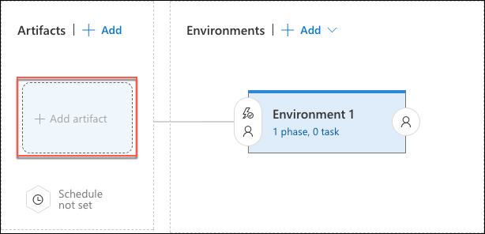
5. In the **Add artifact** dialog, under **Source type**, select **3 more artifact types** to expand the entire list. 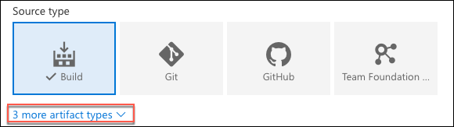
6. Select **Jenkins**, select the **BestForYouJenkins** **Service**, set the **Source (Job)** and **Source alias** to “best-for-you-build,”and select **Add**. 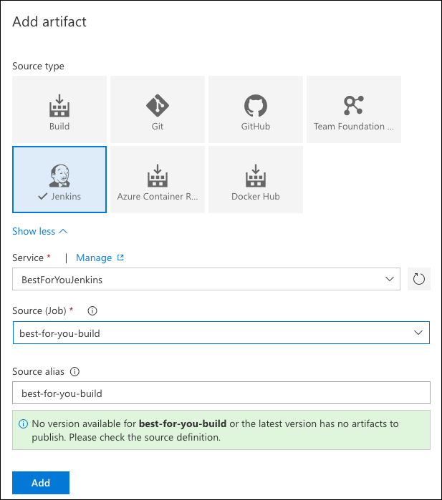
7. Select **Tasks** from the menu. 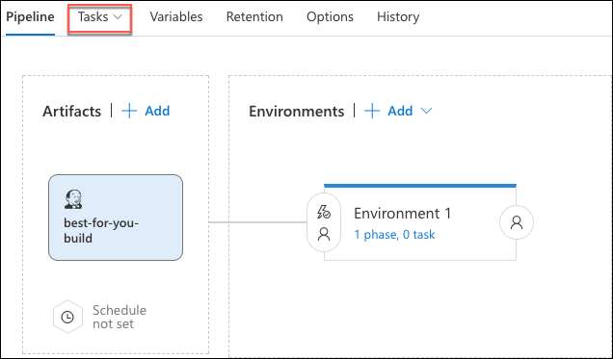
8. Select **Agent phase**, and change the **Agent queue** to **Hosted Linux Preview**. 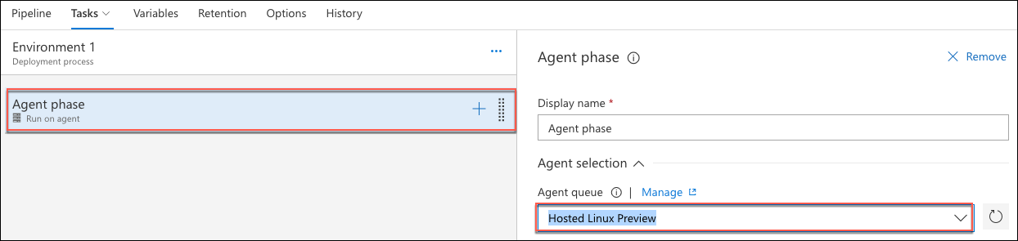
9. Next, select the **+** in **Agent phase**, enter “Docker” in the Search box, and select **Add** next to the **Docker** task.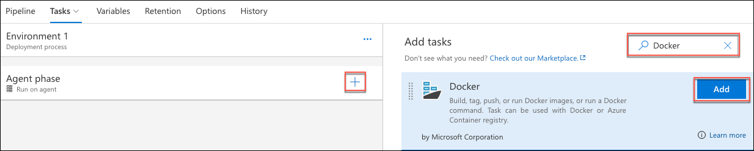
10. Repeat the previous step to add a second Docker task to the phase.
11. Now, change the text in the **Add tasks** search box to **Azure app service**, and select **Add** for the **Azure App Service Deploy** task. 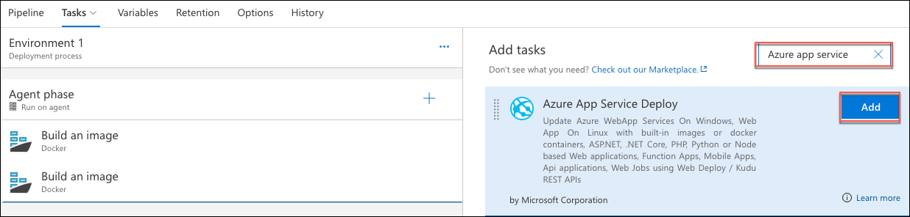
12. Your Environment should now look like the following. 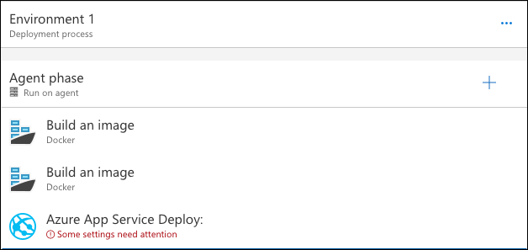
13. Select the first Docker **Build an image** task under **Agent phase**, and set the following:
    1. **Container Registry Type**: **Azure Container Registry**
    2. **Azure subscription**: Select your subscription. You may need to select the **Authorize** button and enter your credentials first.
    3. **Azure Container Registry**: Select **bestforyouregistrySUFFIX**.
    4. **Action**: Leave as Build an image.
    5. **Image name**: Enter **[Your Registry Name].azurecr.io/best-for-you-organics:v1**, for example, bestforyouregistry.azurecr.io/best-for-you-organics:v1.
    6. **Include Latest Tag**: Check this.
    7. Leave all other fields set to their defaults.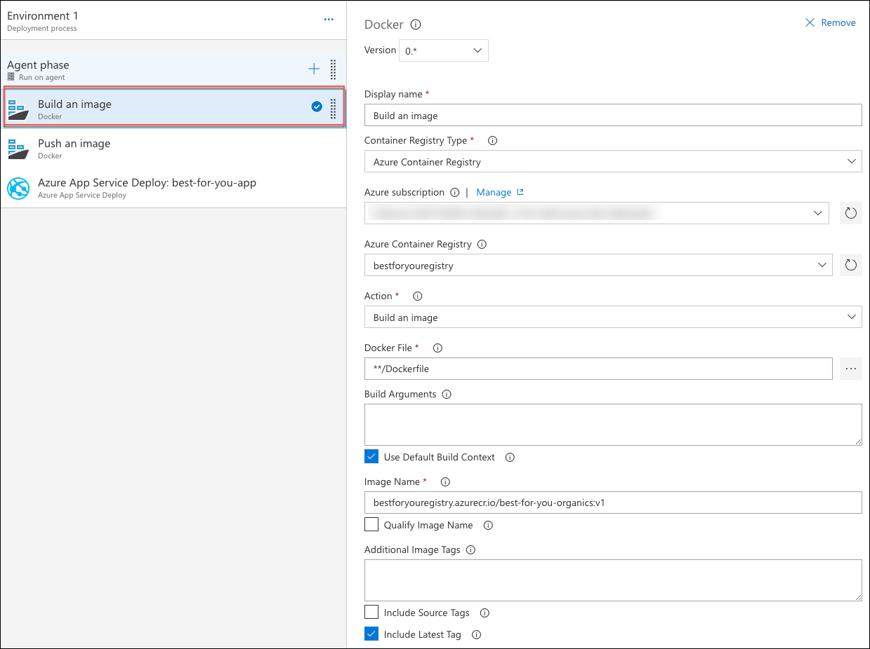
14. Select the second **Docker Build an image** task under Agent phase, and set the following:
    1. **Container Registry Type**: **Azure Container Registry**
    2. **Azure subscription:** Select your subscription.
    3. **Azure Container Registry:** Select **bestforyouregistrySUFFIX**.
    4. **Action:** Select **Push an image** (this will change the display name to Push an image as well).
    5. **Image name:** Enter [Your Registry Name].azurecr.io/best-for-you-organics:v1; for example, bestforyouregistry.azurecr.io/best-for-you-organics:v1.
    6. **Include Latest Tag**: Check this.
    7. Leave all other fields set to their defaults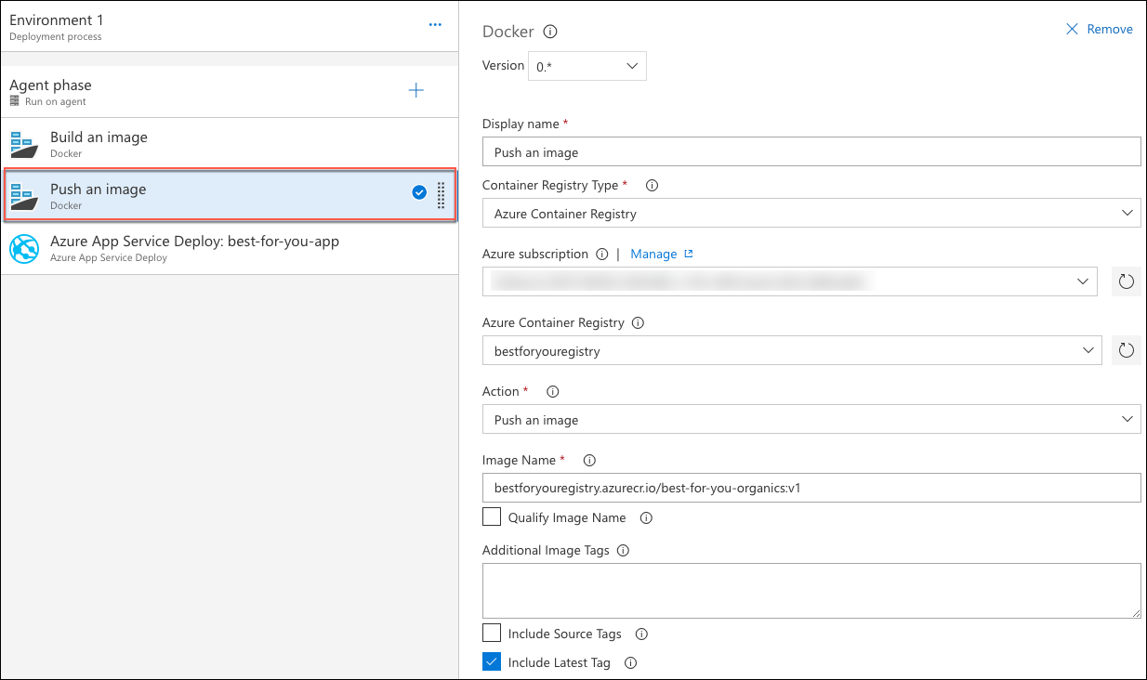
15. Select the **Azure App Service Deploy**: task, and, enter the following:
    1. **Azure Subscription:** Select your subscription. Select **Authorize**, and enter your Azure account credentials, if prompted.
    2. **App type:** Select **Linux App**.
    3. **App service name:** Enter “best-for-you-app-SUFFIX” (you will have to manually enter this, as it won’t show up in the list).
    4. **Image source**: **Container Registry**.
       1. **Registry or Namespace:** Enter “[Your Registry Name].azurecr.io,” for example, bestforyouregistry.azurecr.io.
    5. **Image**: Enter “best-for-you-organics.”
    6. **Tag:** Enter v1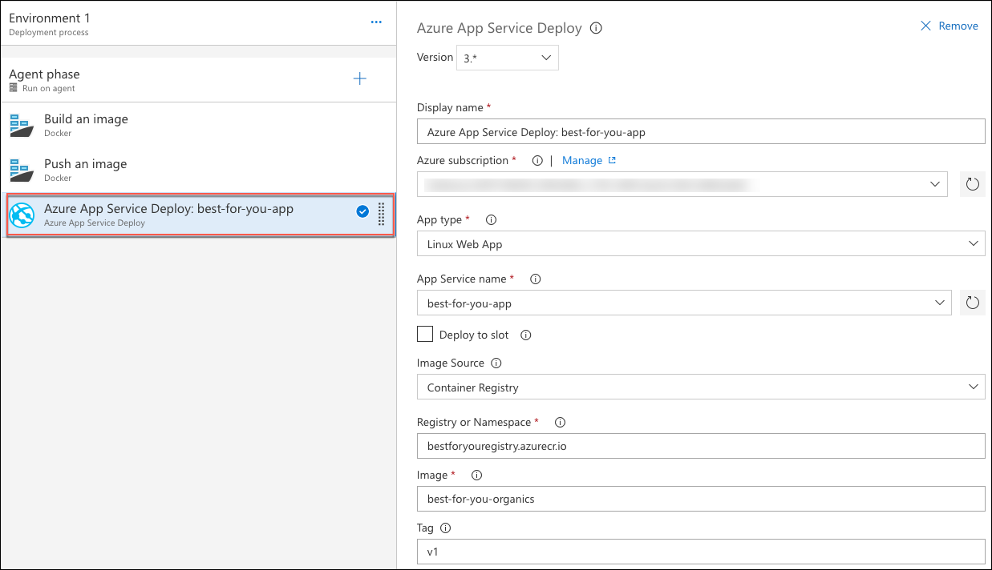
16. Finally, enter “BestForYouOrganics CD” for the release definition name, and select **Save**. (Note: the release definition name must match the release definition name you entered in your Jenkins build definition.)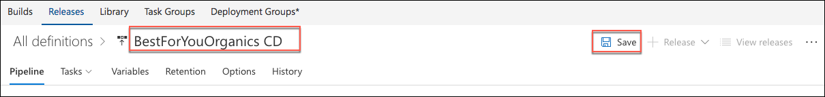

#### Task 9: Trigger CI/CD pipeline

In this task, you will commit a change to the mcw-oss-paas-devops starter application, and trigger the full CI/CD pipeline through Jenkins and VSTS.

1. Return to VS Code on your Lab VM, open the src/components/plan/Plans.js file, and insert the following markup between <div class=”container”> and <Grid>.

<h3>Welcome to Best For You Organics Company</h3>

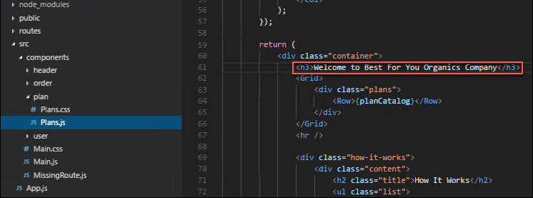

1. Save the file.
2. Run the following command in the Integrated terminal.

npm run build

1. As you did in Task 2, above, select the **Source Control icon** from the left-hand menu, enter a commit comment, select **+** to stage the change, and select the **checkmark** to commit the change, and push to GitHub. This will trigger the CI/CD pipeline, starting with the Jenkins build.
2. Return to your Jenkins dashboard, and select the **best-for-you-build project**, select the **latest build**, and note the build number.

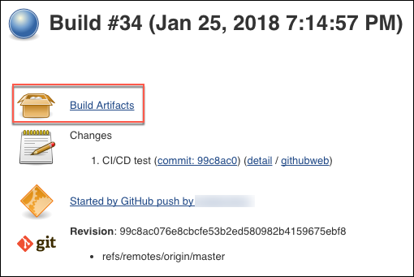

1. Next, go to the **Releases** page in your VSTS account, and you will see an active release, with the same build number as you noted in Jenkins.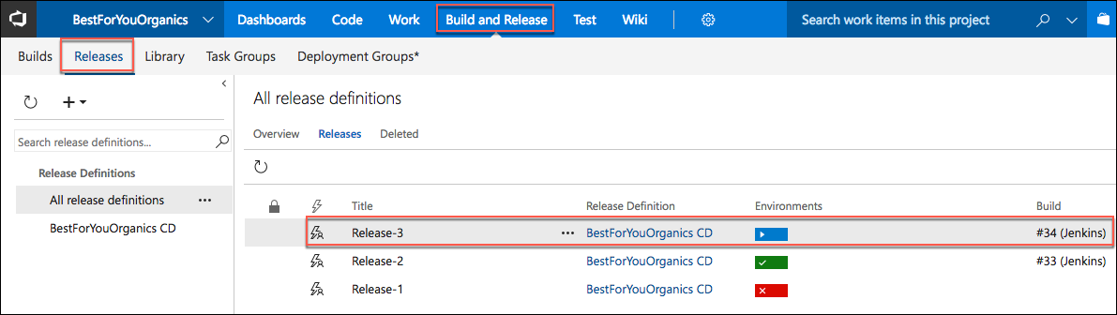
2. Select the **ellipsis** next to the active release, and select **Open**. 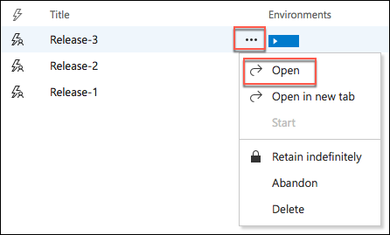
3. On the summary tab, you can see that the release is in progress. Select the **Logs** tabs to see that real-time progress of the release. 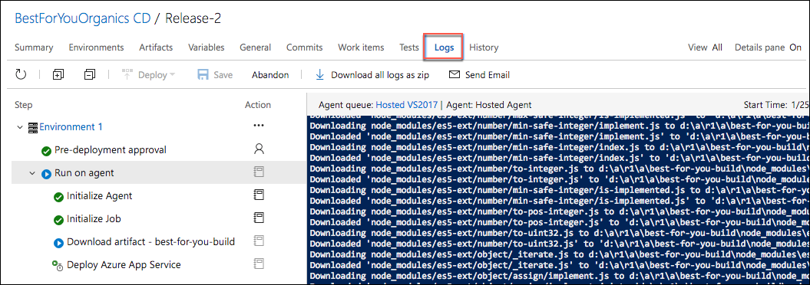
4. When the deployment is complete, check change in by going to Azure reloading the web page for your App Service in the browser. The deployment can take 30+ minutes, so move on to the next exercise, and come back and check the deployment progress periodically.
5. When the deployment is complete you should see the home page, with a new header above the three plans on the page. 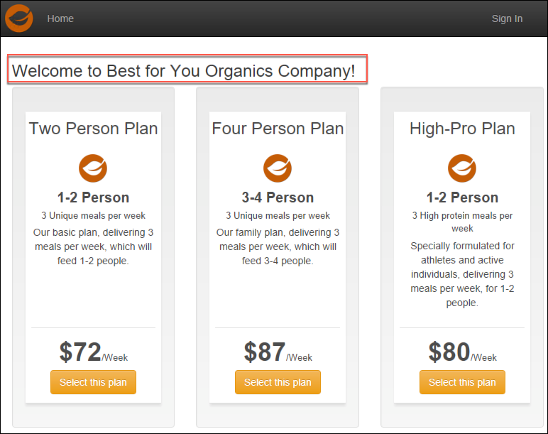

## After the workshop

Duration: 10 minutes

In this exercise, you will deprovision all Azure resources that were created in support of this hands-on lab.

#### Task 1: Delete Azure resource groups

1. In the Azure portal, select **Resource groups** from the left-hand menu, and locate and delete the following resource groups.
   1. hands-on-labs-SUFFIX
   2. jenkins-SUFFIX

#### Task 2: Delete WebHooks and Service Integrations

1. In your GitHub account
   1. Delete the Jenkins service integration
   2. Delete the Personal Access Token you created for integration with VS Code.
2. In your VSTS account
   1. Delete the Personal Access Token you created for integration with Jenkins.
   2. Delete the Jenkins service endpoint you added
   3. Delete the BestForYouOrganics CD release

You should follow all steps provided *after* attending the Hands-on lab.

## Appendix A: Manually provision resources from ARM template

#### Provision a lab virtual machine

The steps below detail how to provision the Lab virtual machine (VM) without the use of the ARM template.

1. In the [Azure Portal](https://portal.azure.com/), select **+New**, then enter “Windows 10” into the search bar, and select **Windows 10 Pro, Version 1709** from the results. 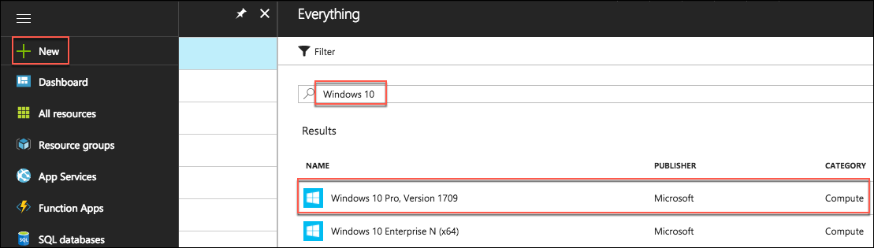
2. On the **Windows 10 Pro, Version 1709** blade, select **Create**.

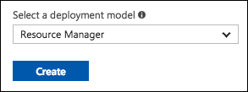

1. Set the following configuration on the **Basics** tab.
   1. **Name:** Enter LABVM.
   2. **VM disk type:** Select **SSD**.
   3. **User name:** Enter demouser
   4. **Password:** Enter Password.1!!
   5. **Subscription:** Select the subscription you are using for this hands-on lab
   6. **Resource Group:** Select **Use existing**, and select the “hands-on-labs-(SUFFIX)” resource group
   7. **Location:** Use the same location as you used for the resource group 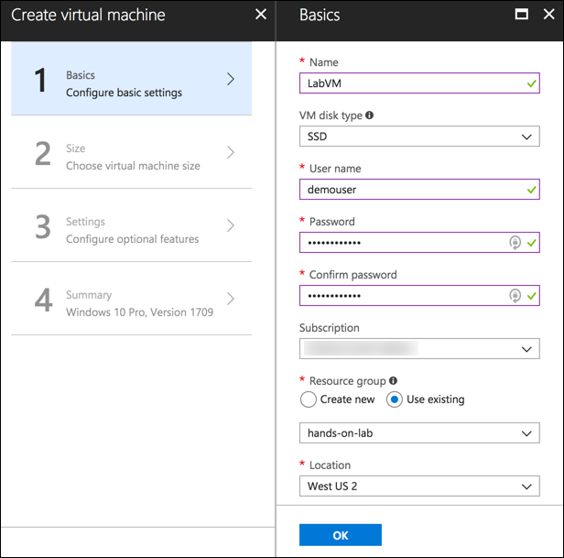
2. Select **OK** to move to the next step.
3. On the **Choose a size** blade, ensure the **Supported disk type** is set to SSD, and select **View all**. This machine will be doing nested virtualization, so it needs to be in either the Dv3 or Ev3 series to enable Hyper-V, so selecting **D4S_V3 Standard** is a good baseline option. If that size is not available in the region you selected, go back to the **Basics** blade, and try one of the other regions listed above. 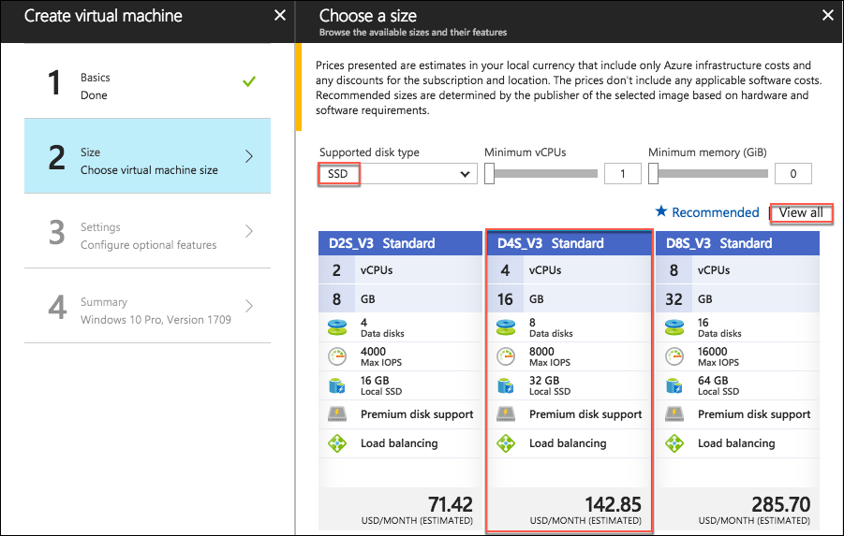
4. Select to move on to the **Settings** blade.
5. Accept all the default values on the **Settings** blade, and Select **OK**.
6. Select **Create** on the **Create** blade to provision the virtual machine. 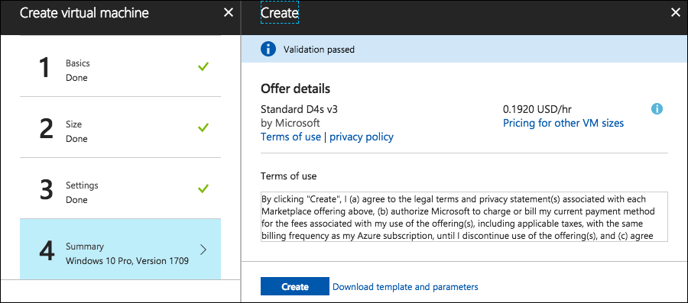
7. It may take 10+ minutes for the virtual machine to complete provisioning. You can move on to the next task while you wait for this to complete.